Moduldokumentation

Modul Applikationssicherheit (apsi)

Simon Wächter

2019

Inhalt

1 Einleitung 7

1.1 Einleitung 7

1.2 Lernziele 7

1.3 Prüfungen 7

2 Woche 1 8

2.1 Agenda 8

2.2 Administrative Issues 8

2.3 Who is Your Lecturer (Wagner) 8

2.4 whoami (Schläpfer) 9

2.5 Why is Application Security Important? 9

2.6 Lecture Overview (1) 10

2.7 Lecture Overview (2) 10

2.8 Lecture Overview (3) 11

2.9 Example: Buffer Overflow 11

2.10 How does a Buffer Overflow Work? 11

2.11 Buffer Overflow Demo 12

2.12 Not Really a Fix for Buffer Overflow: Stack Protection 12

2.13 Fix for Buffer Overflow: Checked Buffers 12

2.14 Example: Taint Checking in Perl (1) 13

2.15 Example: Taint Checking (2) 13

2.16 Example: Taint Checking (3) 14

2.17 Example: Taint Checking (4) 14

2.18 Example: Data Leakage by Behavior (1) 14

2.19 Example: Data Leakage by Behavior (2) 15

2.20 Example: Data Leakage by Error Output 15

2.21 Human Factors 16

2.22 Exercises and Preparation for Next Week 16

2.23 Reserve 16

3 Woche 2 17

3.1 Agenda 17

3.2 Recap: What do Attackers Want? 17

3.3 Buffer Overflow II 17

3.4 Buffer Overflow II 18

3.5 Buffer Overflow II 18

3.6 Buffer Overflow II 19

3.7 Buffer Overflow II 19

3.8 Attack Technique: Fuzzing 20

3.9 Error Handling 20

3.10 Case study – Handling too long input 21

3.11 Case-study: Compression Bomb 21

3.12 Error Handling 22

3.13 Algorithmic Complexity Attacks 23

3.14 Algorithmic Complexity: Sorting 23

3.15 Algorithmic Complexity: Hashing 24

3.16 Algorithmic Complexity: Regular Expressions 24

4 Woche 3 25

4.1 Agenda 25

4.2 Secure Coding Principle: Test-before-use 25

4.3 Input Validation 25

4.4 Input Normalization 26

4.5 Unix Permission Model (simplified) 26

4.6 Chroot 27

4.7 Mandatory Access Control (MAC) 27

4.8 MAC Example: SELinux 28

4.9 MAC Example: AppArmor 28

4.10 Secure Coding Principle: Defense in Depth 29

4.11 Privilege Separation 29

4.12 Overall Idea 30

4.13 Form of the Modules 30

4.14 Example: OpenSSH 31

4.15 OpenSSH: Privilege Separation Approach 31

4.16 Example: Postfix MTA (Email Server) 31

4.17 Postfix System View 32

4.18 Postfix: Example Data-Flow 32

5 Woche 4 33

5.1 Agenda 33

5.2 Security Testing (for Software) 33

5.3 Pen-Test 33

5.4 How does a Pen-Test fail? 34

5.5 Code Inspection and Review 34

5.6 Code Scanners 35

5.7 Execution Emulators 35

5.8 Patching 36

5.9 How to Patch 36

5.10 Problems with Patching 37

5.11 Problems with not Patching 37

5.12 Problems with Unavailability of Patches 37

5.13 Economic Aspects of Security 38

5.14 Case Study: DDoS on Brian Krebs (20.9.2016) 38

5.15 What can Perform Such an Attack? 38

5.16 IoT: Internet of insecure Things 39

5.17 Why are These IoT Devices so Insecure? 39

5.18 Possible Solutions 40

5.19 Does it Pay to make Software Secure? 40

5.20 So, what to do? 41

6 Woche 5 42

6.1 Agenda 42

6.2 Generating Cryptographic Keys 42

6.3 Information-Theoretical Entropy 43

6.4 Estimating Entropy is Tricky 43

6.5 Seeding a CPRNG 44

6.6 Bad Seeding Examples 44

6.7 Storing Cryptographic Keys Securely 44

6.8 Storing Passwords 45

6.9 Rainbow Table 45

6.10 Storing Passwords 46

6.11 So What is Wrong with PBKDF2? 46

6.12 Hardware RNGs 47

6.13 Example 1: Via C3 Hardware CPRNG Schematic 47

6.14 Example 2: Intel RDRAND Schematic 48

6.15 Compromise on Design-Level 48

6.16 Storing Private Data (as a Service Provider) 49

6.17 Disk/Storage Encryption 49

6.18 Disk Encryption Protects Against What? 49

6.19 Decryption Only With User Logged In 50

6.20 Encryption in the Cloud 50

6.21 JavaScript Client-Side Encryption in Web-Apps 51

7 Woche 6 52

7.1 Agenda 52

7.2 Virtualization vs. Security 52

7.3 DoS on Application Layer 53

7.4 DoS on Application Layer 53

7.5 Code Analysis for Security 54

7.6 Backdoors in Code 54

7.7 Backdoor Hiding Techniques 55

7.8 Finding Backdoors 55

7.9 Backdoors in Cryptography 56

7.10 Example 1: ECC 56

7.11 Example 2: Specially selected Primes for Discreet Logarithms 57

7.12 Fuzz-Testing: The Idea 57

7.13 Possibilities and Limitations 58

7.14 Structured Fuzzing vs. Random Fuzzing 58

7.15 Fuzzing for Regular Tests 59

7.16 Useful Fuzzing Tools 59

8 Woche 7 60

8.1 Agenda 60

8.2 Example Request in the TCP/IP Model 60

8.3 HTTP 60

8.4 HTTP Request Example: GET 61

8.5 HTTP Request Example: POST 61

8.6 HTTP Response Example 62

8.7 Exotic Requests: PUT, DELETE, ... 62

8.8 HTTP Authentication 63

8.9 HTTP Authentication 63

8.10 Cookies 64

8.11 Cookie Options 64

8.12 Cookies: Access via JavaScript 65

8.13 Session Management 65

8.14 Security Problems with Session Management 66

8.15 Keeping State Securely on Client-Side 66

8.16 Remark: Cookies and Application Paths vs. Proxies 67

8.17 SSL/TLS 67

8.18 SSL/TLS 68

8.19 CGI: General Idea 68

8.20 CGI Scripts in Different Languages 69

8.21 CGI in BASH 70

8.22 CGI in BASH: Output 70

8.23 CGI in Perl 71

8.24 CGI in Perl: Output 71

8.25 CGI in C 72

8.26 CGI in C: Output 72

8.27 CGI in Java 73

8.28 CGI Security 73

9 Woche 8 74

9.1 Dates 74

9.2 11.11.19: Guest Speaker about WAF 74

9.3 Agenda 74

9.4 OWASP – Open Web Application Security Project 75

9.5 OWASP Top Ten 75

9.6 OWASP Top Ten 76

9.7 Cross-Site Scripting (XSS): Cookie Theft 76

9.8 Stored XSS Countermeasures 77

9.9 Reflected XSS 77

9.10 Defense Against Reflected XSS 78

9.11 Cross Site Request Forgery (CRSF) 78

9.12 CRSF Example 2 78

9.13 CRSF Countermeasures 79

9.14 Same-Origin Policy 79

9.15 Cookies and Same Origin 80

9.16 Same Origin Policy (SOP) and its Limits 80

9.17 CORS Overview 81

9.18 CORS Preflight Requests 81

9.19 CORS Example (slightly abbreviated) 82

9.20 CORS for Multiple Domains 82

9.21 Content Security Policy (CSP) Headers 83

9.22 Overview of Common CSP Options 83

9.23 Exercise: U08 84

10 Woche 9 85

10.1 Agenda 85

10.2 Coding Style Guides / Coding Standards 85

10.3 Linux Kernel Coding Style: Introduction 85

10.4 Linux Kernel Coding Style: Examples (1) 86

10.5 Linux Kernel Coding Style: Examples (2) 86

10.6 Linux Kernel Coding Style: Examples (3) 87

10.7 Linux Kernel Coding Style: Examples (4) 87

10.8 CERT/SEI Rules and Recommendations 87

10.9 What do Coding Style Guides Accomplish in Reality? 88

10.10 Problems with Restrictive Coding Environments 88

10.11 What About Interfaces and Naming in Them? 89

10.12 So use a Style Guide or not? 89

11 Woche 10 90

11.1 Agenda 90

11.2 Authentication 90

11.3 Authorization 90

11.4 Access to a Resource 91

11.5 Recap: Public Key Cryptography 91

11.6 JSON Object Signing and Encryption (JOSE) 92

11.7 JSON Web Signatures (JWS) 92

11.8 JSON Web Encryption (JWE) 93

11.9 JSON Web Token (JWT) 93

11.10 Nested JWT 94

11.11 JOSE Implementation Details 94

11.12 OAuth 2.0 95

11.13 OAuth Access Flow 95

11.14 Identity Federation 96

11.15 OpenID Connect 96

11.16 OAuth vs. OpenID 97

11.17 OpenID Connect 97

11.18 Recent OAuth 2.0 Flaws 97

11.19 SAML 2.0 98

11.20 SAML 2.0 98

12 Woche 11 99

13 Woche 12 100

# Einleitung

## Einleitung

Dieses Dokument stellt die Moduldokumentation für das Modul apsi dar. Allfällige Unterlagen sind im Modulordner zu finden.

## Lernziele

Das Modul beinhaltet folgende Lernziele:

* Kennen typische Bedrohungen von Applikationen sowie ihren Daten und können abschätzen, wieweit diese für durch sie zu entwickelnde Software ein Sicherheitsrisiko darstellen
* Kennen typische Sicherheitsprobleme und können sie vermeiden
* Sind in der Lage, einschlägige Quellen zu konsultieren, um neu veröffentlichte Sicherheitsprobleme zu erfassen und zu verstehen, wie diese zu vermeiden sind
* Verfügen über Konzeptwissen, nicht nur Produktwissen, um das Gelernte auch in anderen Umfeldern und mit anderen Programmiersprachen anwenden zu können

## Prüfungen

Die Modulnote setzt sich zu 100% aus einer Semesterprüfung und einer Modulschlussprüfung zu je 50% zusammen.

# Woche 1

## Agenda

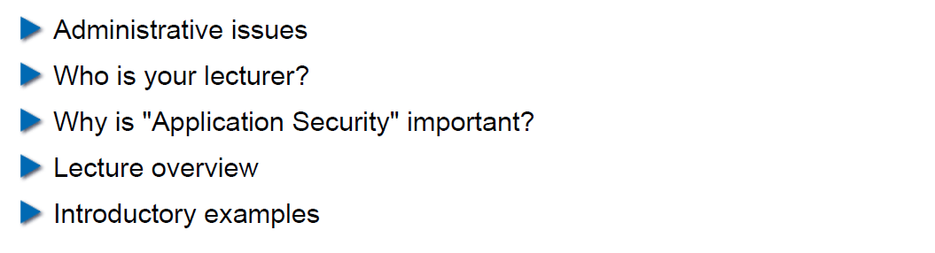

## Administrative Issues

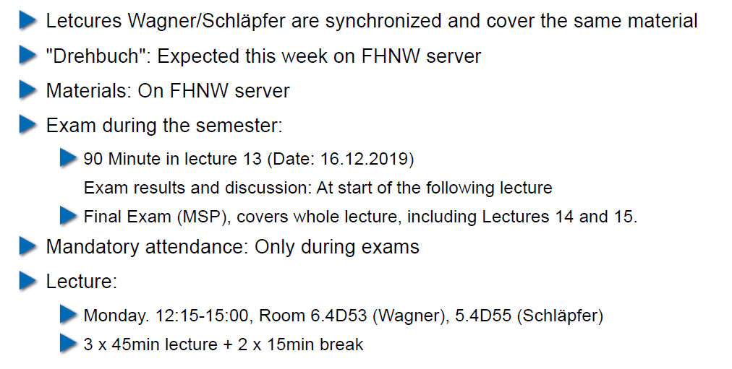

## Who is Your Lecturer (Wagner)

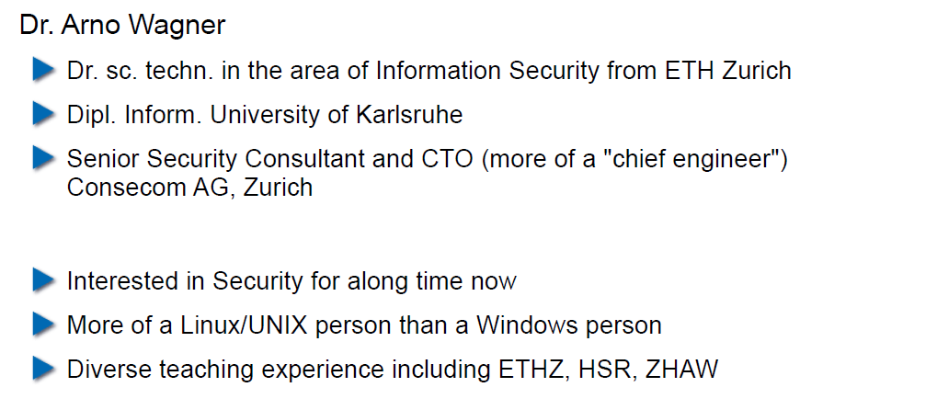

## whoami (Schläpfer)

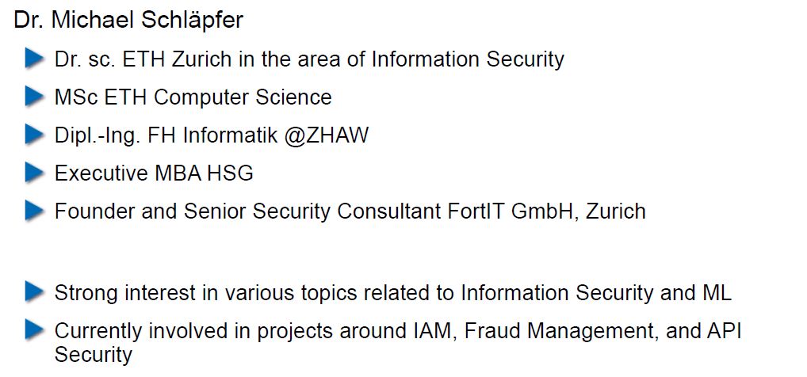

## Why is Application Security Important?

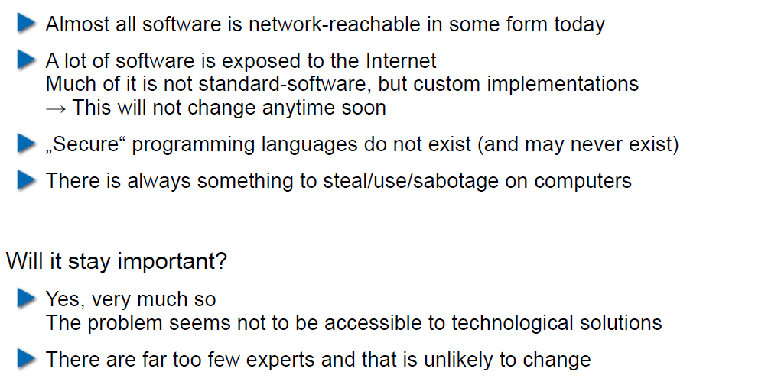

## Lecture Overview (1)

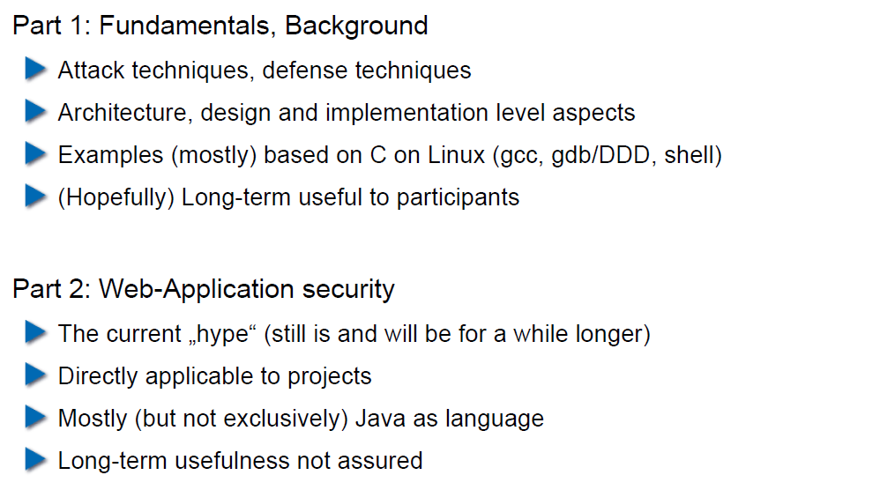

## Lecture Overview (2)

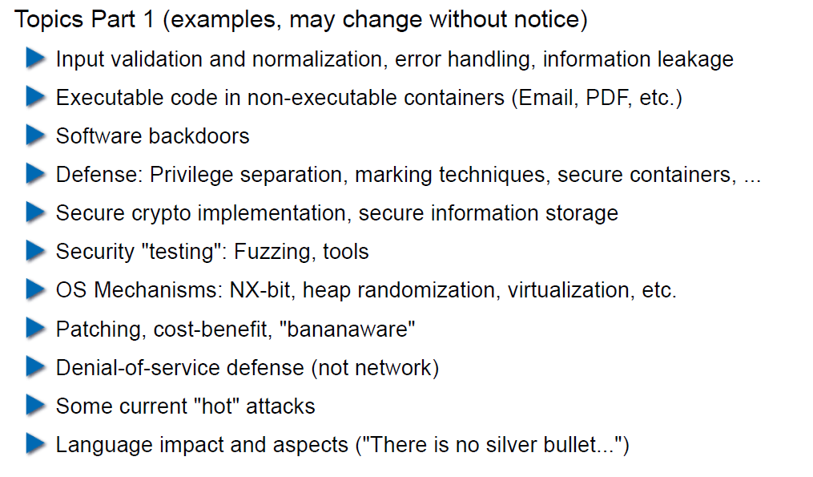

## Lecture Overview (3)

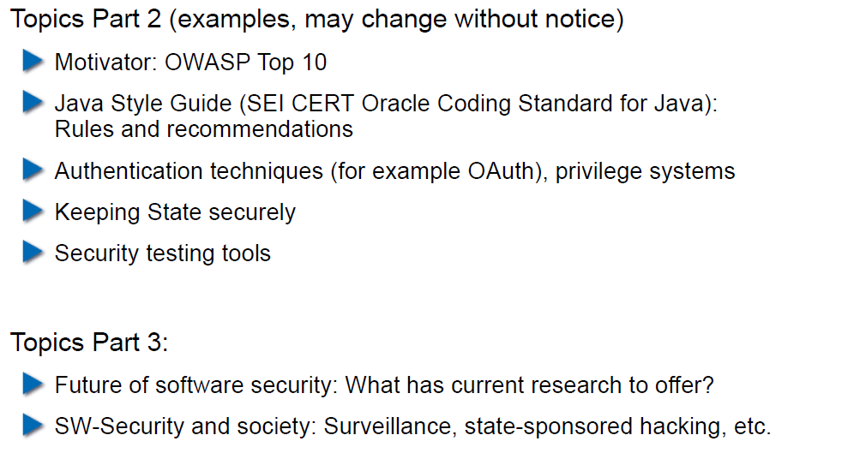

## Example: Buffer Overflow

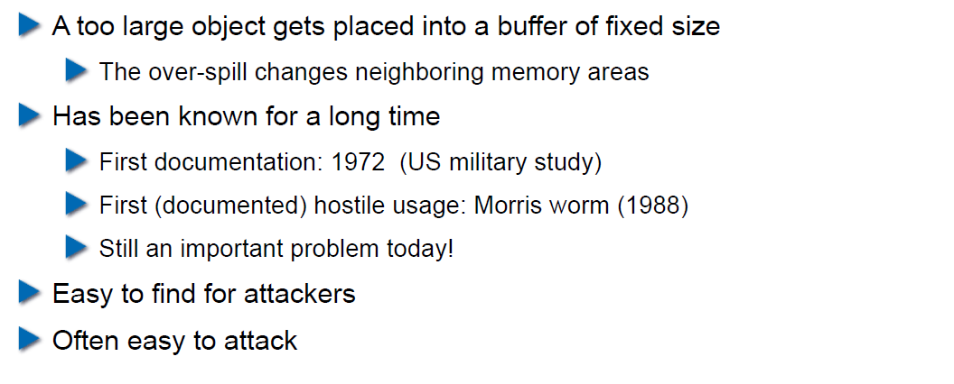

## How does a Buffer Overflow Work?

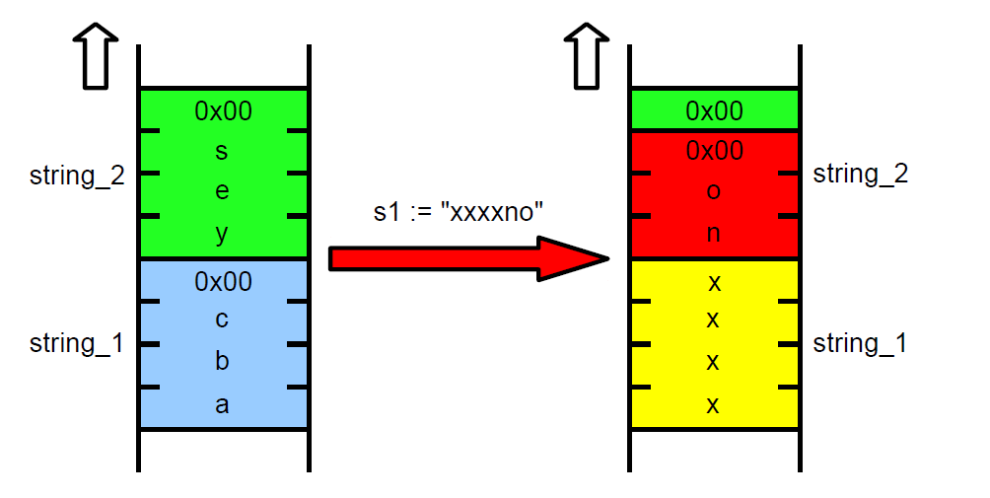

## Buffer Overflow Demo

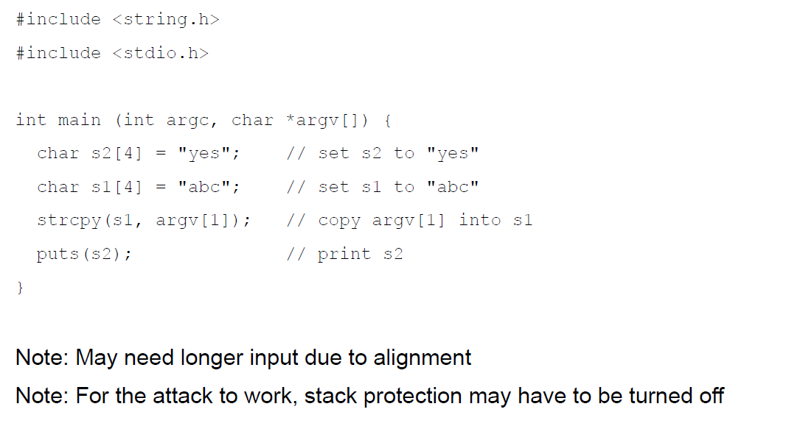

## Not Really a Fix for Buffer Overflow: Stack Protection

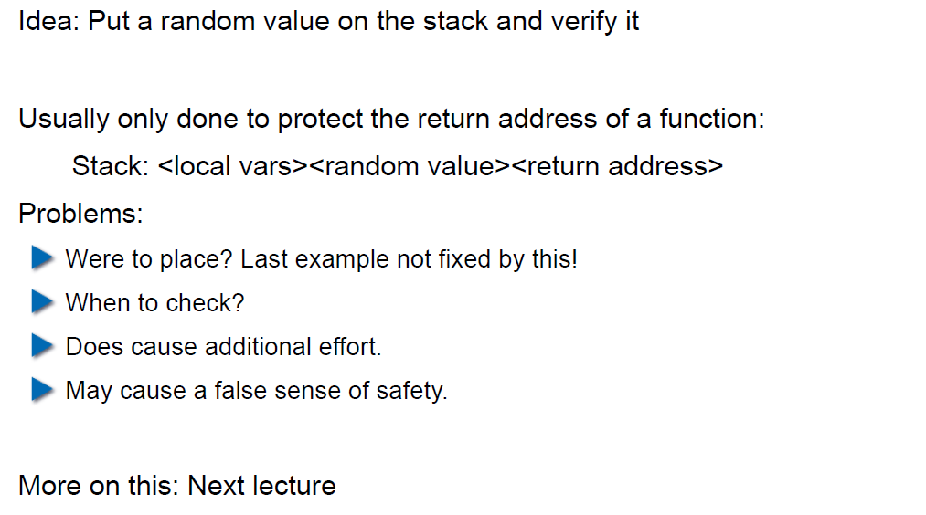

## Fix for Buffer Overflow: Checked Buffers

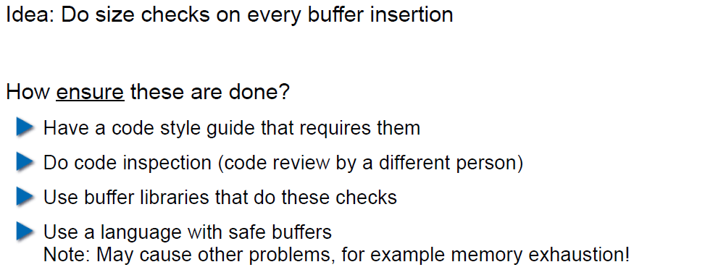

## Example: Taint Checking in Perl (1)

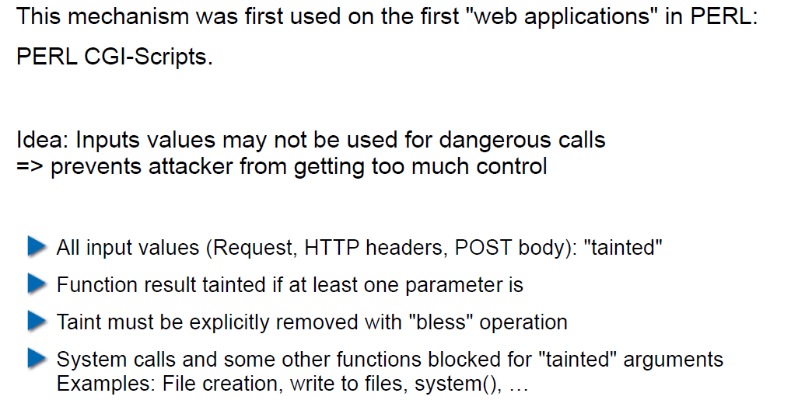

## Example: Taint Checking (2)

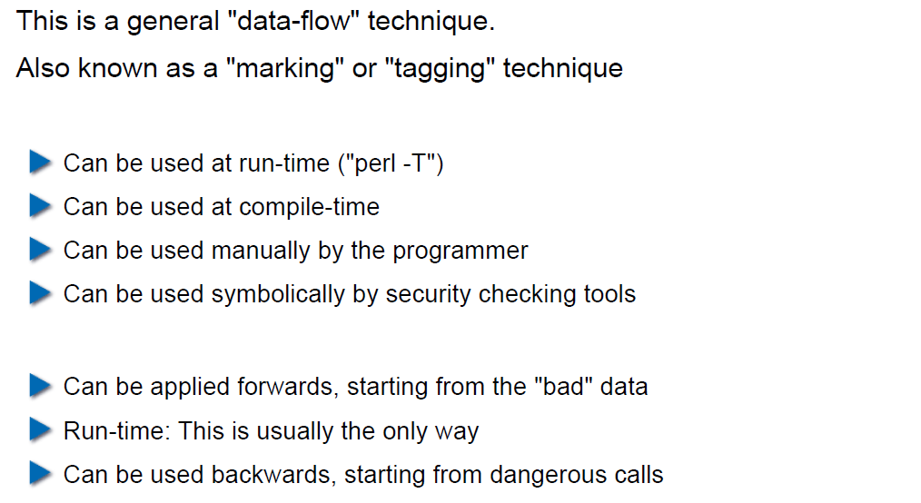

## Example: Taint Checking (3)

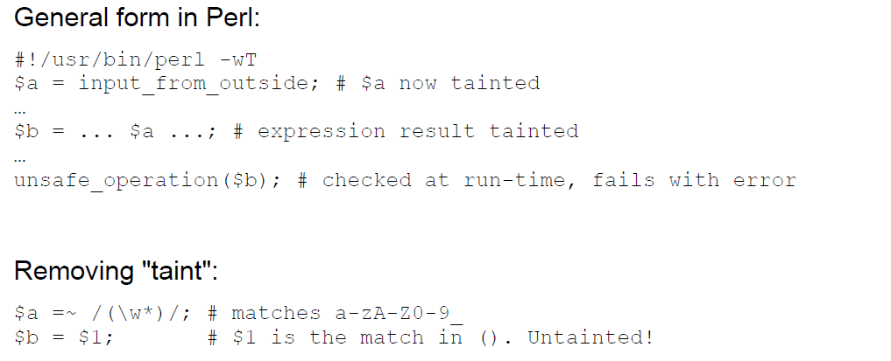

## Example: Taint Checking (4)

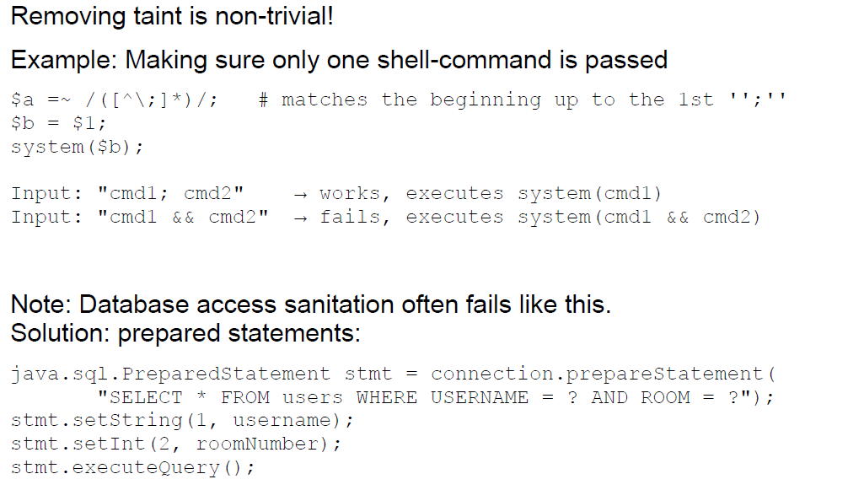

## Example: Data Leakage by Behavior (1)

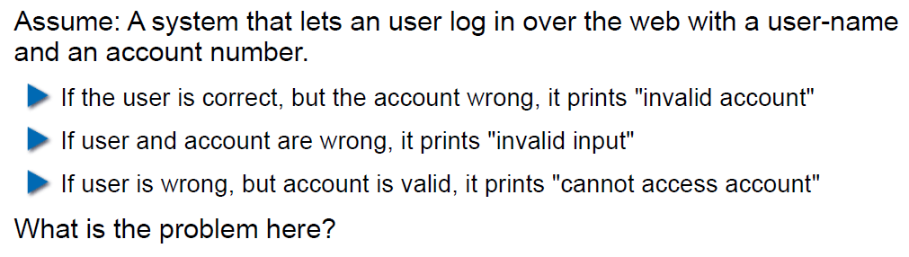

## Example: Data Leakage by Behavior (2)

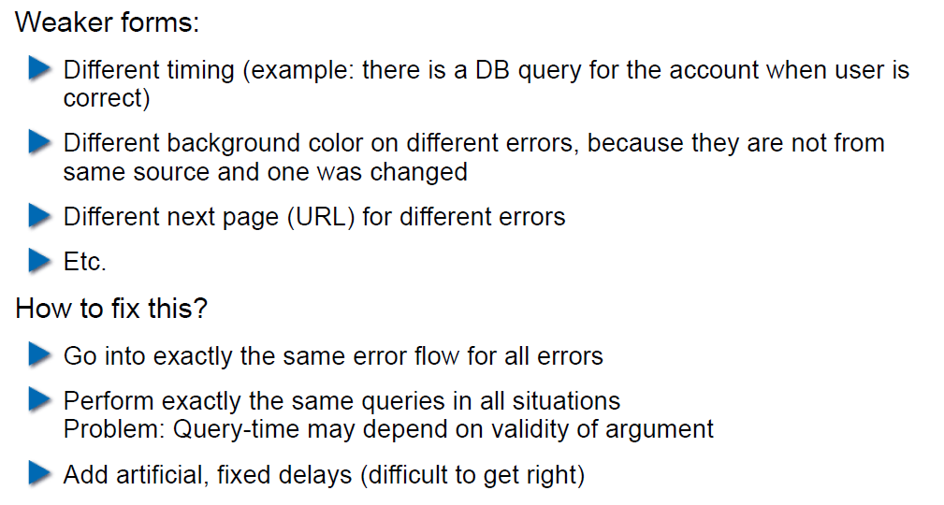

## Example: Data Leakage by Error Output

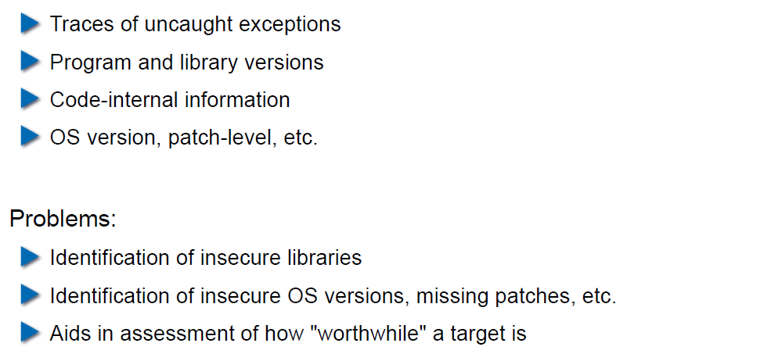

## Human Factors

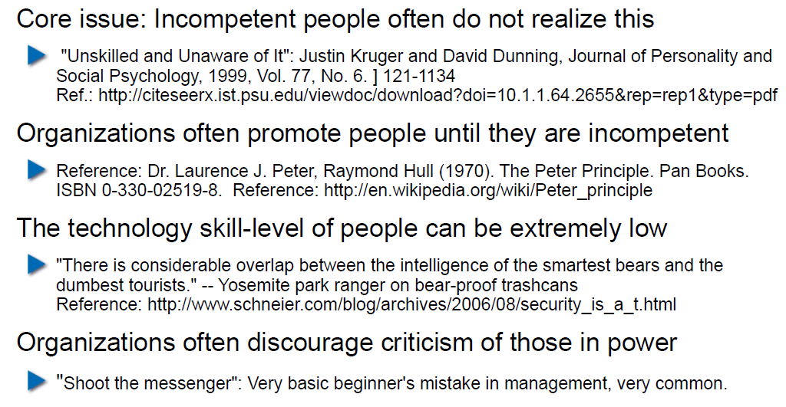

## Exercises and Preparation for Next Week

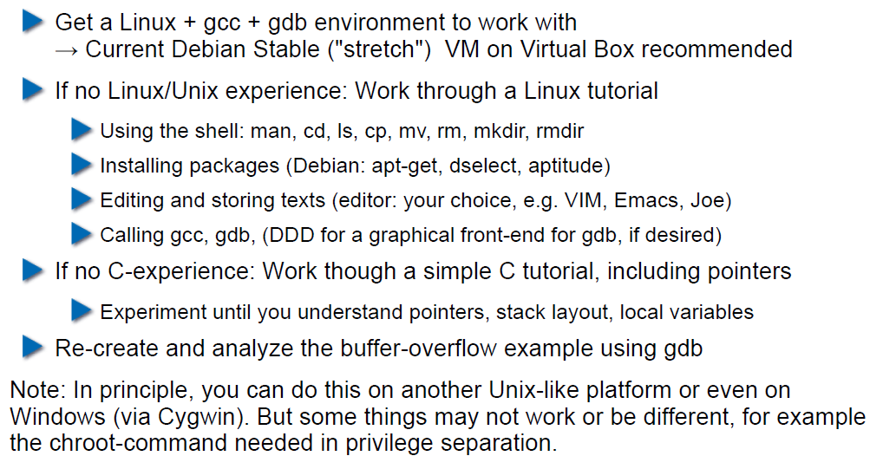

## Reserve

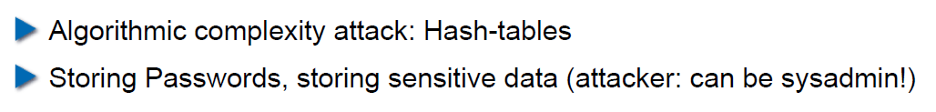

# Woche 2

## Agenda

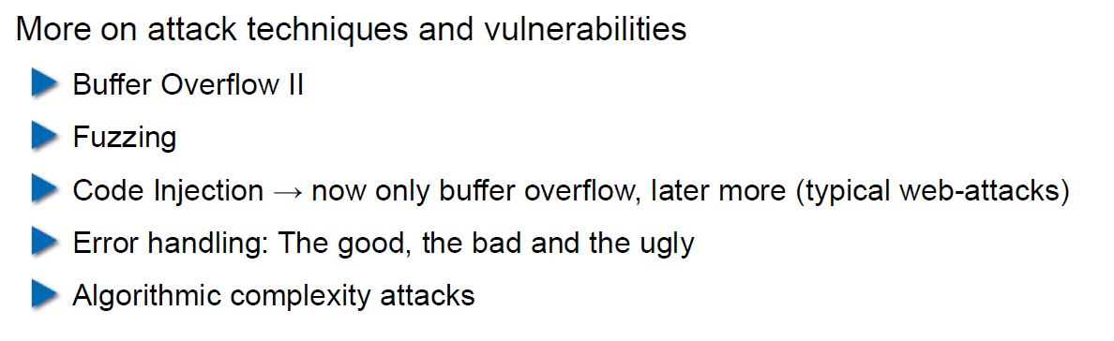

## Recap: What do Attackers Want?

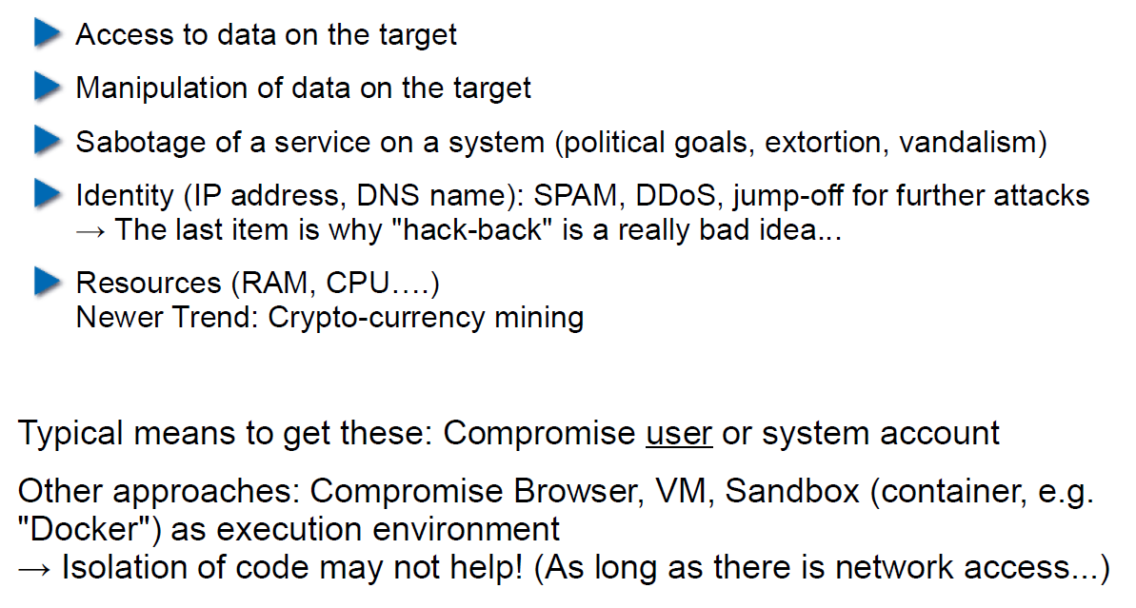

## Buffer Overflow II

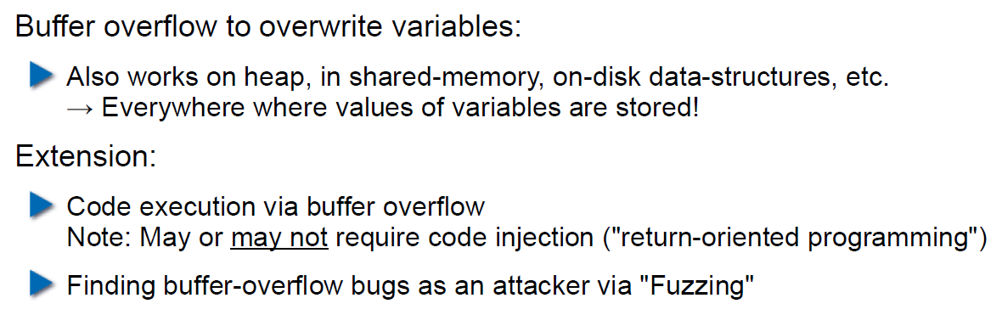

## Buffer Overflow II

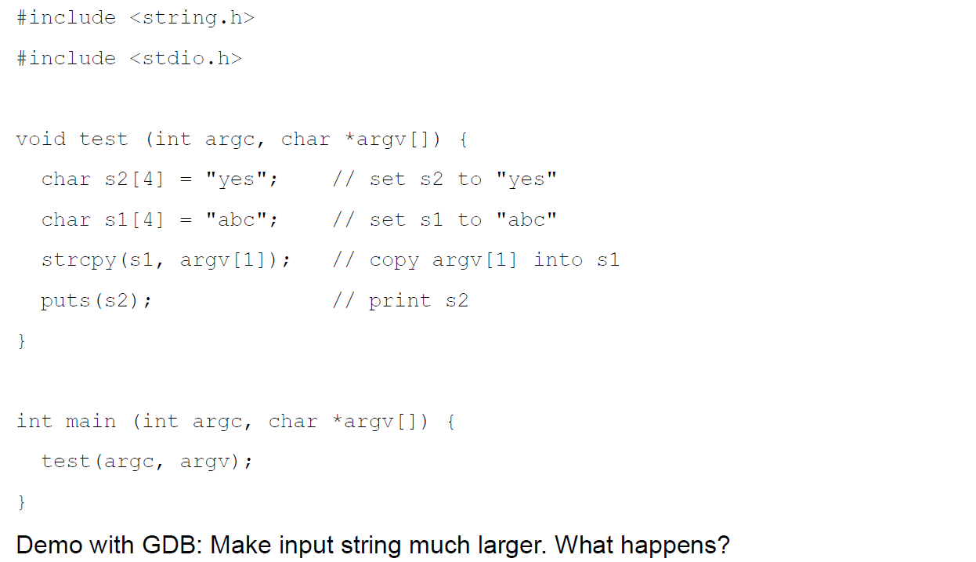

## Buffer Overflow II

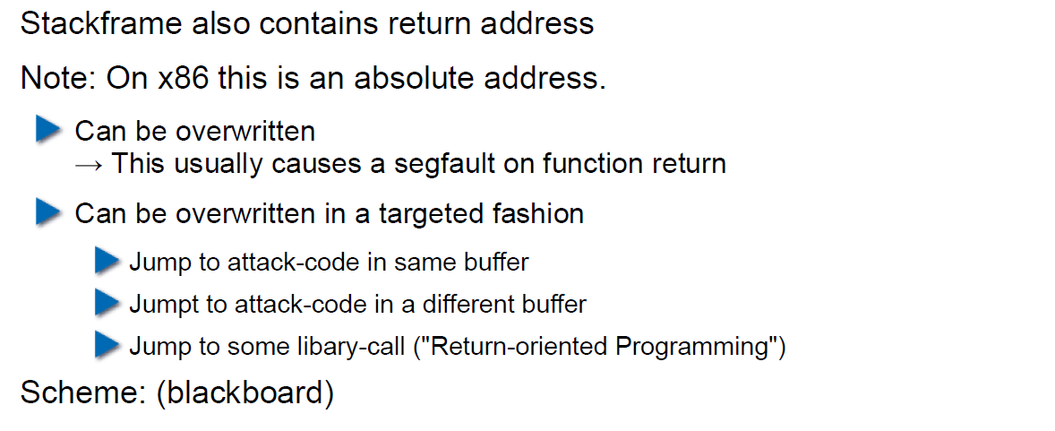

## Buffer Overflow II

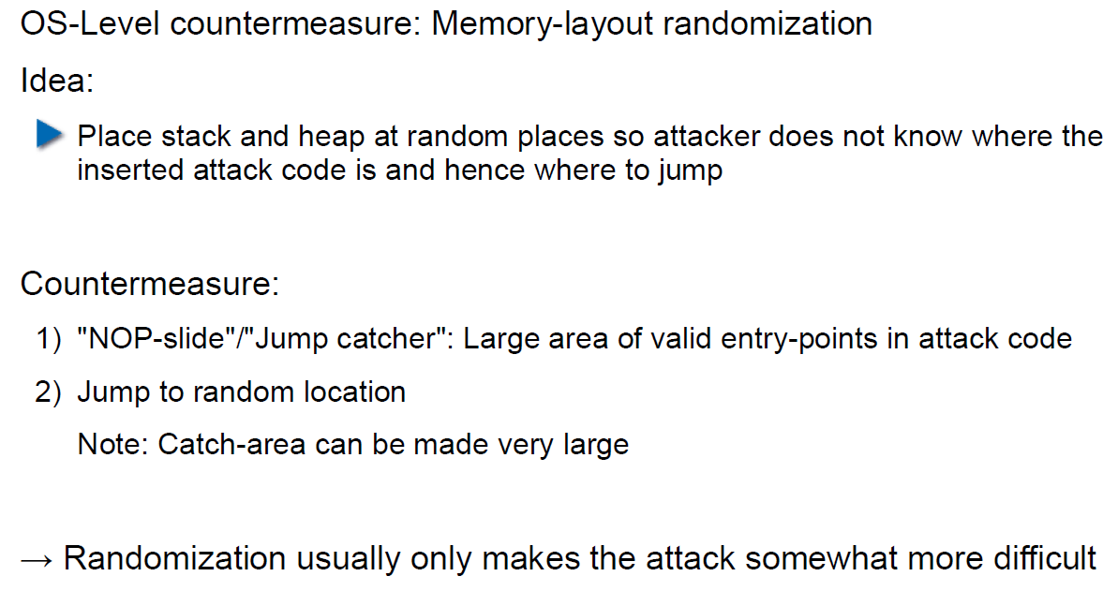

## Buffer Overflow II

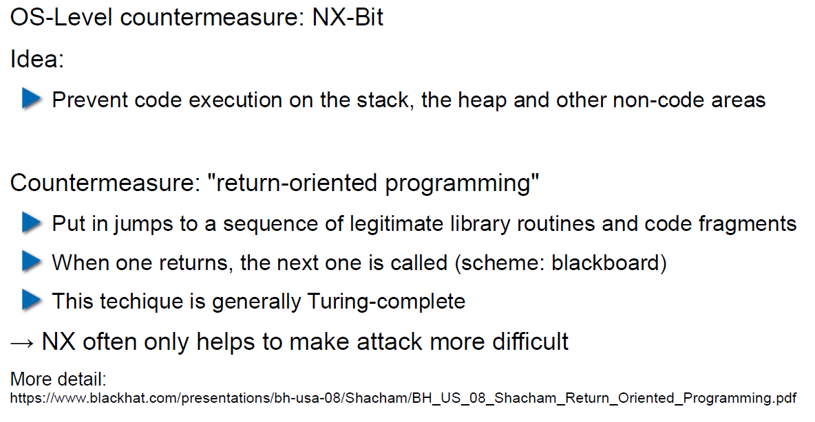

## Attack Technique: Fuzzing

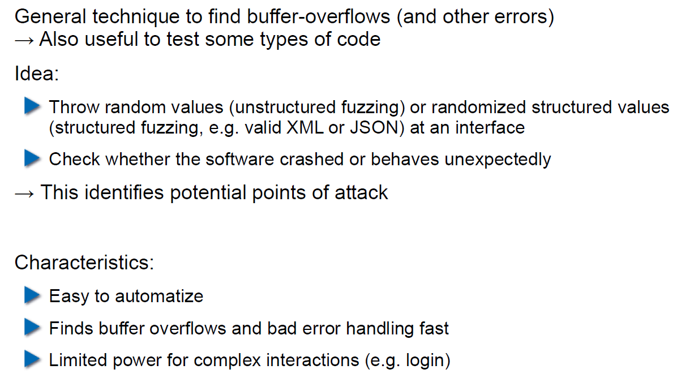

## Error Handling

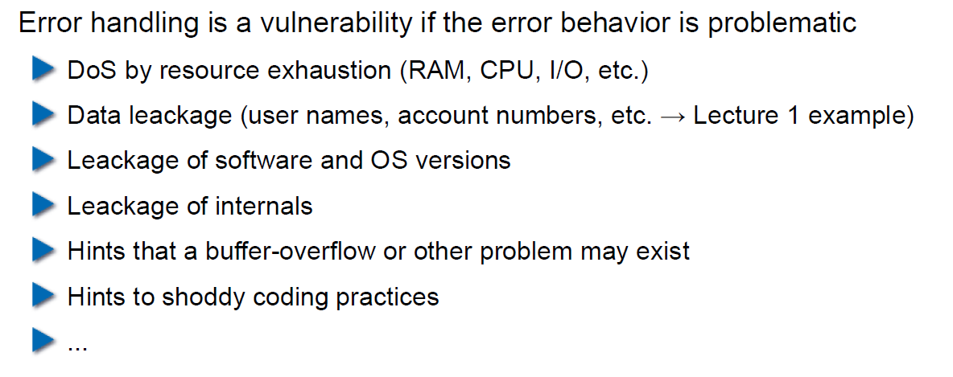

## Case study – Handling too long input

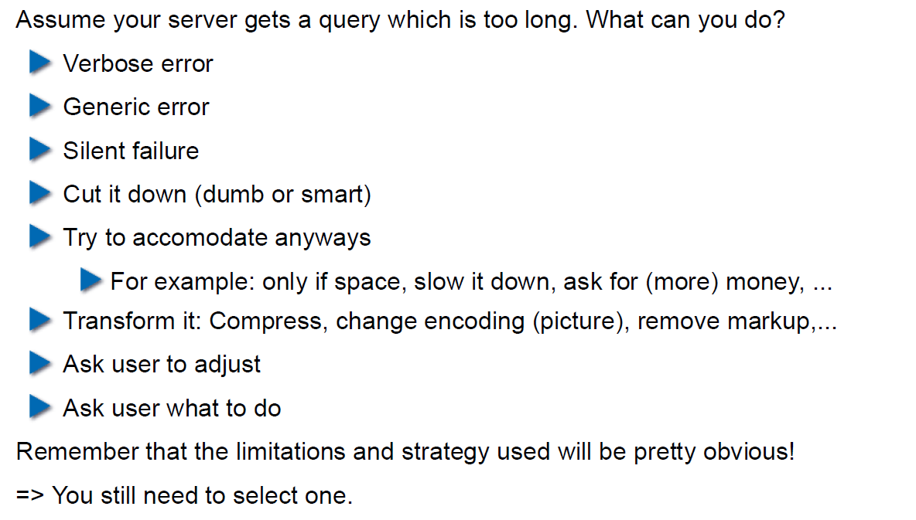

## Case-study: Compression Bomb

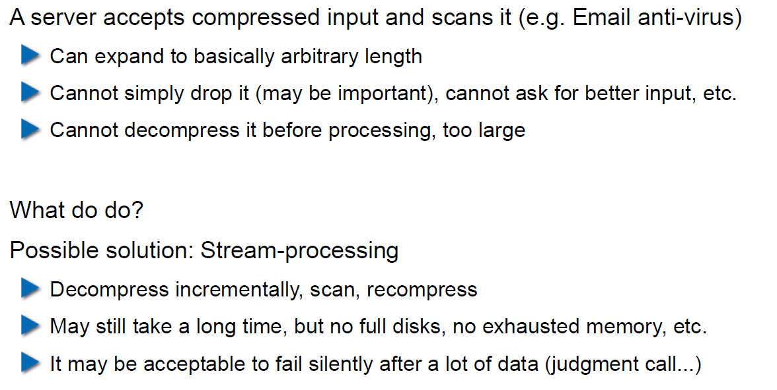

## Error Handling

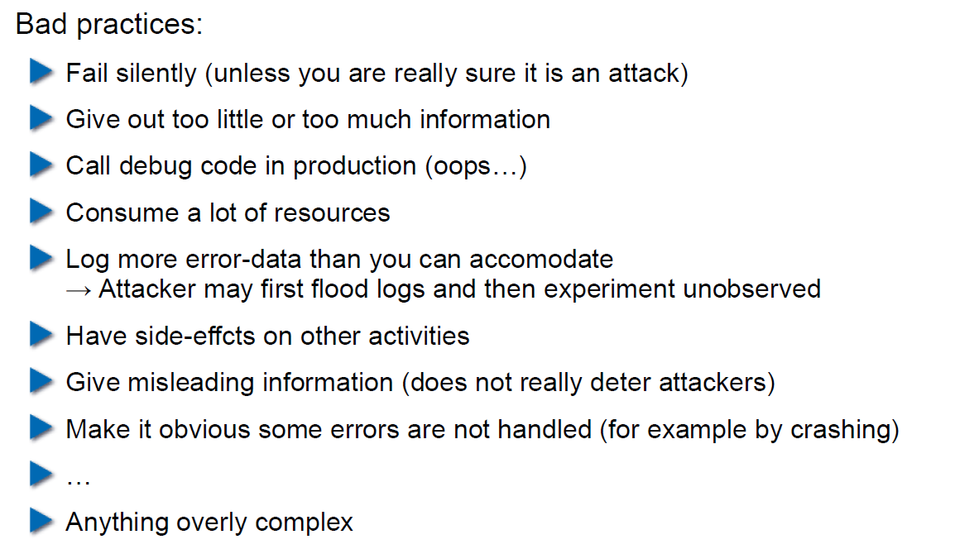

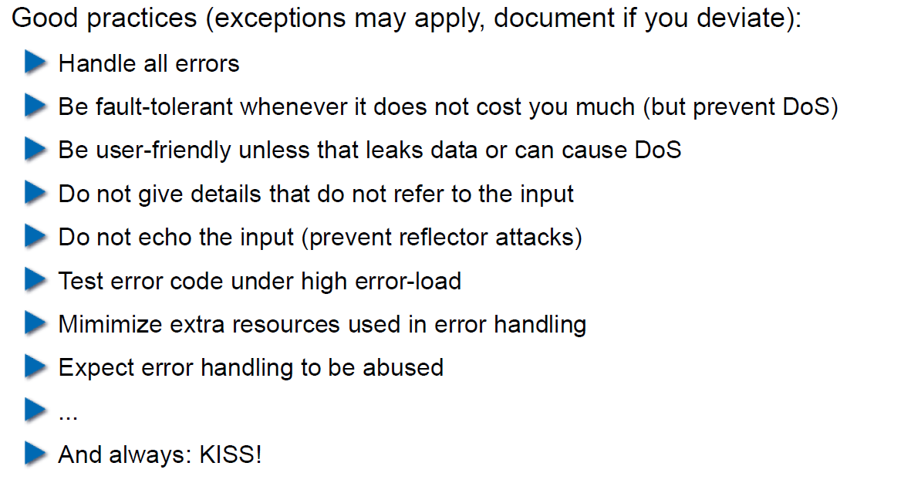

## Algorithmic Complexity Attacks

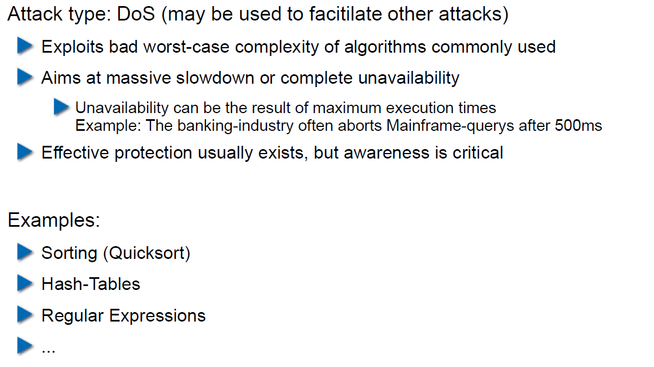

## Algorithmic Complexity: Sorting

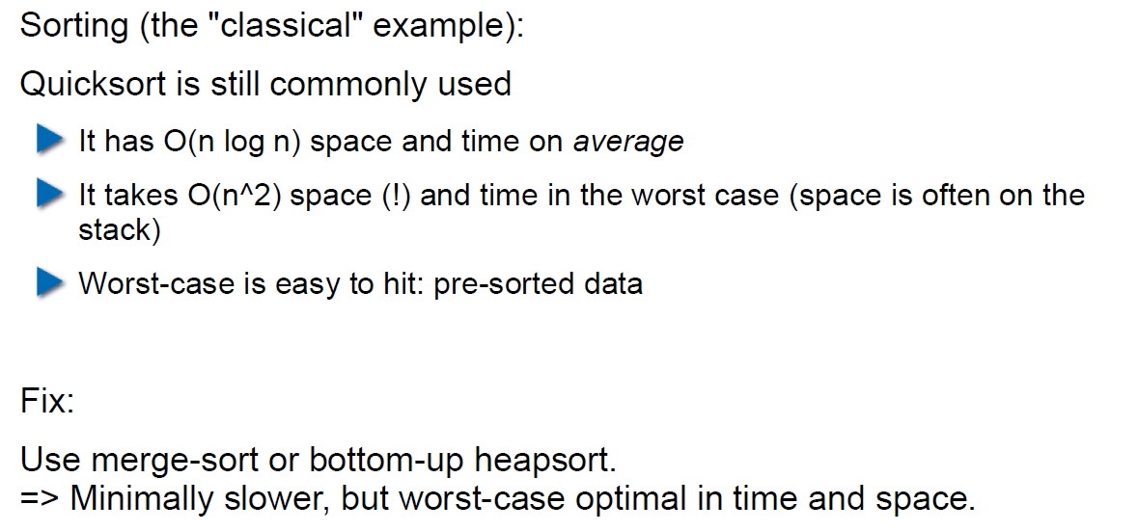

## Algorithmic Complexity: Hashing

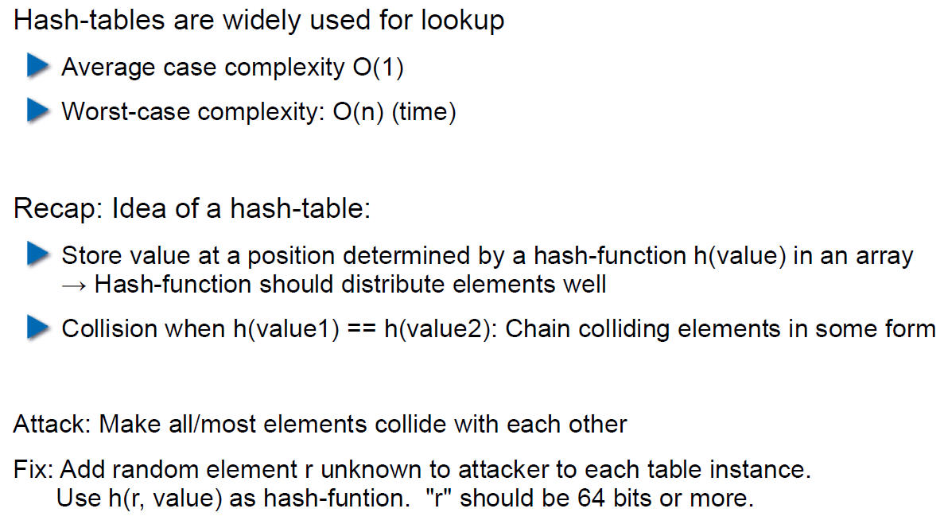

## Algorithmic Complexity: Regular Expressions

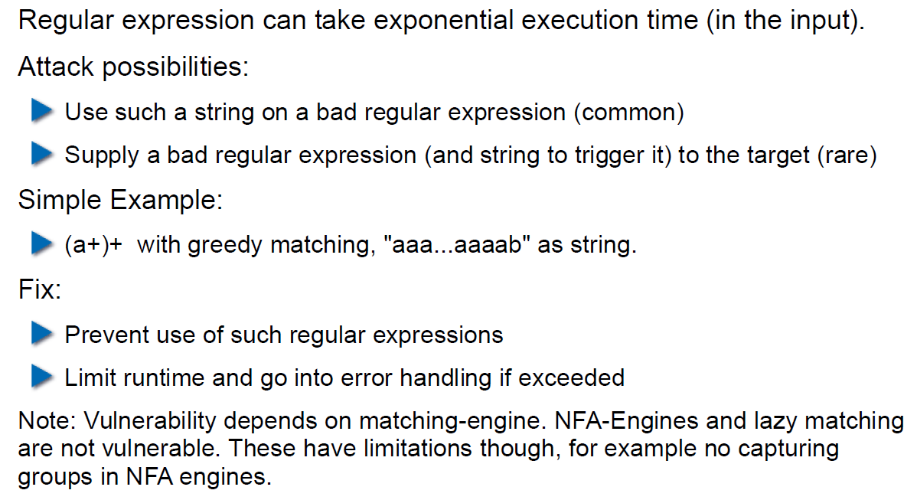

# Woche 3

## Agenda

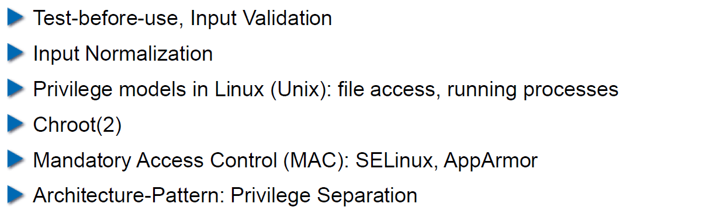

## Secure Coding Principle: Test-before-use

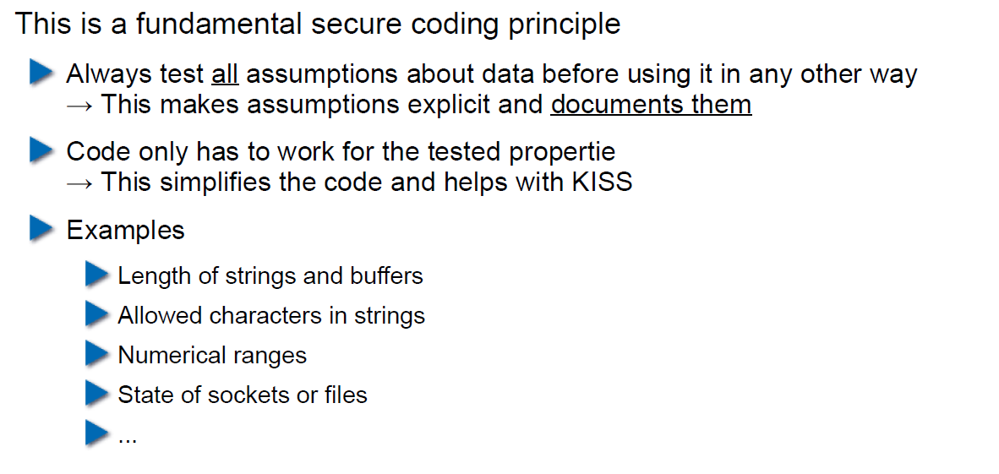

## Input Validation

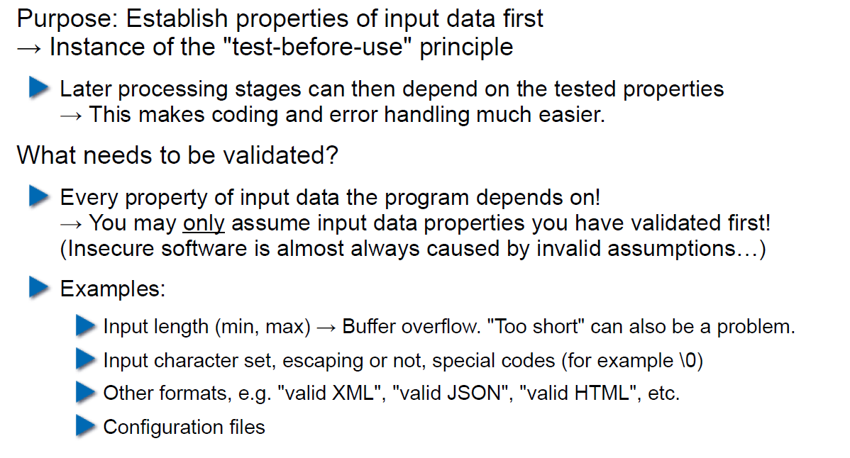

## Input Normalization

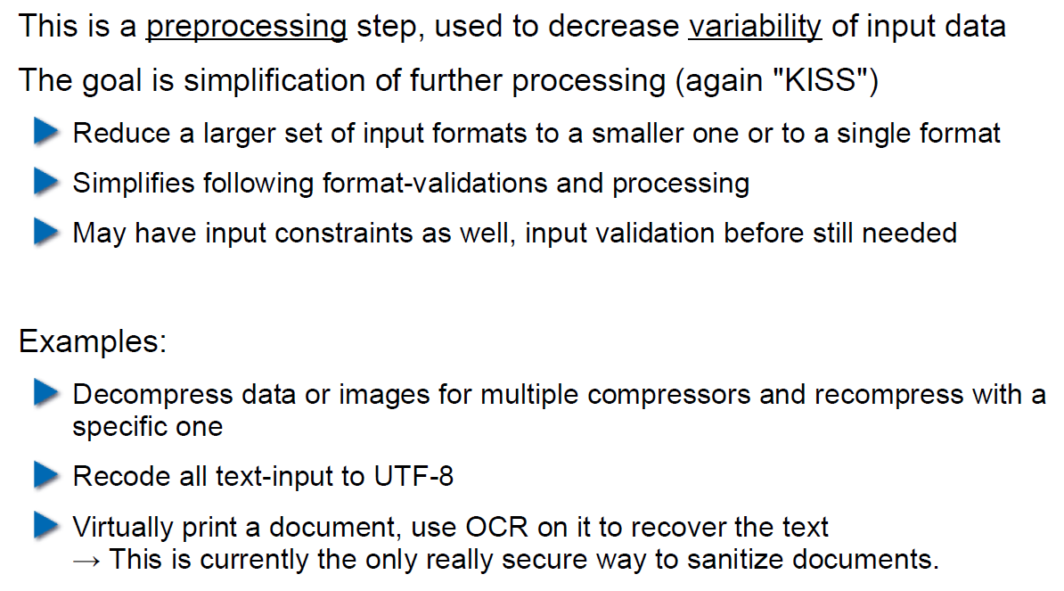

## Unix Permission Model (simplified)

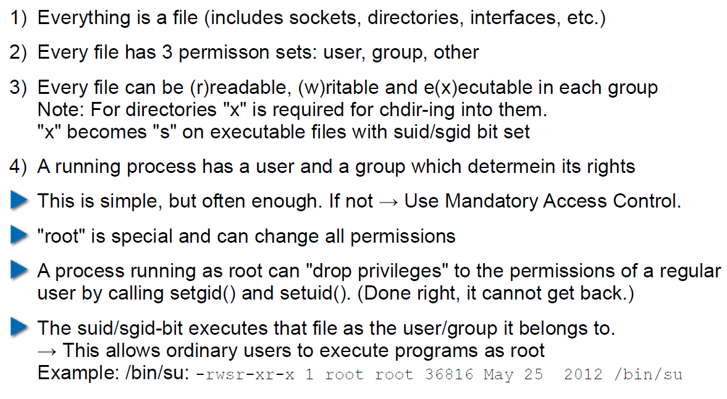

## Chroot

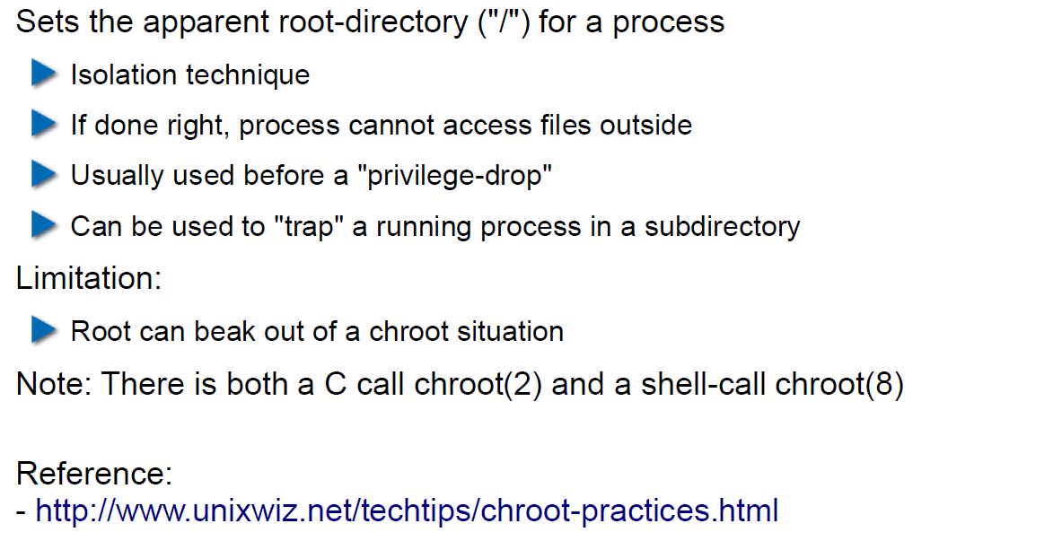

## Mandatory Access Control (MAC)

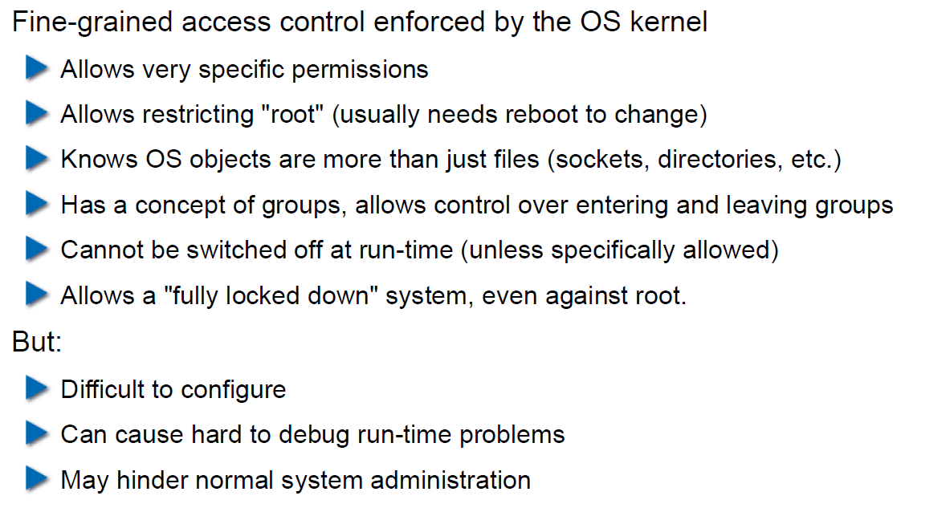

## MAC Example: SELinux

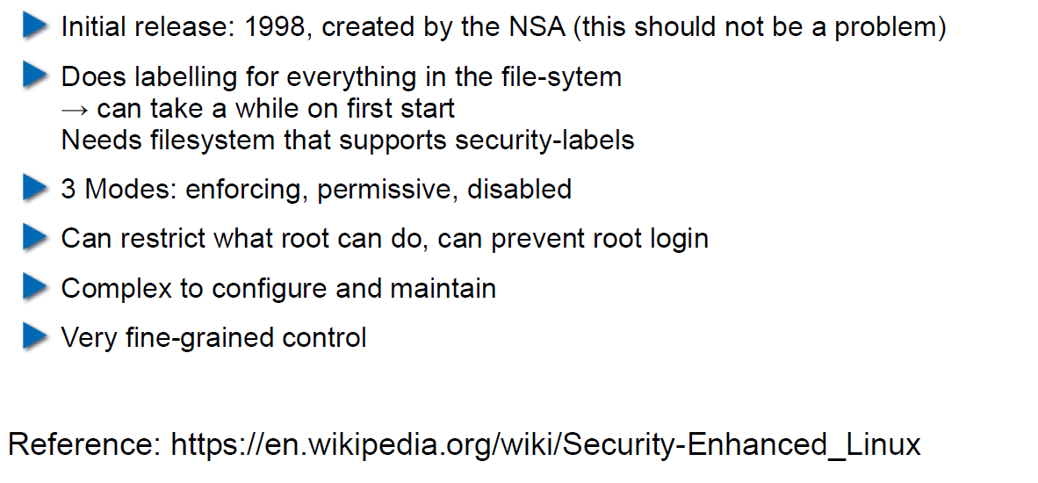

## MAC Example: AppArmor

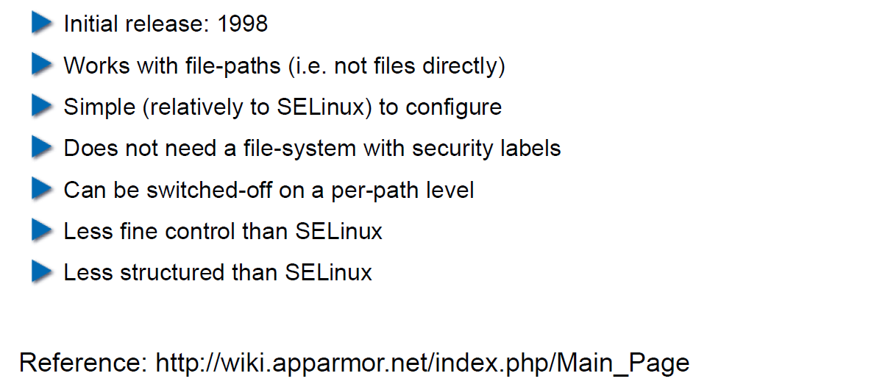

## Secure Coding Principle: Defense in Depth

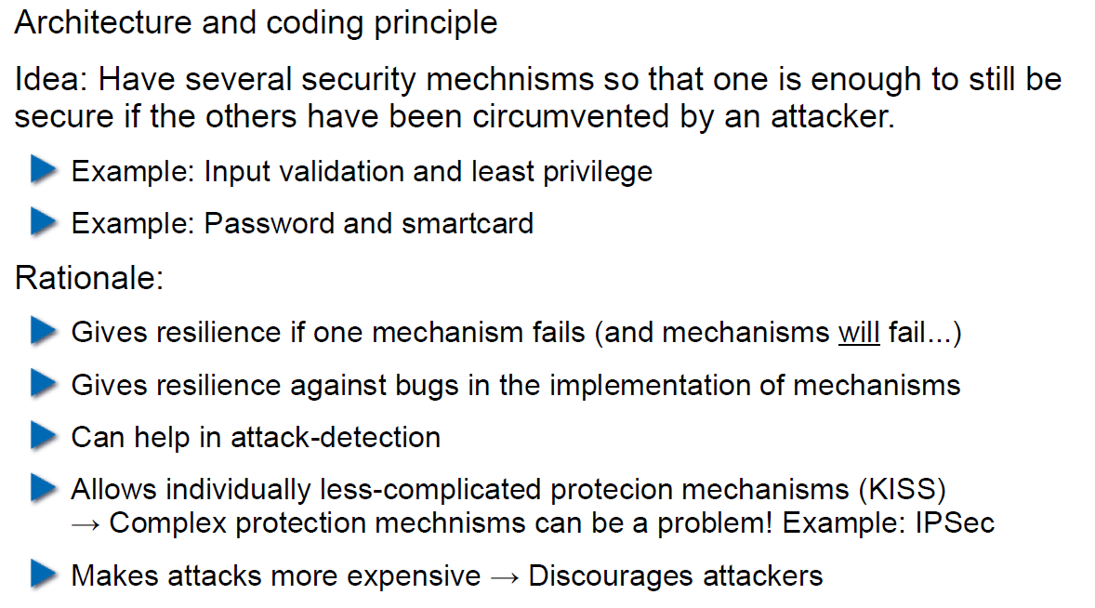

## Privilege Separation

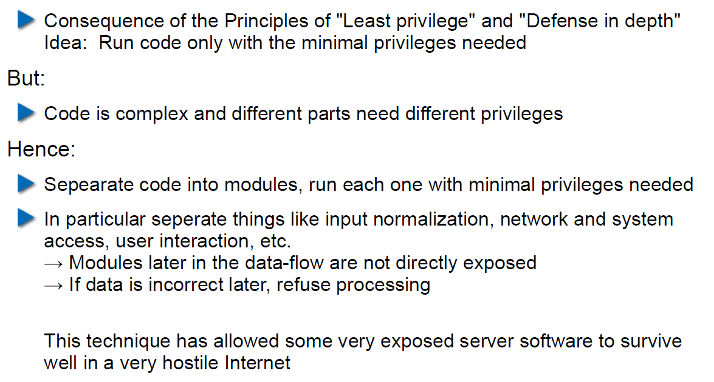

## Overall Idea

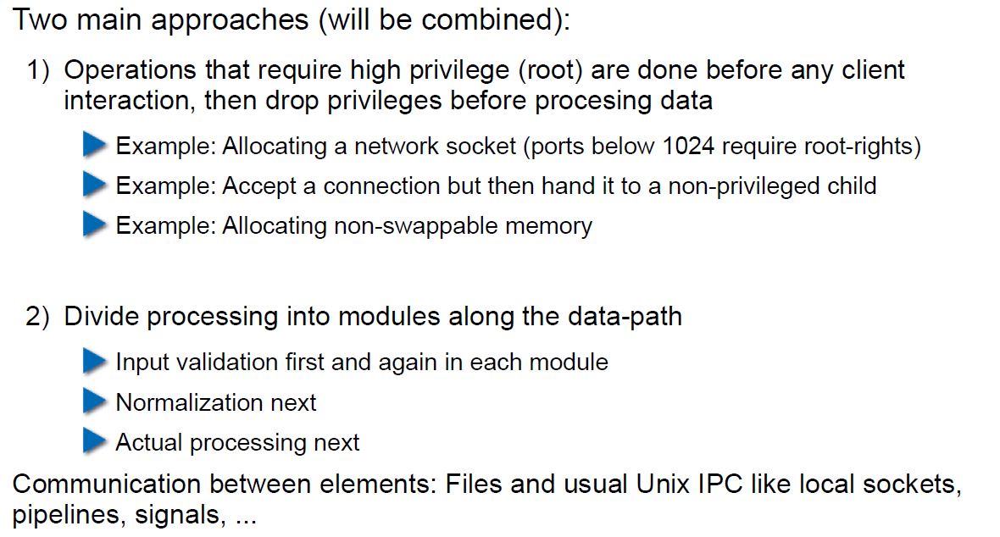

## Form of the Modules

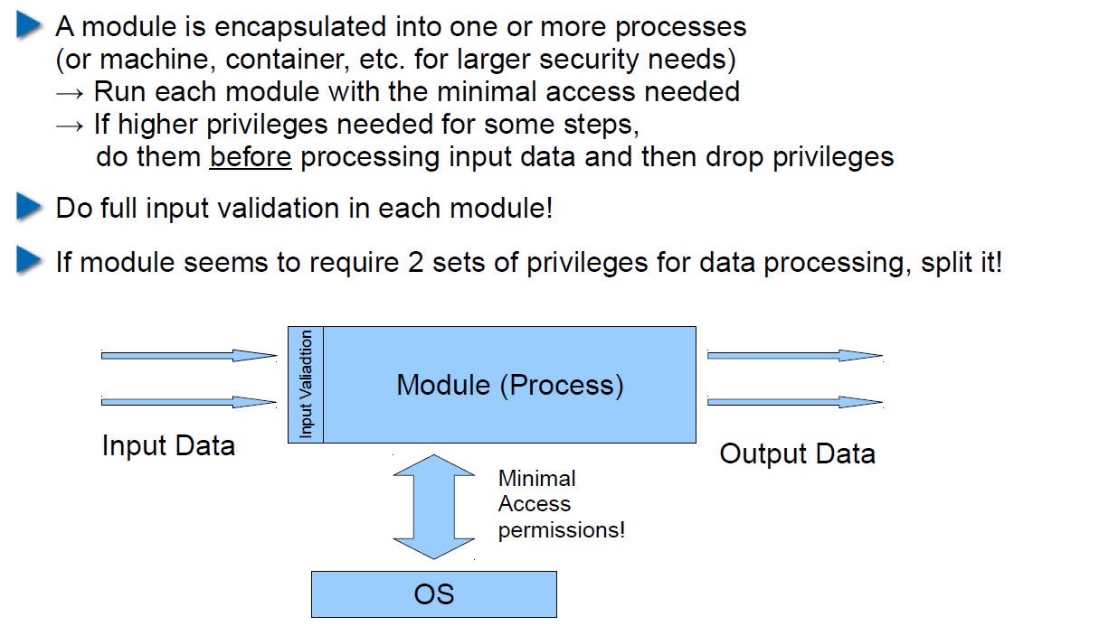

## Example: OpenSSH

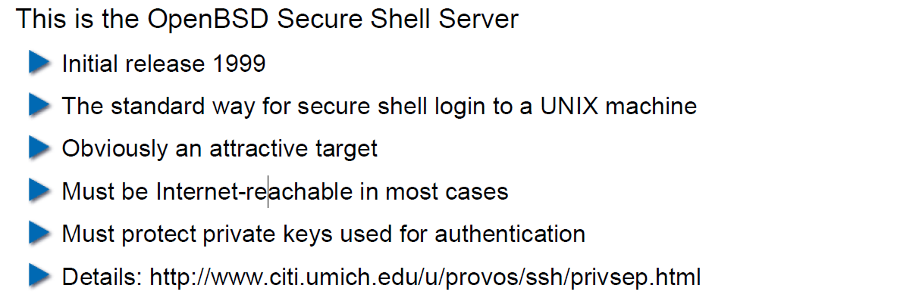

## OpenSSH: Privilege Separation Approach

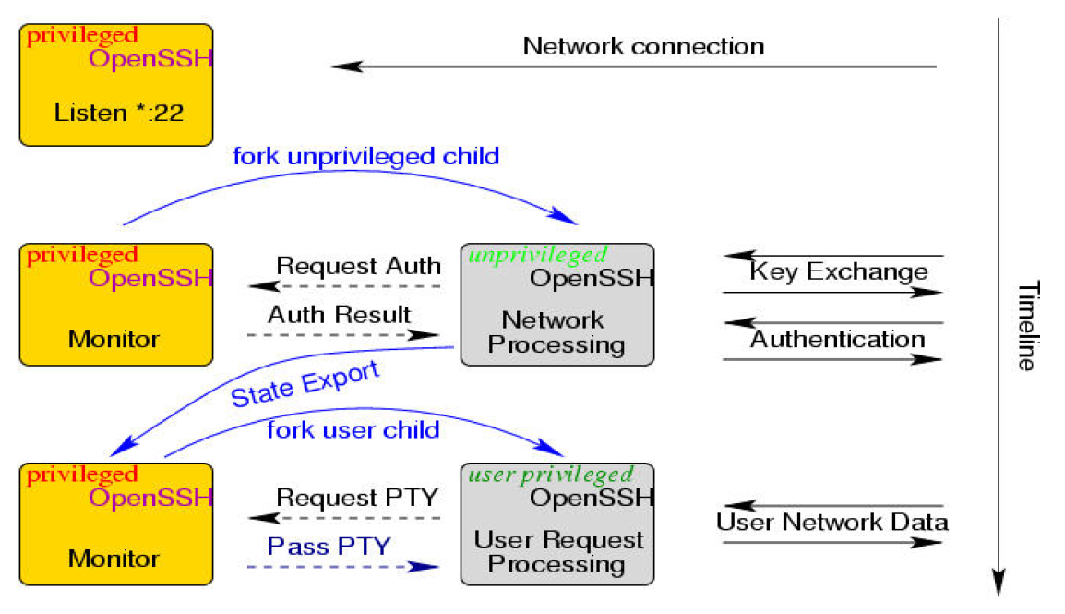

## Example: Postfix MTA (Email Server)

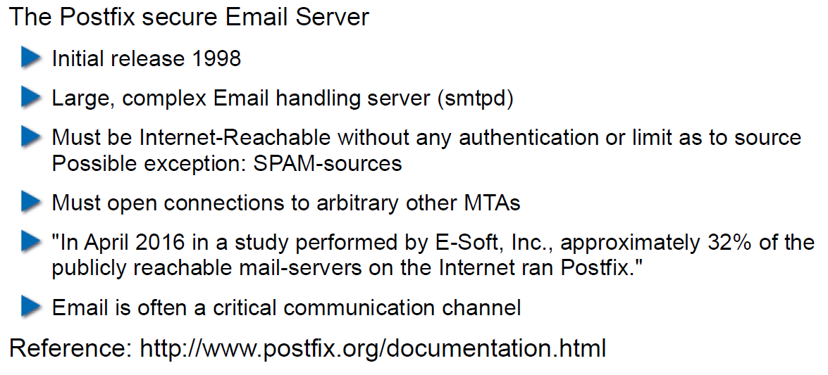

## Postfix System View

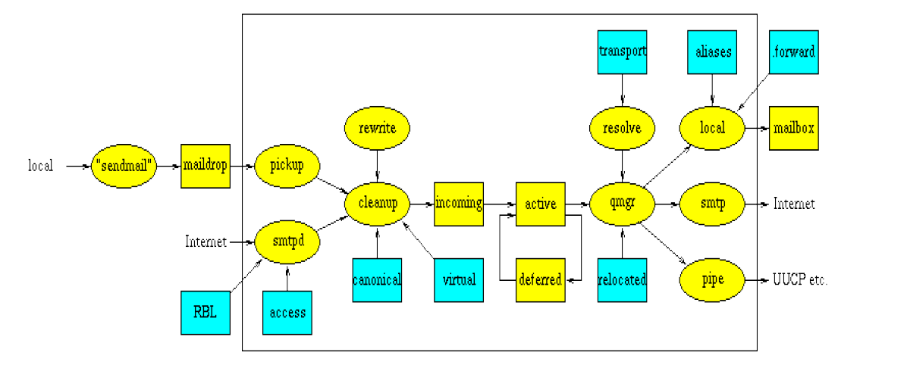

## Postfix: Example Data-Flow

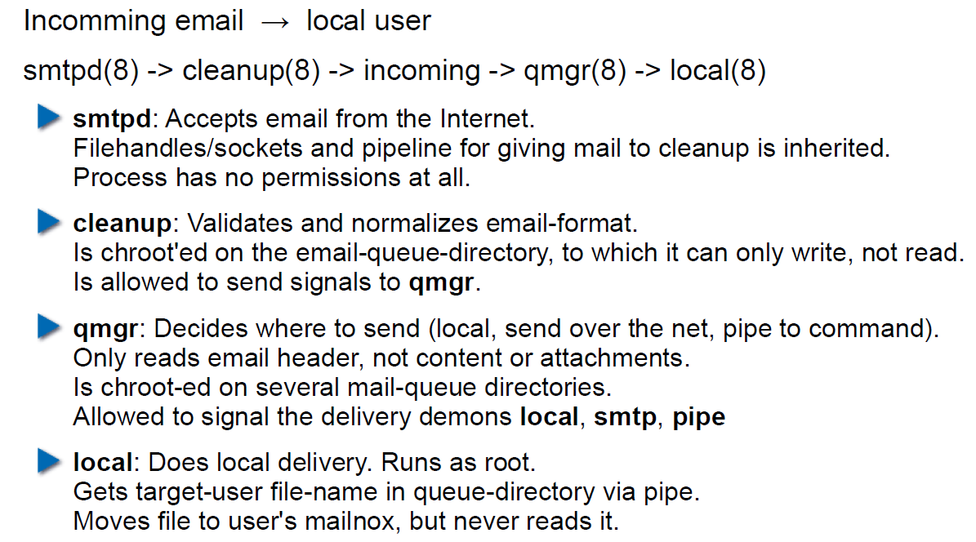

# Woche 4

## Agenda

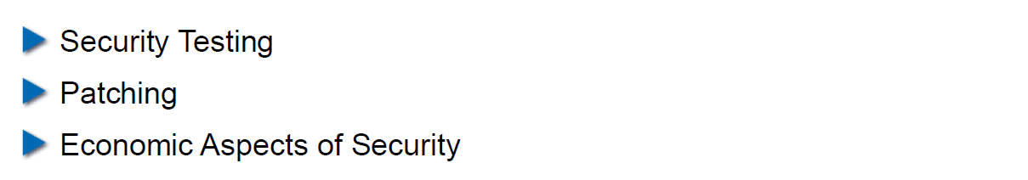

## Security Testing (for Software)

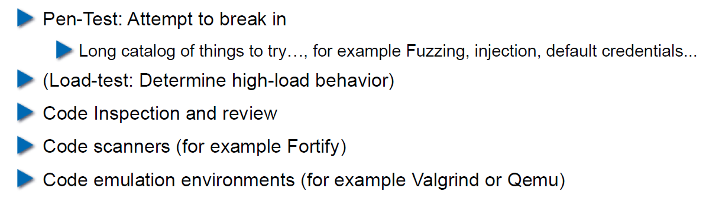

## Pen-Test

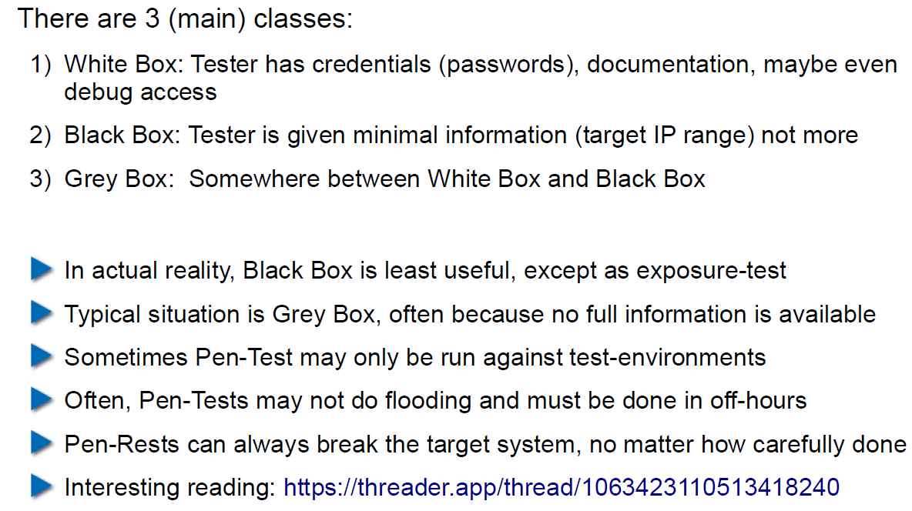

## How does a Pen-Test fail?

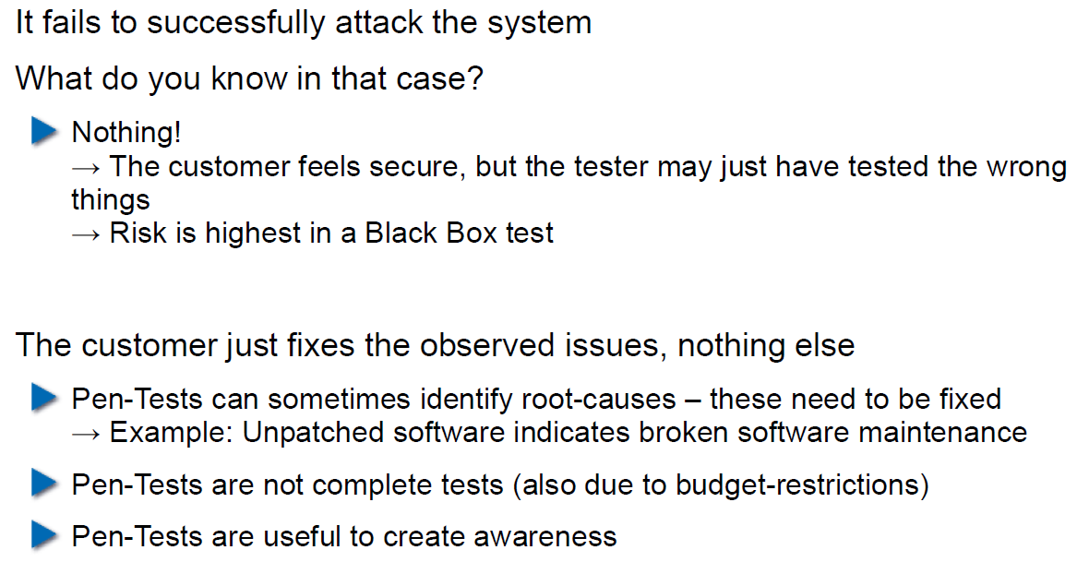

## Code Inspection and Review

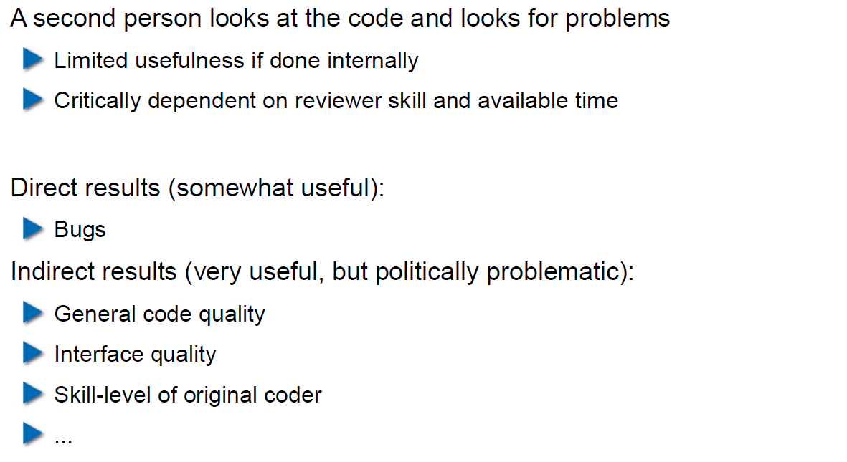

## Code Scanners

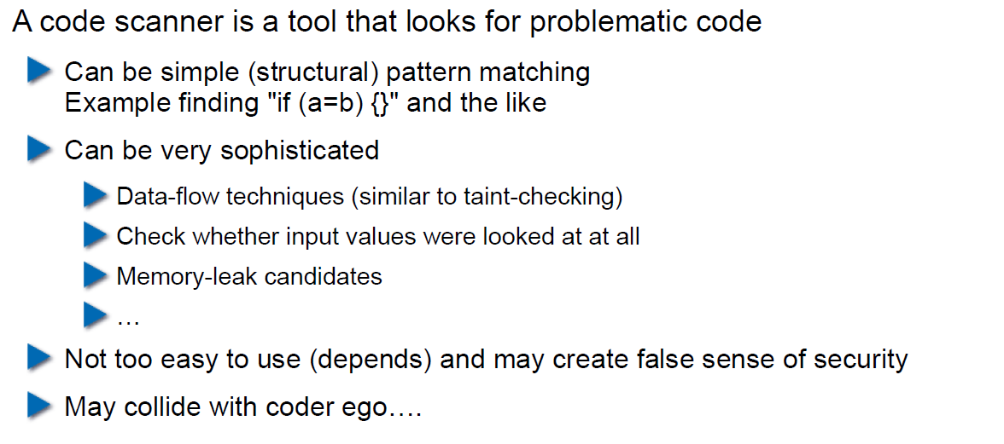

## Execution Emulators

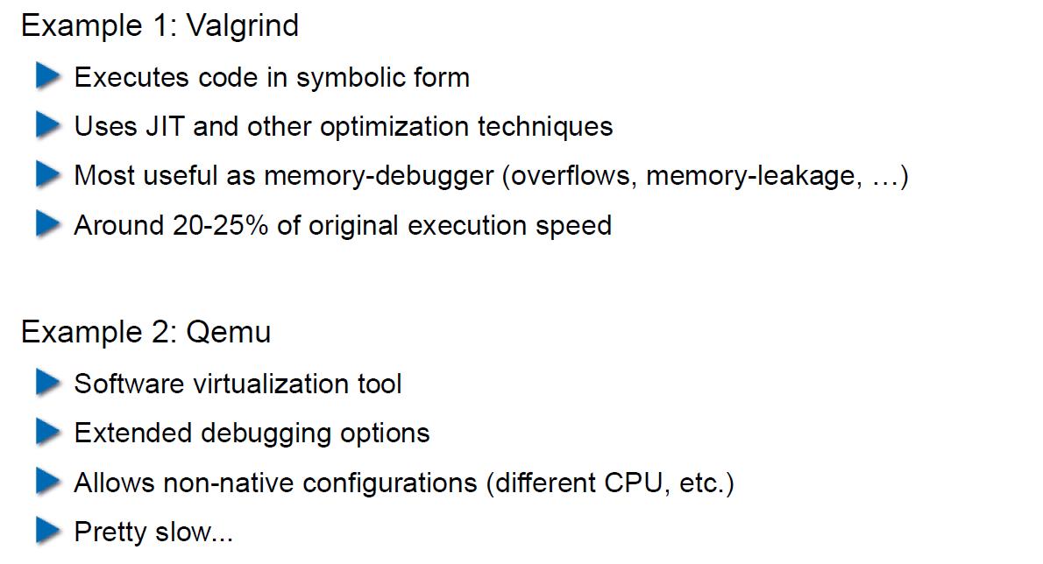

## Patching

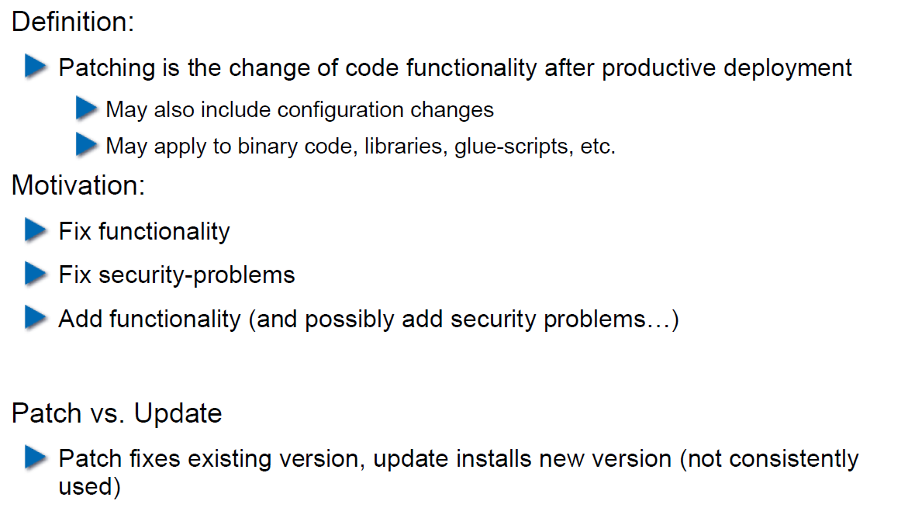

## How to Patch

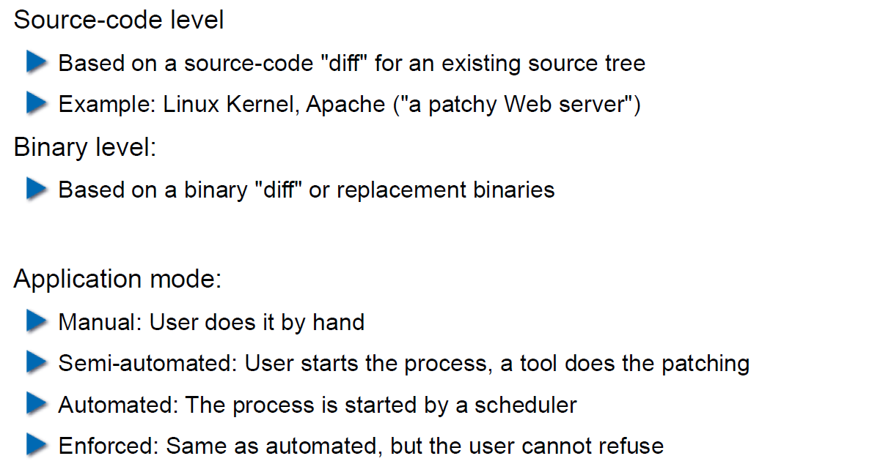

## Problems with Patching

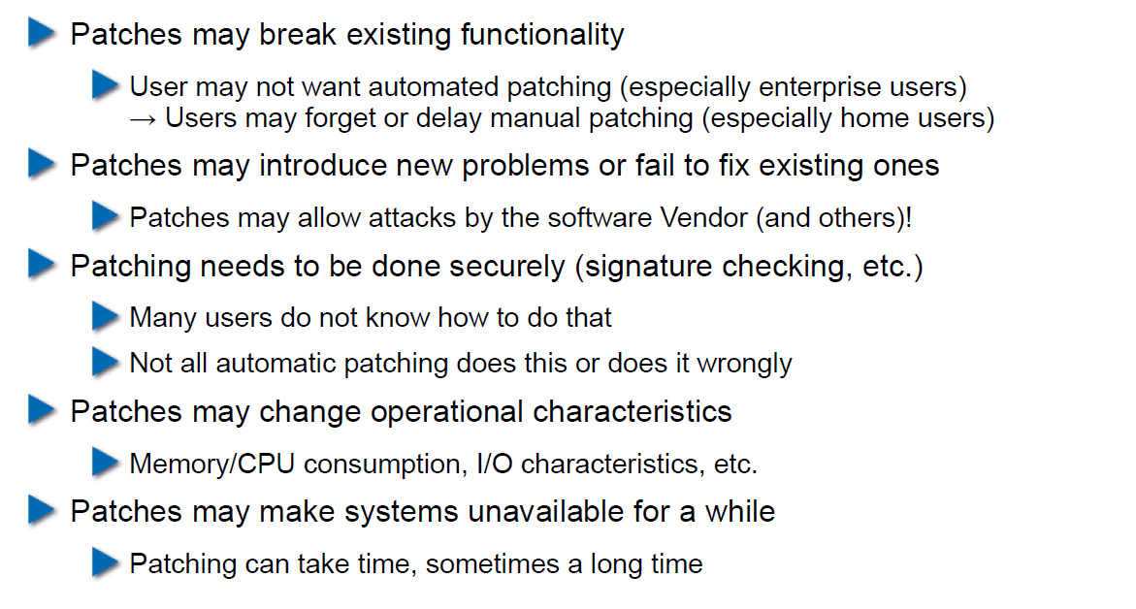

## Problems with not Patching

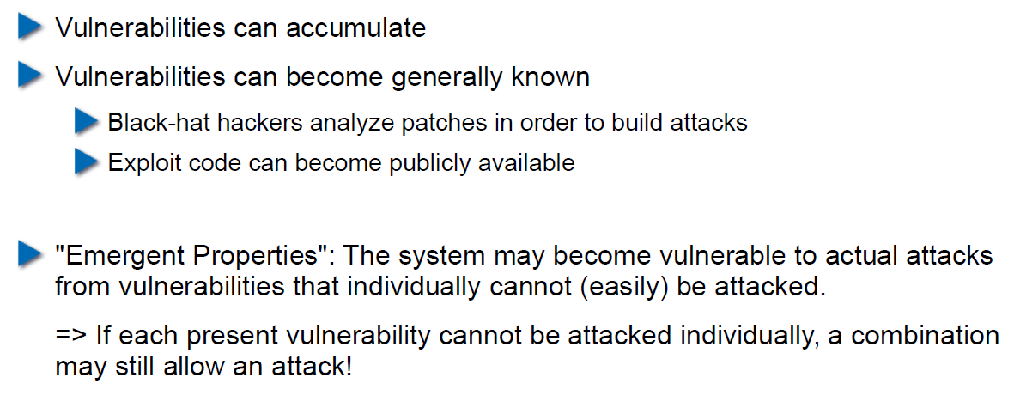

## Problems with Unavailability of Patches

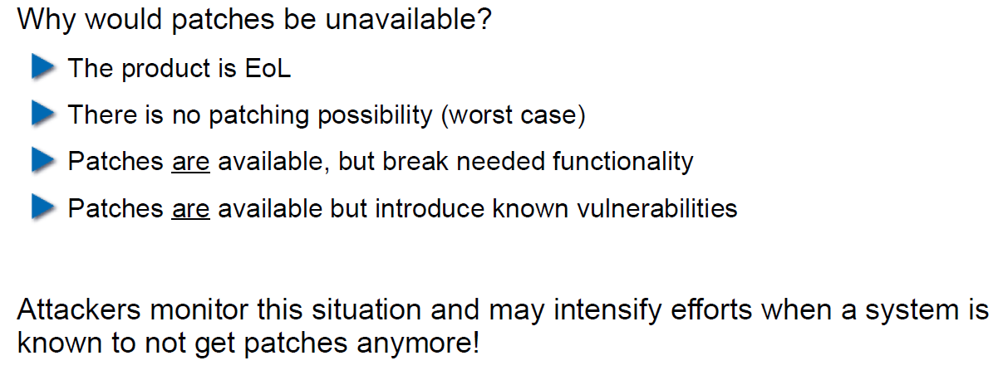

## Economic Aspects of Security

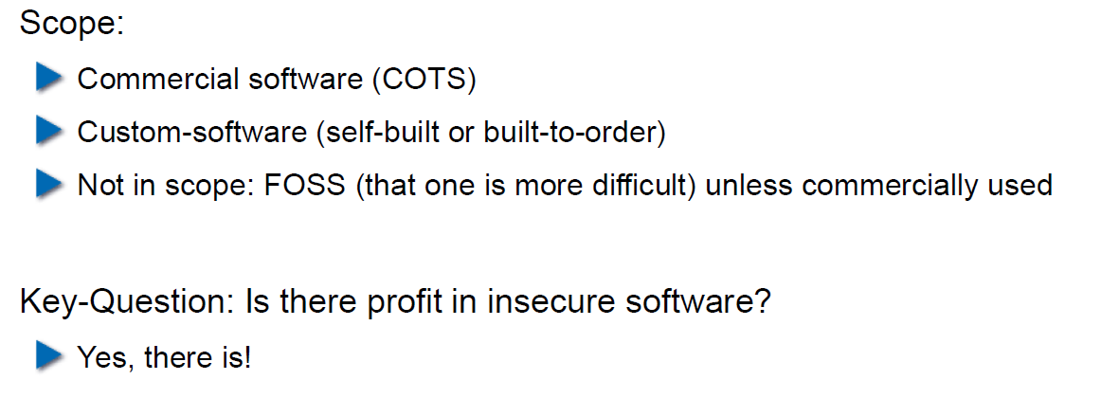

## Case Study: DDoS on Brian Krebs (20.9.2016)

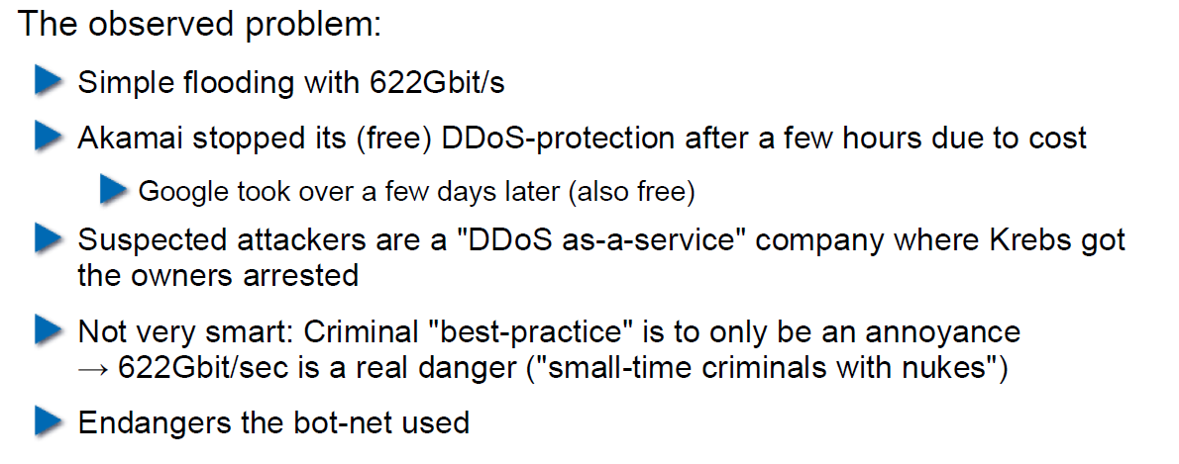

## What can Perform Such an Attack?

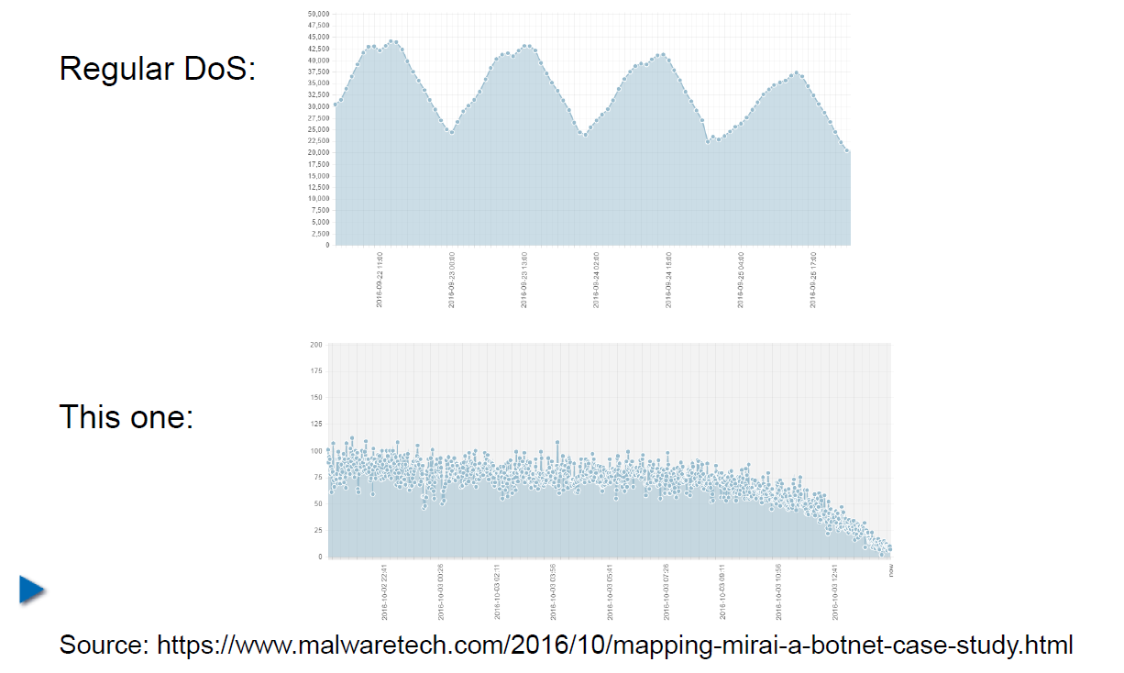

## IoT: Internet of insecure Things

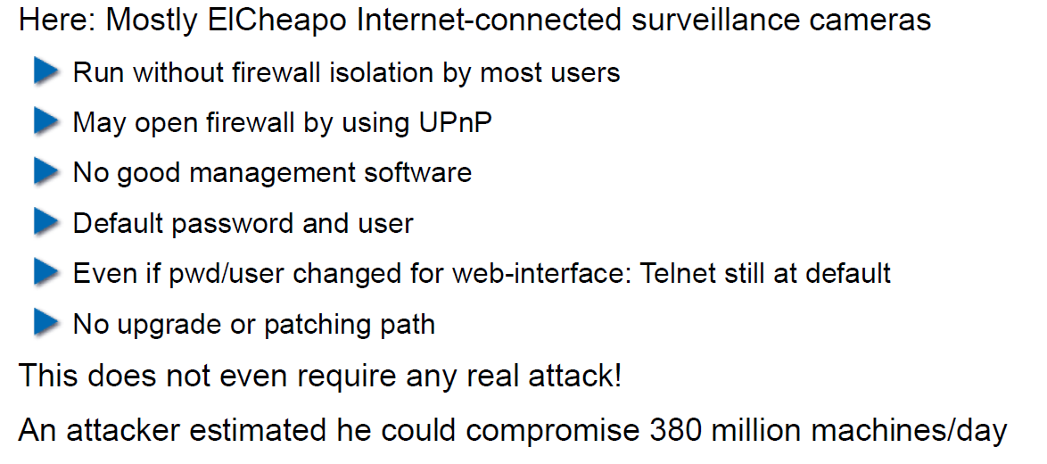

## Why are These IoT Devices so Insecure?

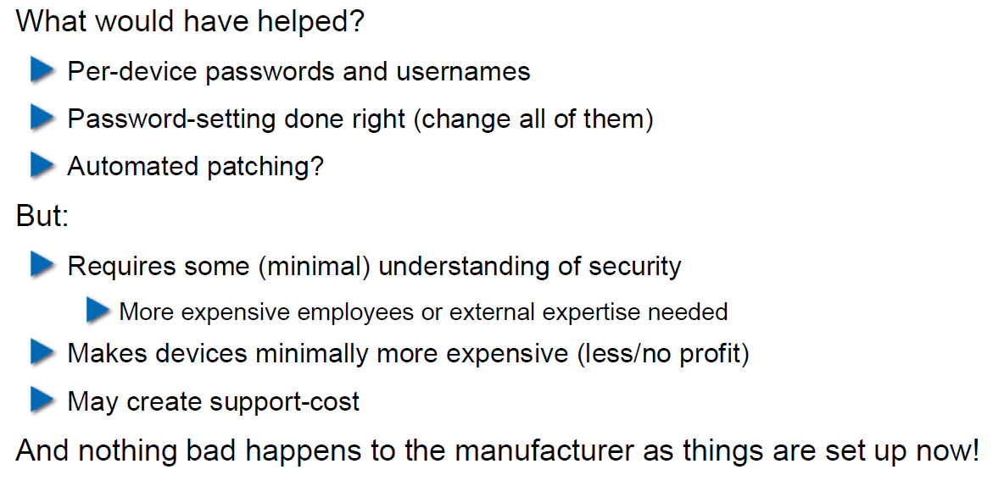

## Possible Solutions

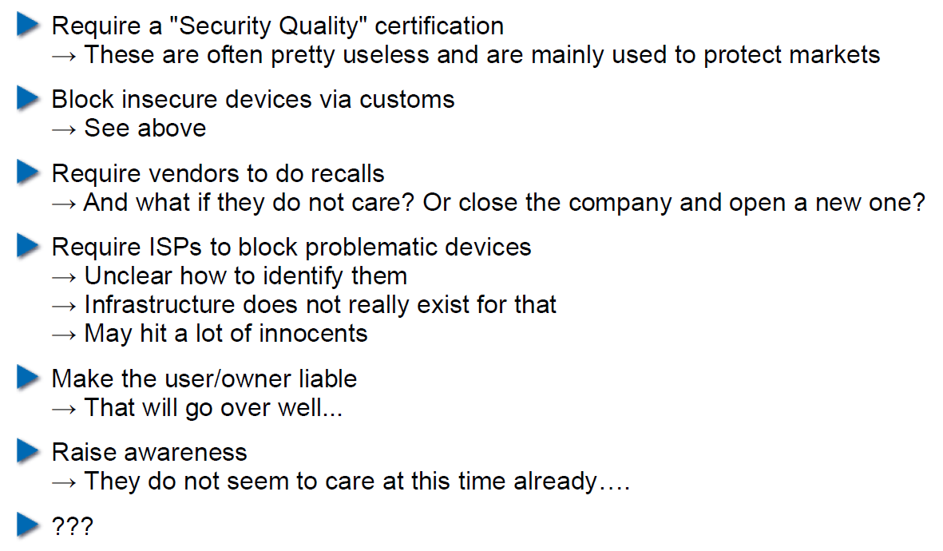

## Does it Pay to make Software Secure?

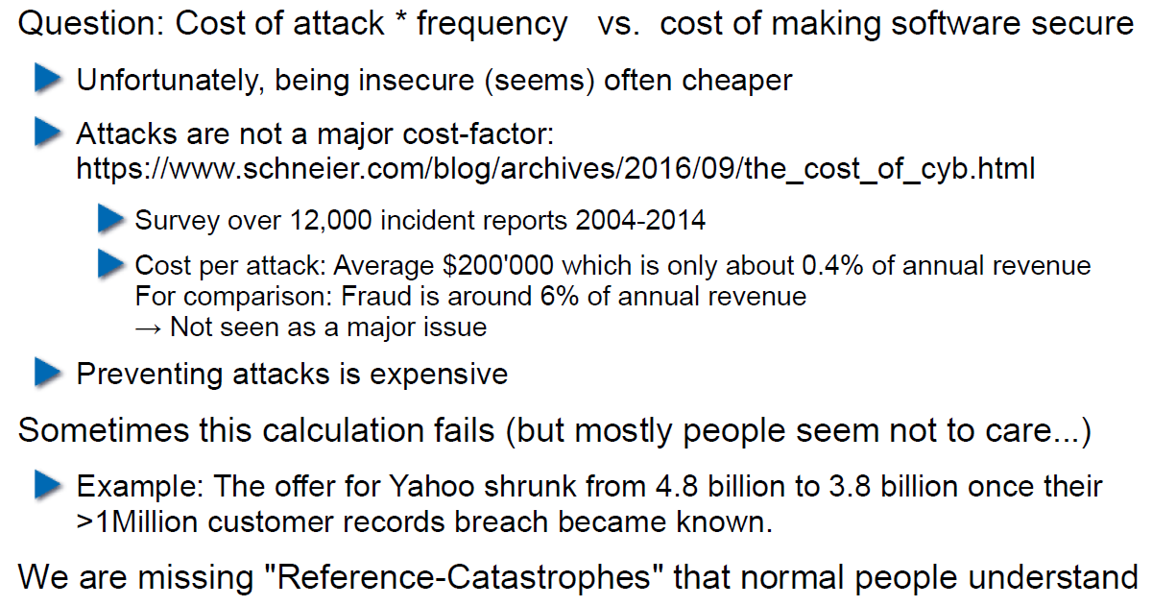

## So, what to do?

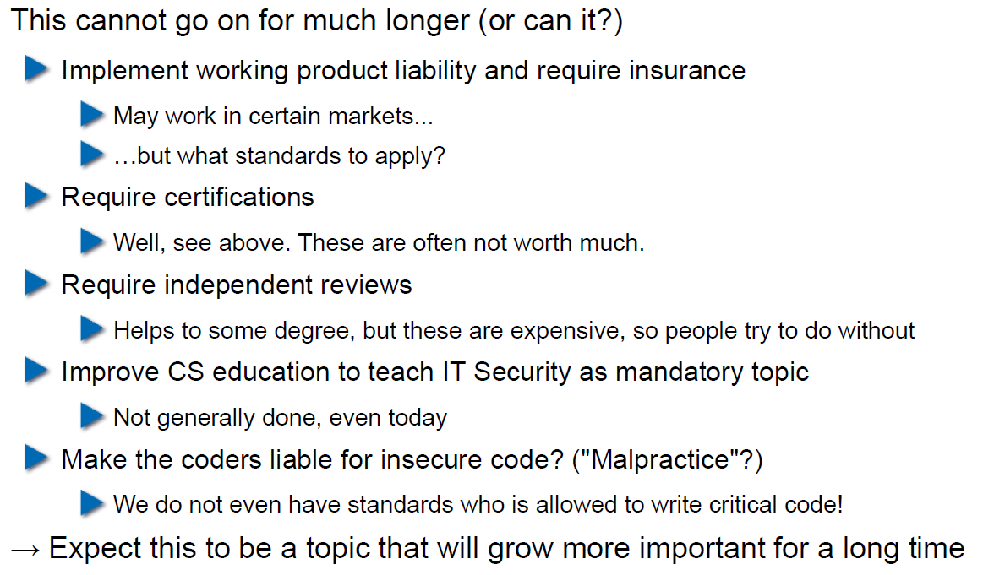

# Woche 5

## Agenda

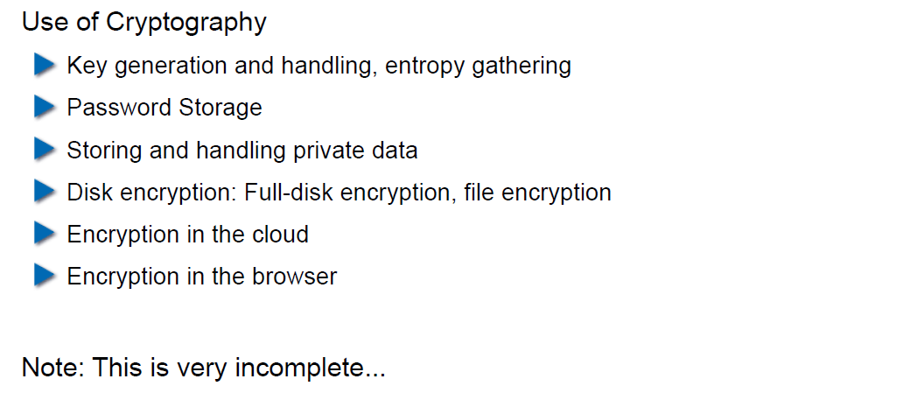

## Generating Cryptographic Keys

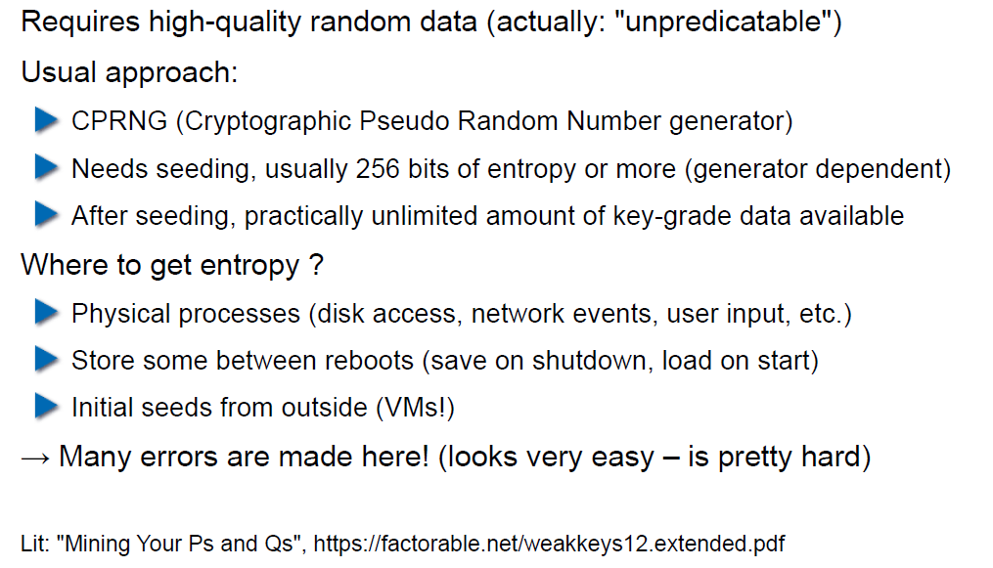

## Information-Theoretical Entropy

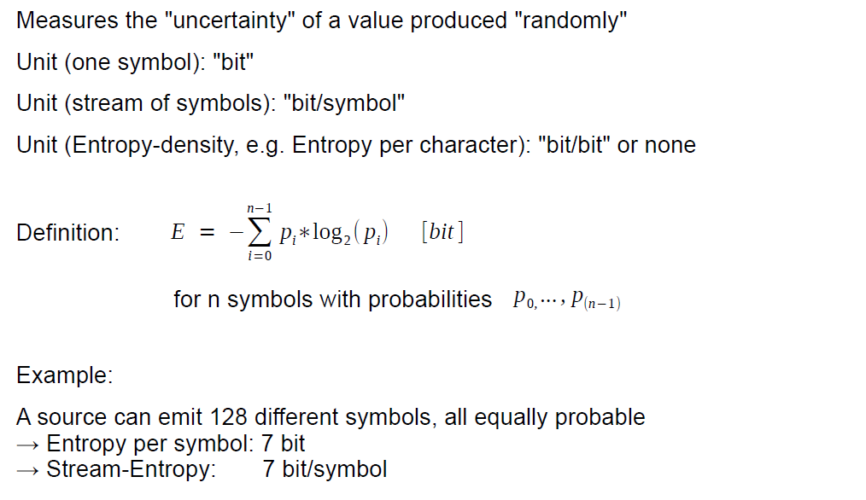

## Estimating Entropy is Tricky

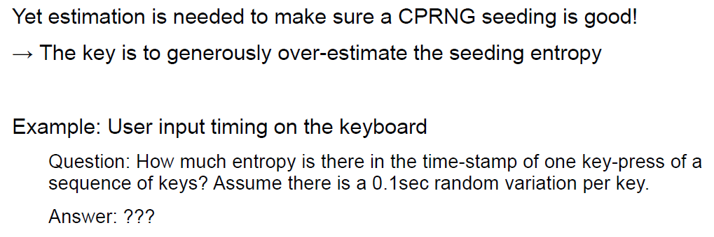

## Seeding a CPRNG

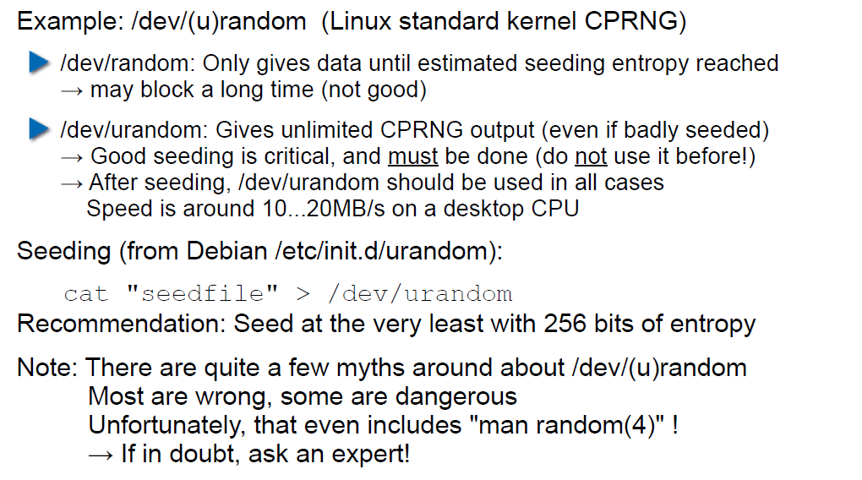

## Bad Seeding Examples

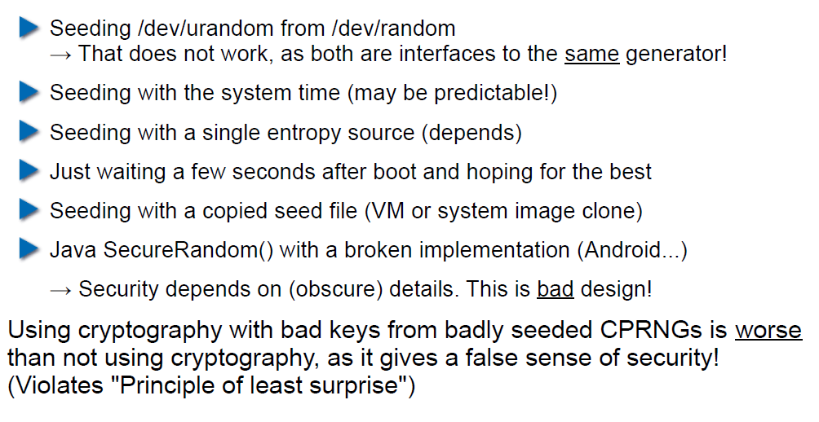

## Storing Cryptographic Keys Securely

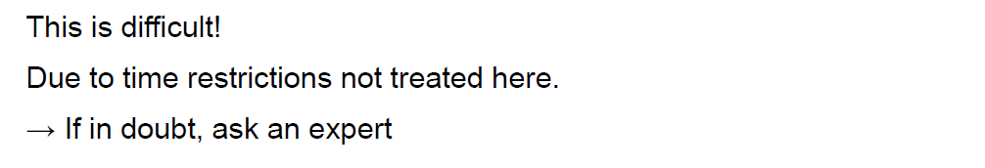

## Storing Passwords

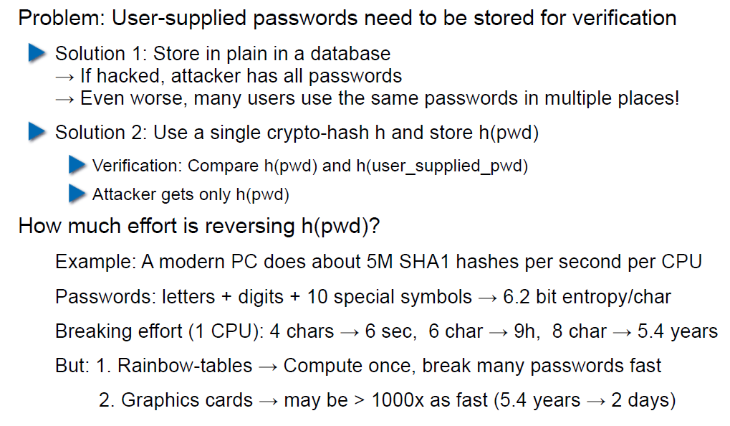

## Rainbow Table

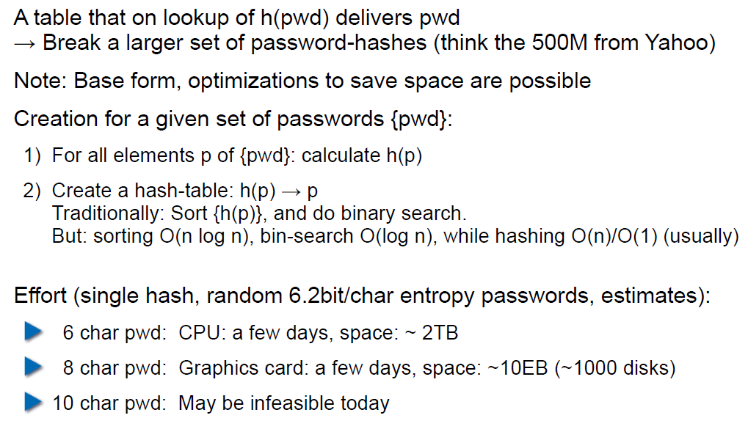

## Storing Passwords

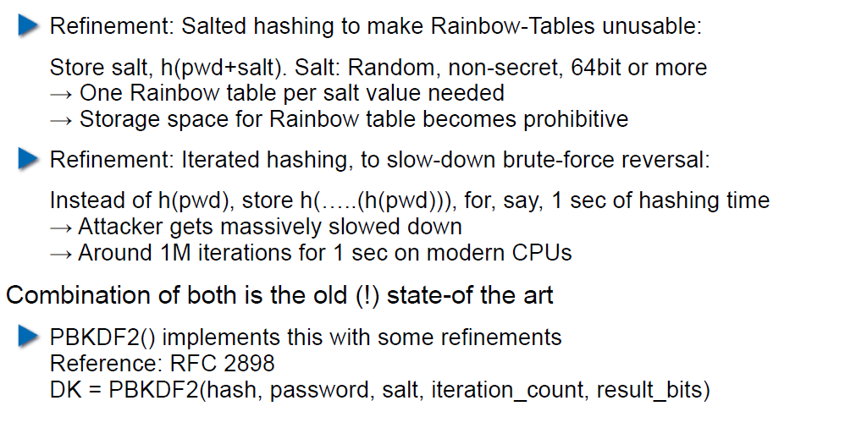

## So What is Wrong with PBKDF2?

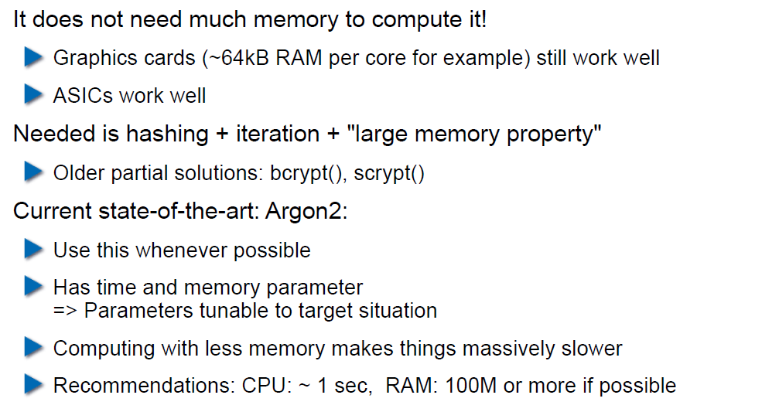

## Hardware RNGs

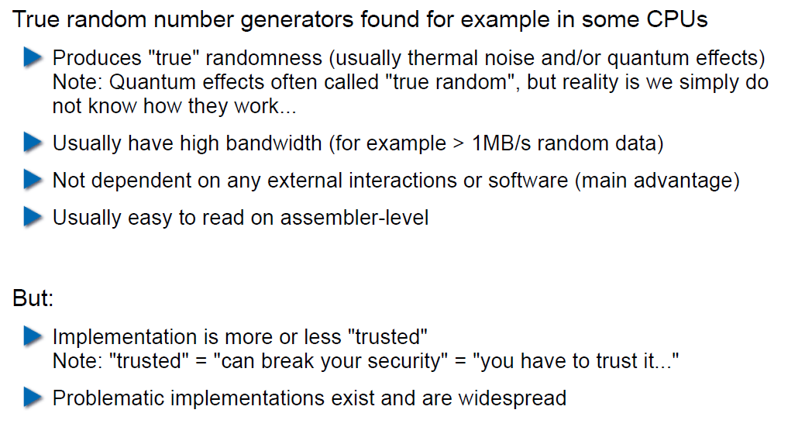

## Example 1: Via C3 Hardware CPRNG Schematic

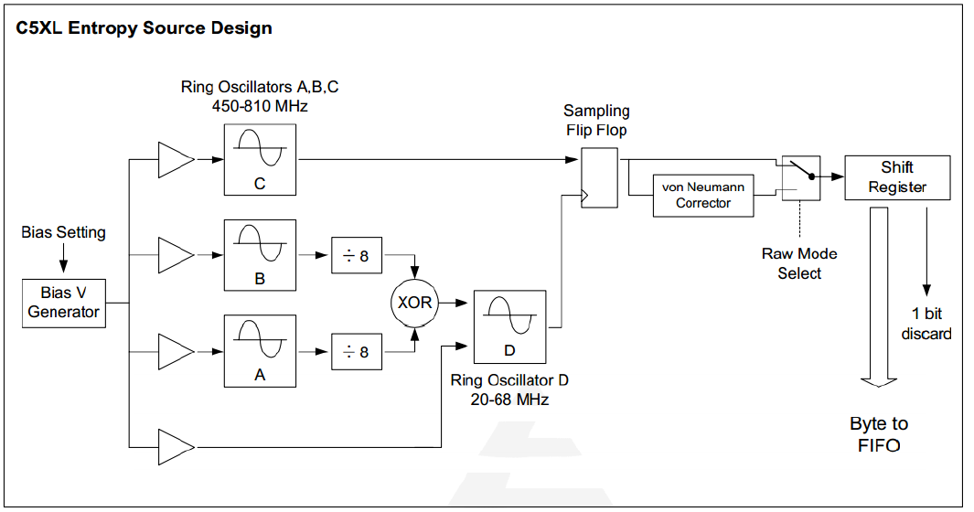

## Example 2: Intel RDRAND Schematic

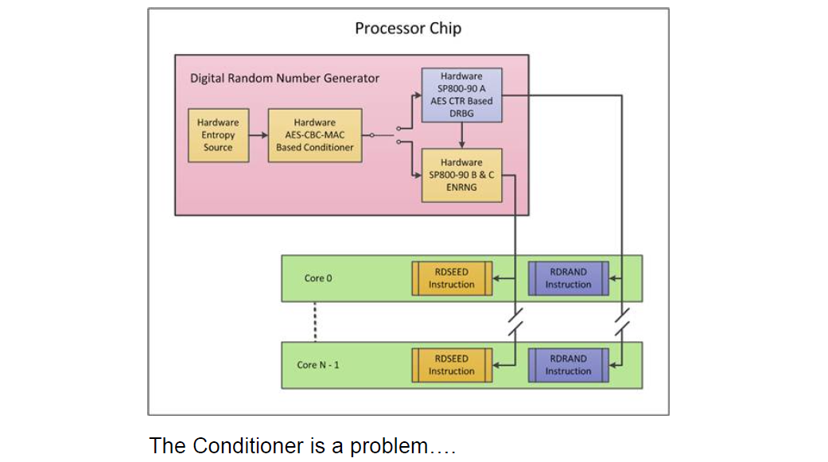

## Compromise on Design-Level

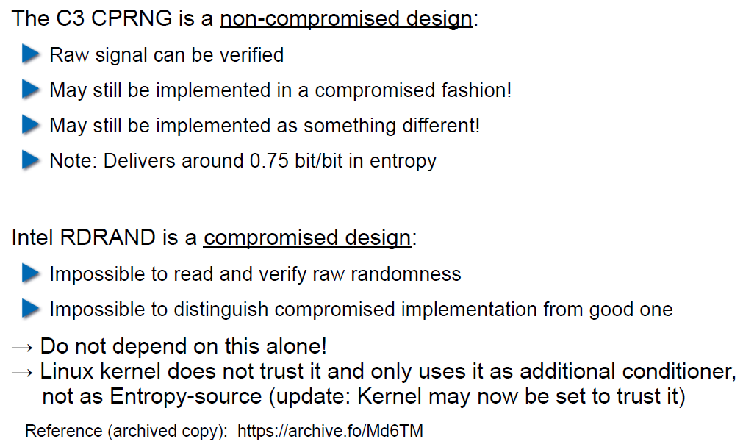

## Storing Private Data (as a Service Provider)

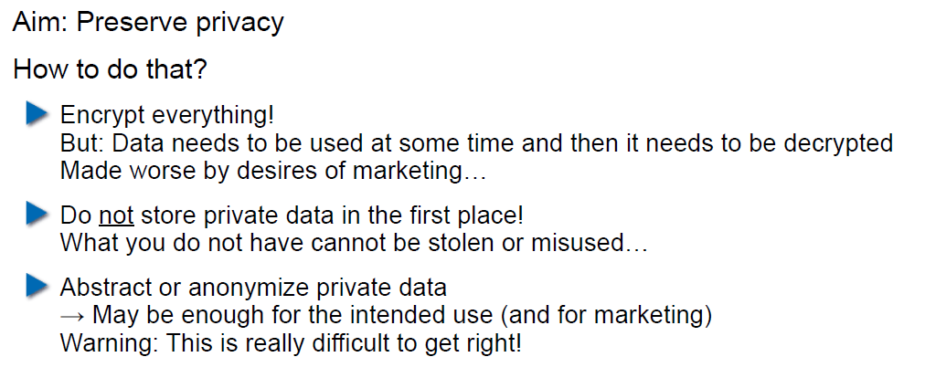

## Disk/Storage Encryption

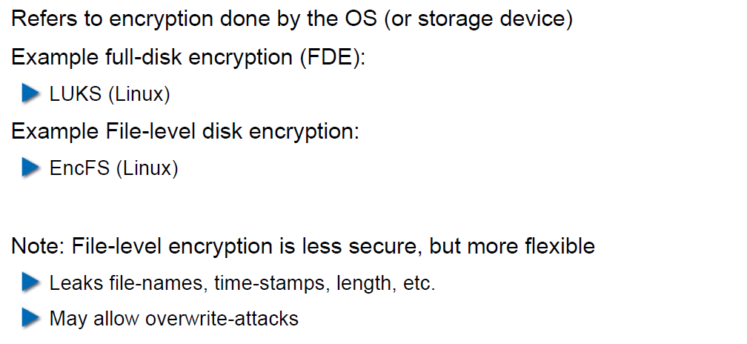

## Disk Encryption Protects Against What?

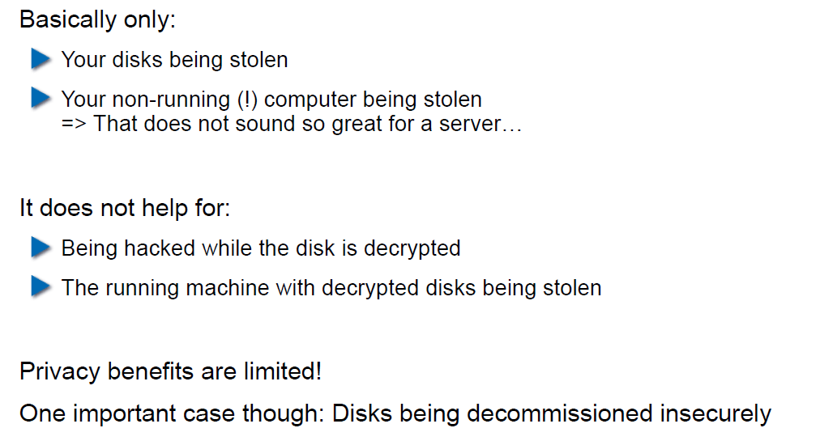

## Decryption Only With User Logged In

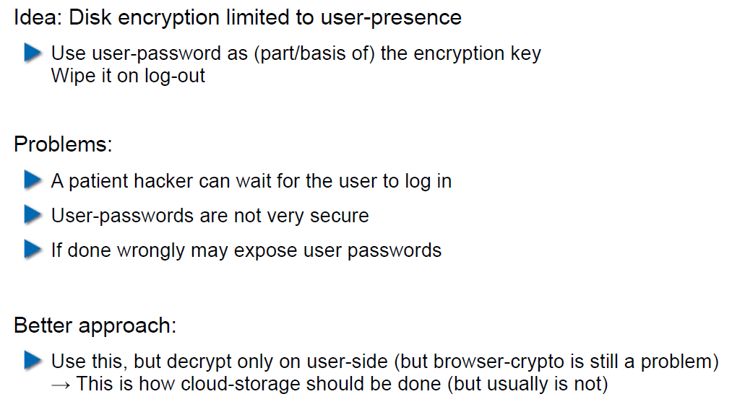

## Encryption in the Cloud

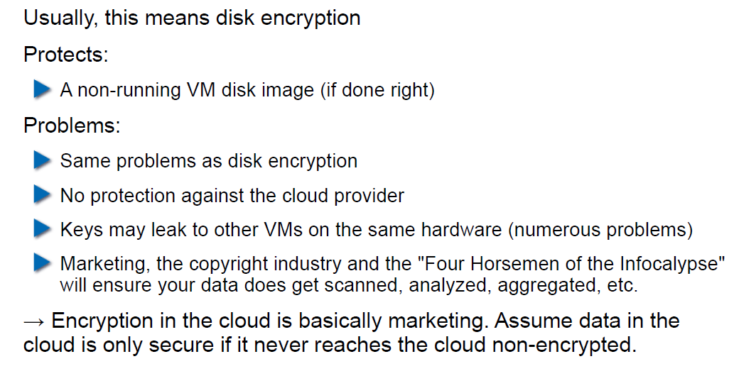

## JavaScript Client-Side Encryption in Web-Apps

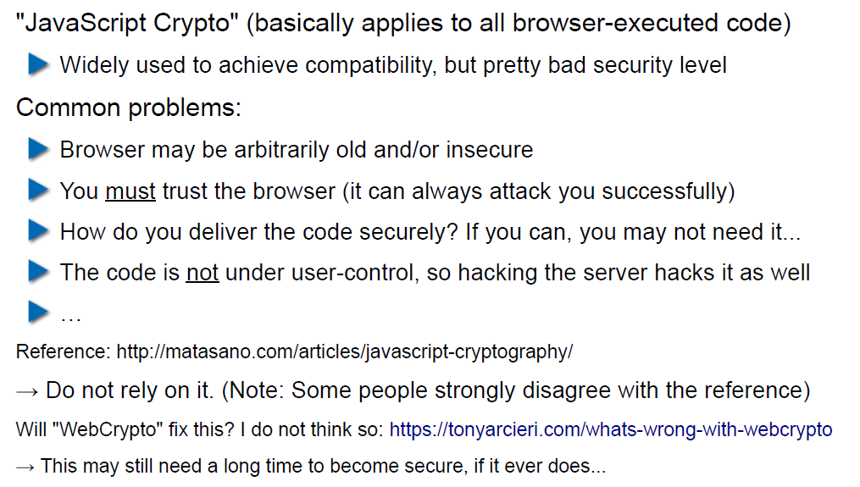

# Woche 6

## Agenda

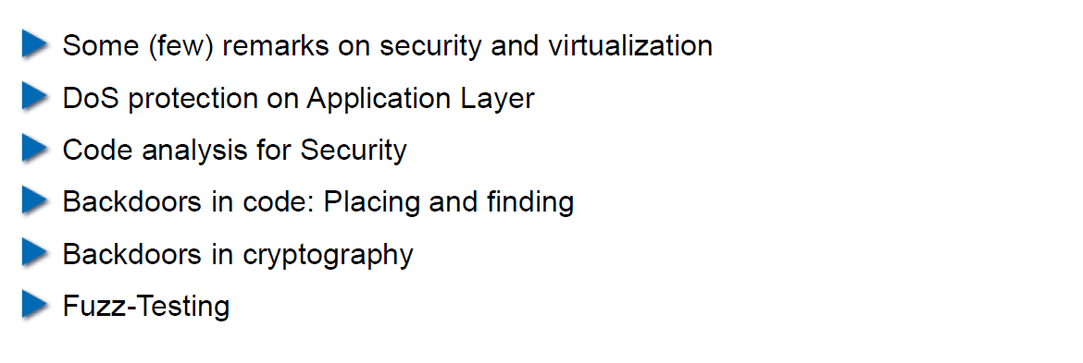

## Virtualization vs. Security

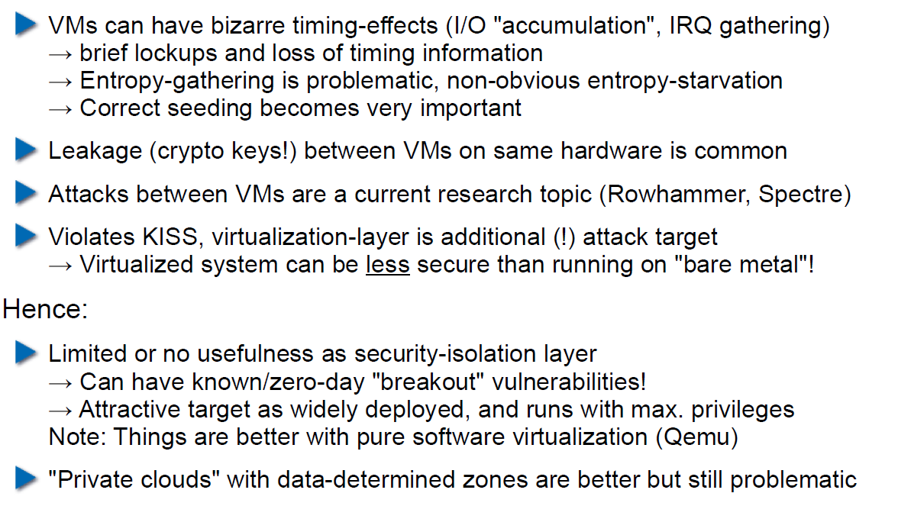

## DoS on Application Layer

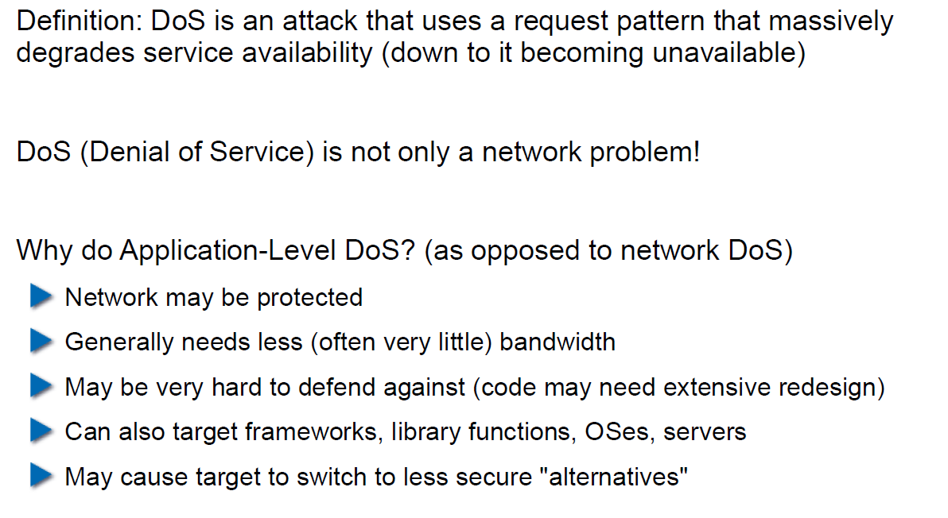

## DoS on Application Layer

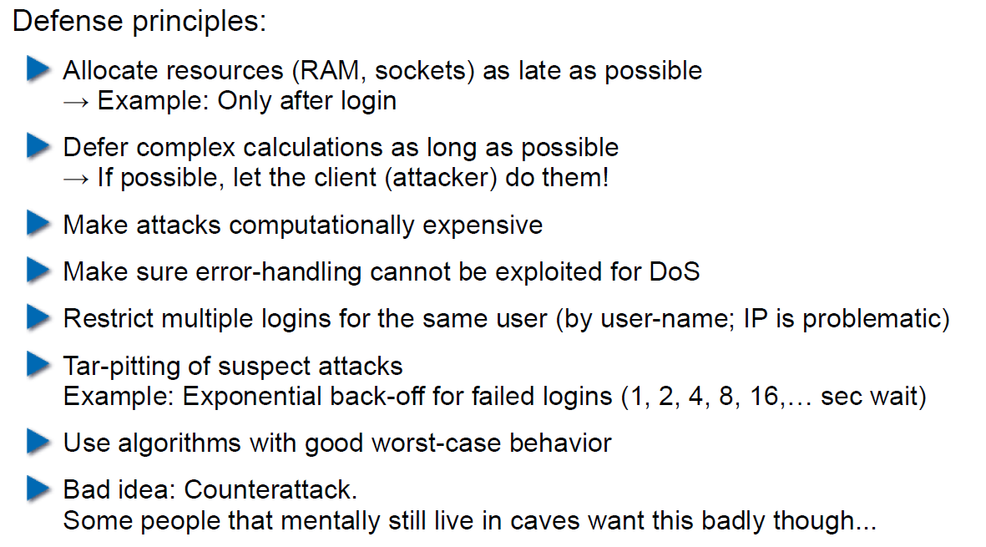

## Code Analysis for Security

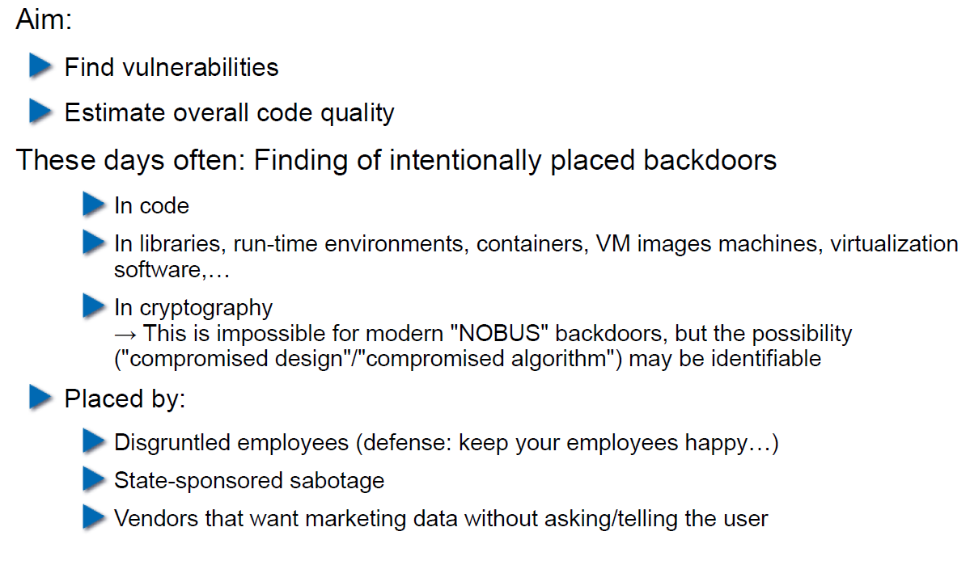

## Backdoors in Code

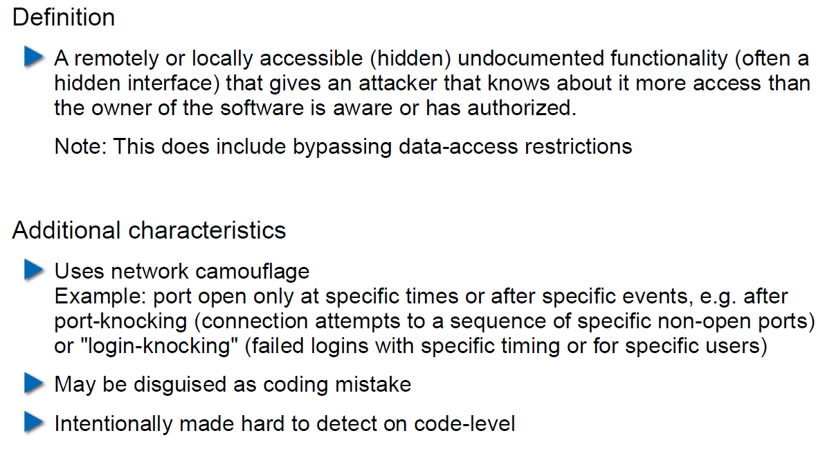

## Backdoor Hiding Techniques

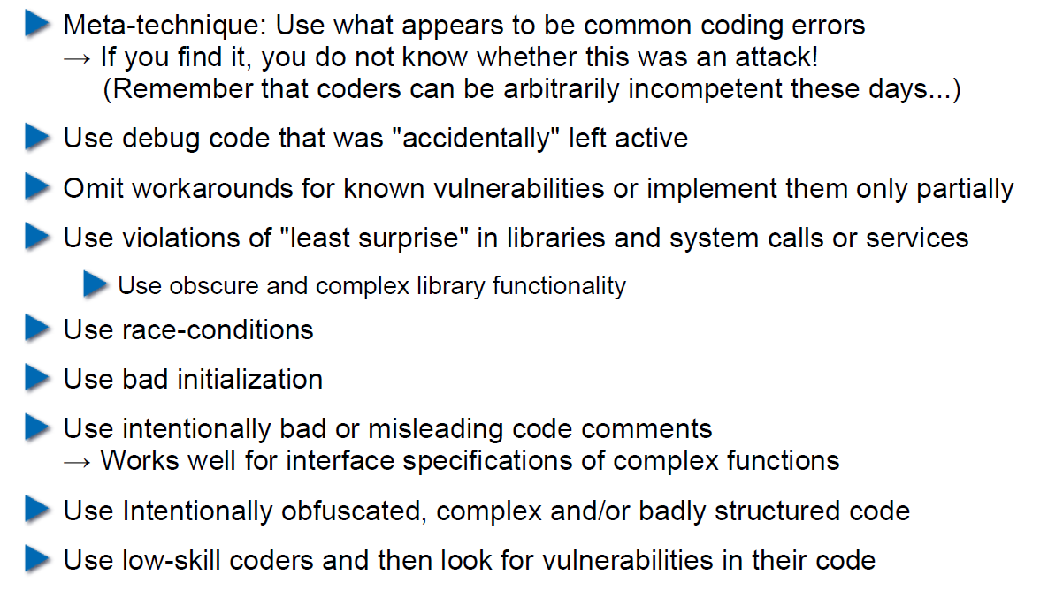

## Finding Backdoors

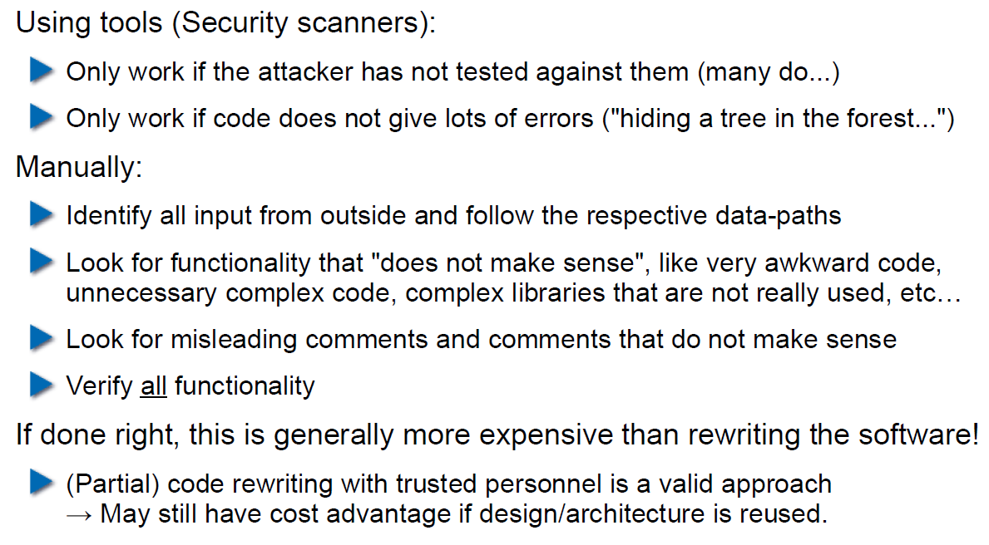

## Backdoors in Cryptography

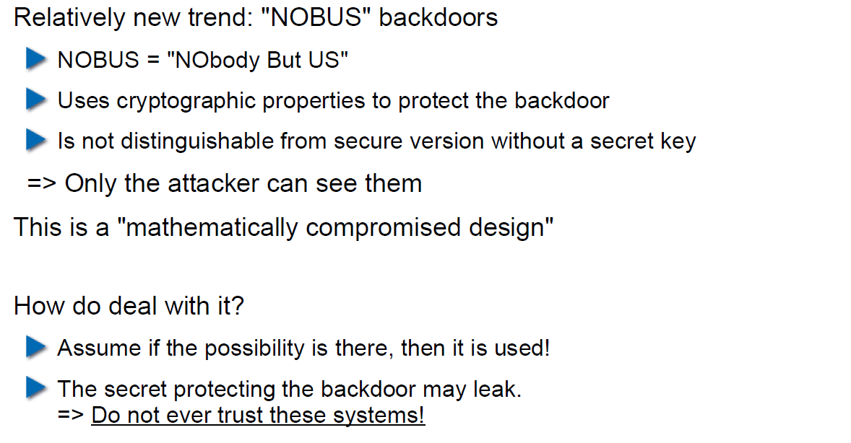

## Example 1: ECC

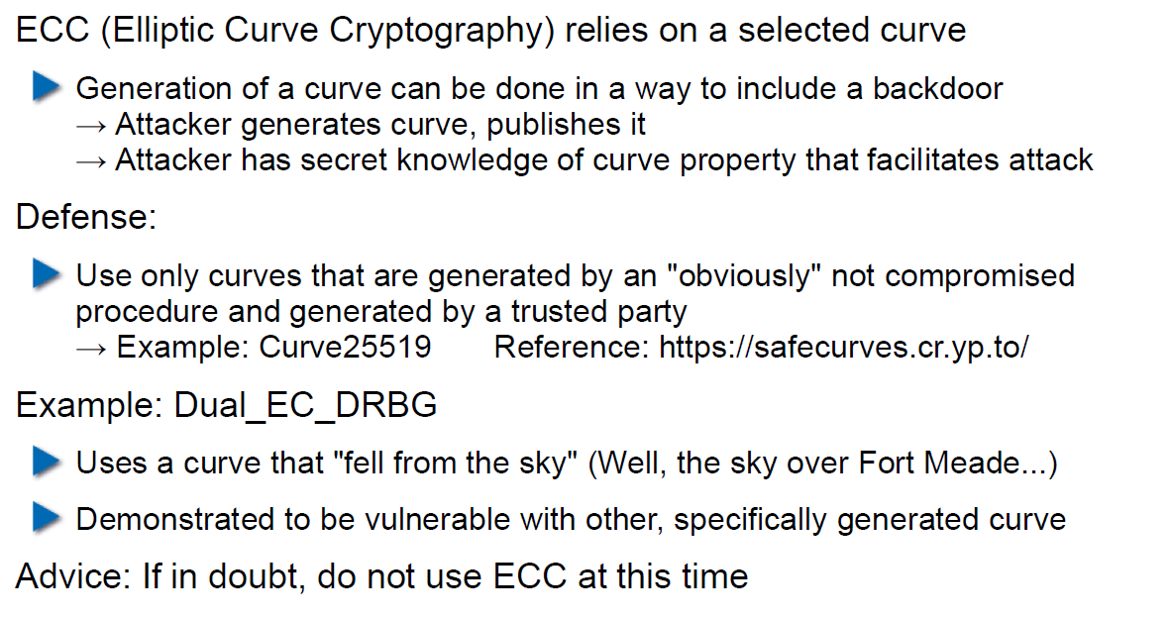

## Example 2: Specially selected Primes for Discreet Logarithms

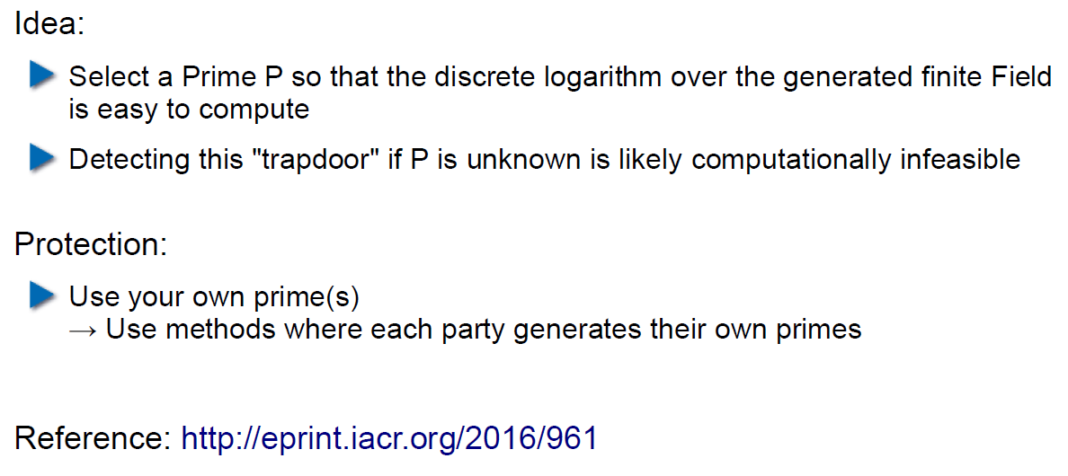

## Fuzz-Testing: The Idea

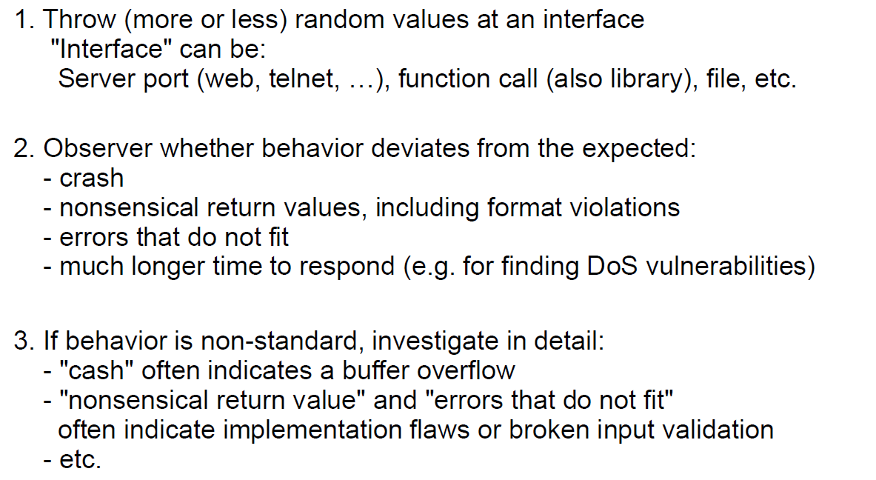

## Possibilities and Limitations

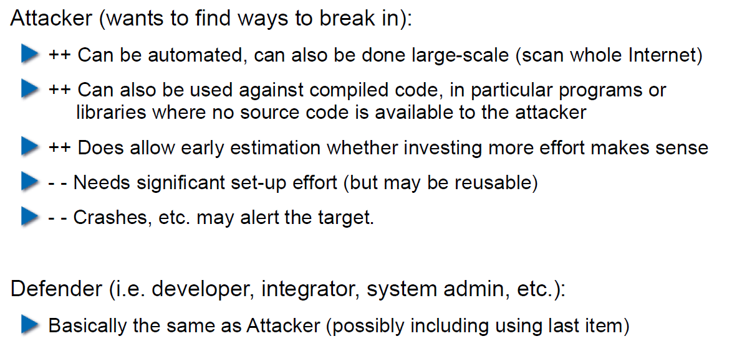

## Structured Fuzzing vs. Random Fuzzing

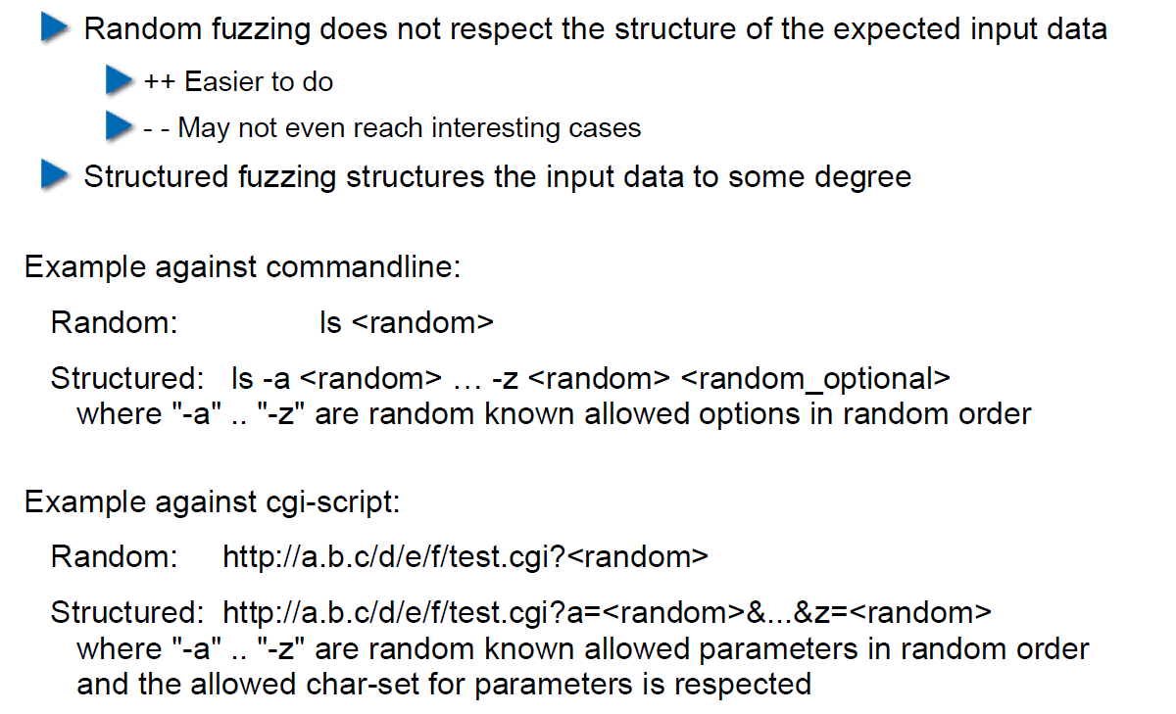

## Fuzzing for Regular Tests

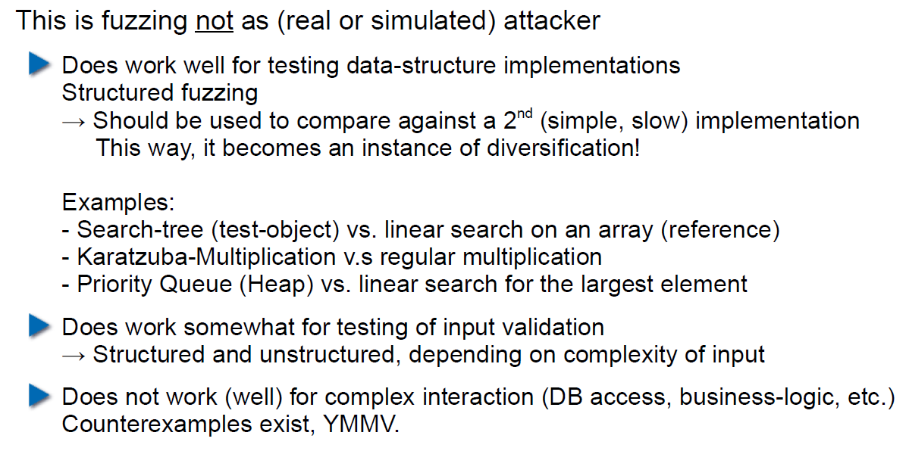

## Useful Fuzzing Tools

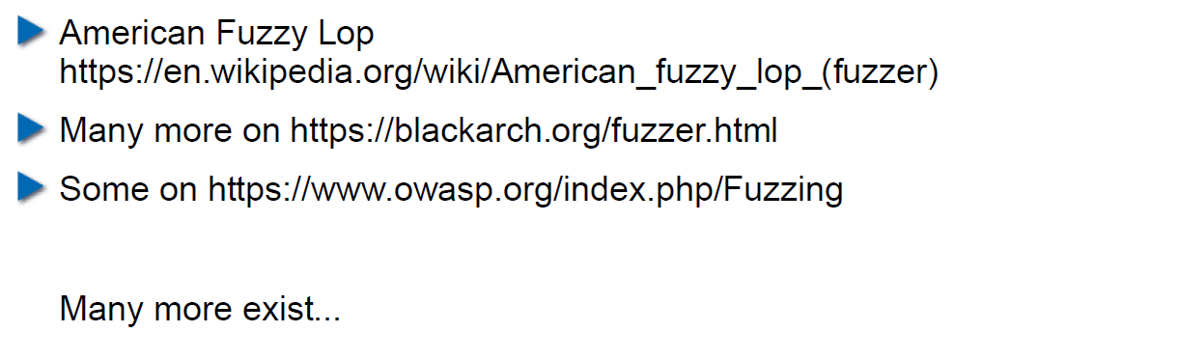

# Woche 7

## Agenda

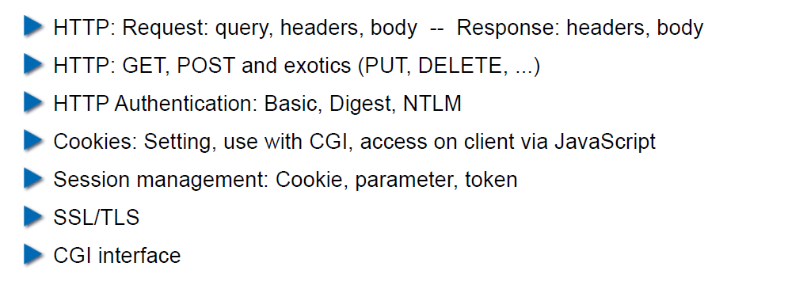

## Example Request in the TCP/IP Model

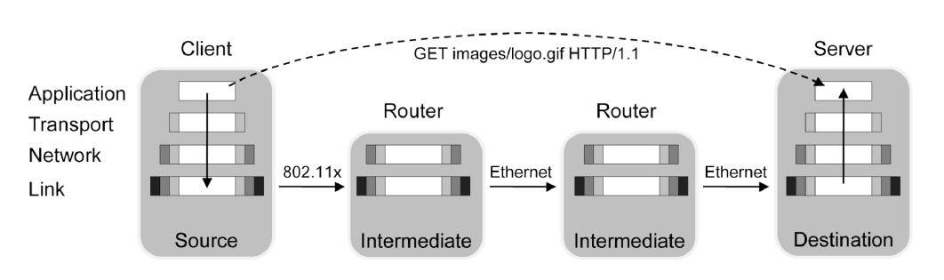

## HTTP

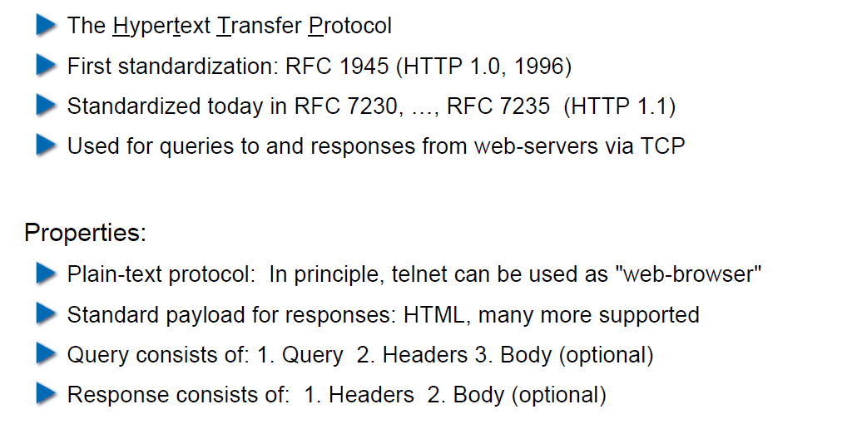

## HTTP Request Example: GET

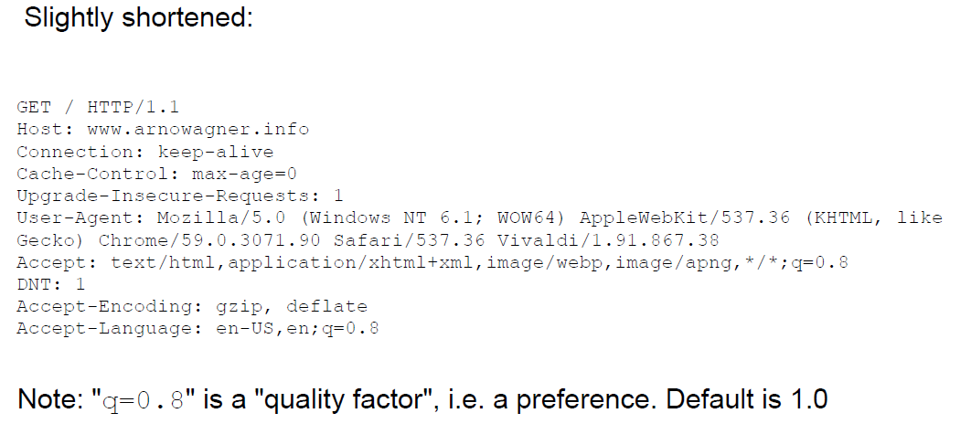

## HTTP Request Example: POST

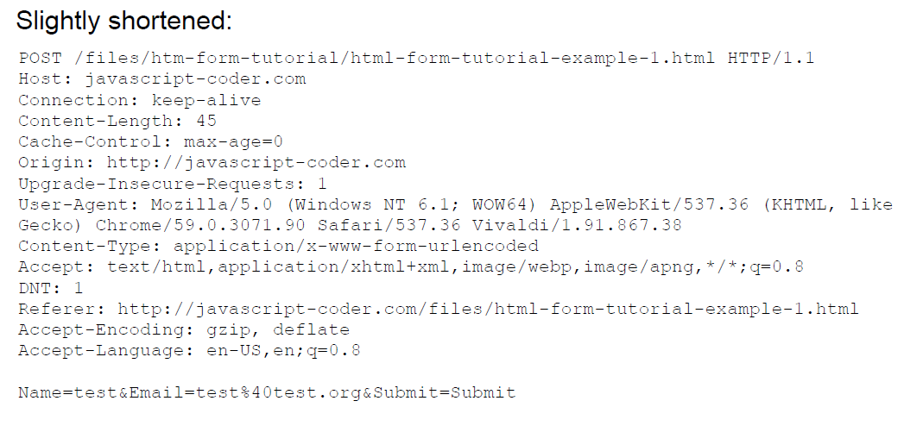

## HTTP Response Example

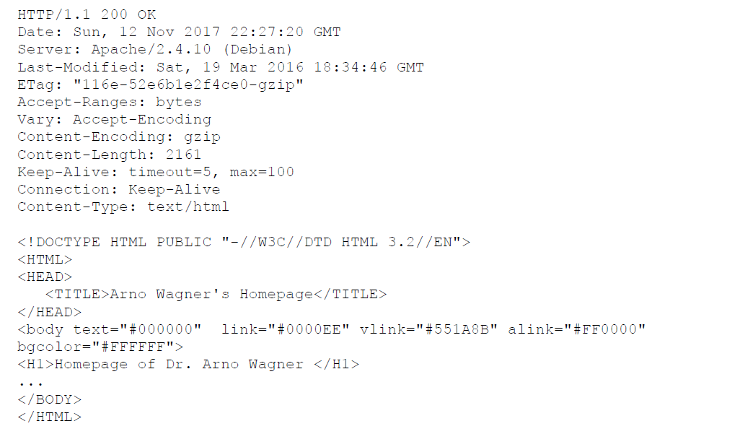

## Exotic Requests: PUT, DELETE, ...

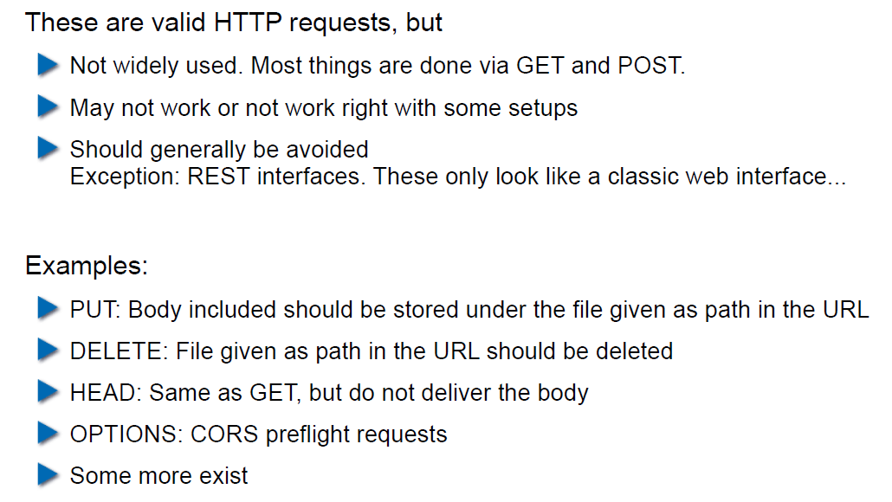

## HTTP Authentication

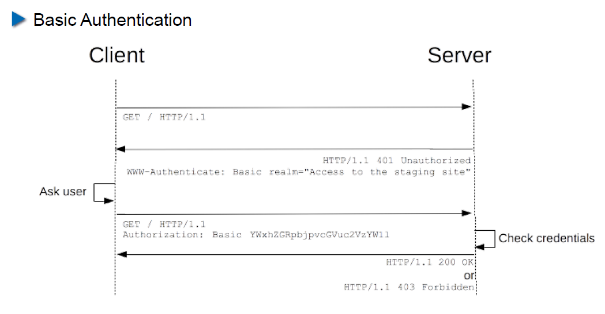

## HTTP Authentication

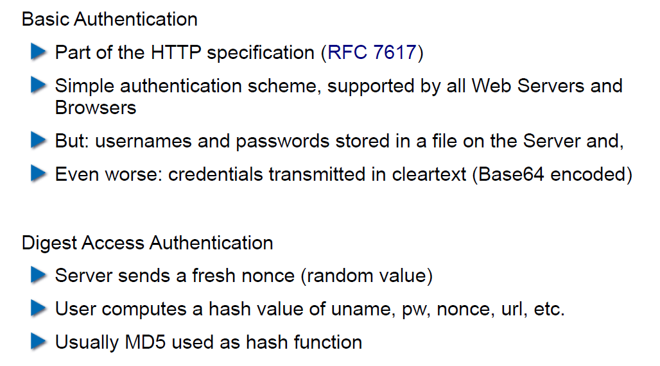

## Cookies

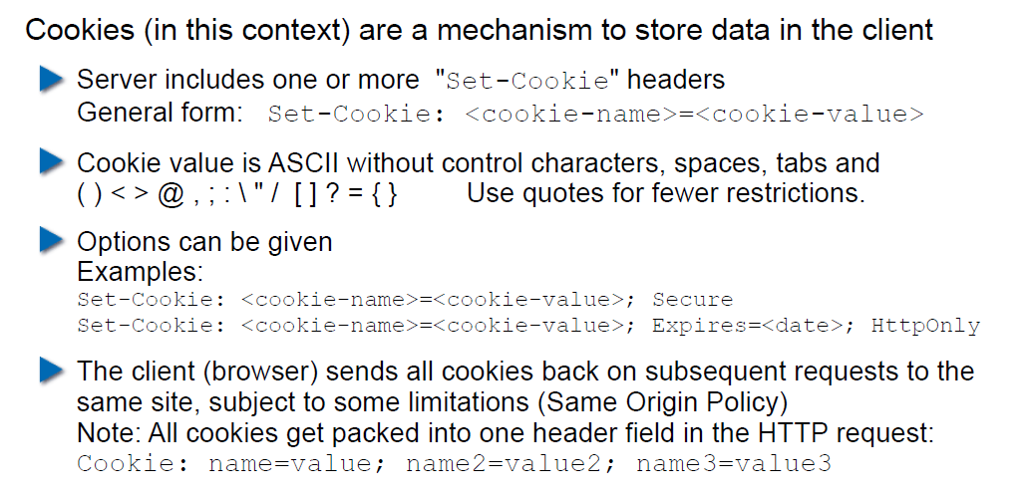

## Cookie Options

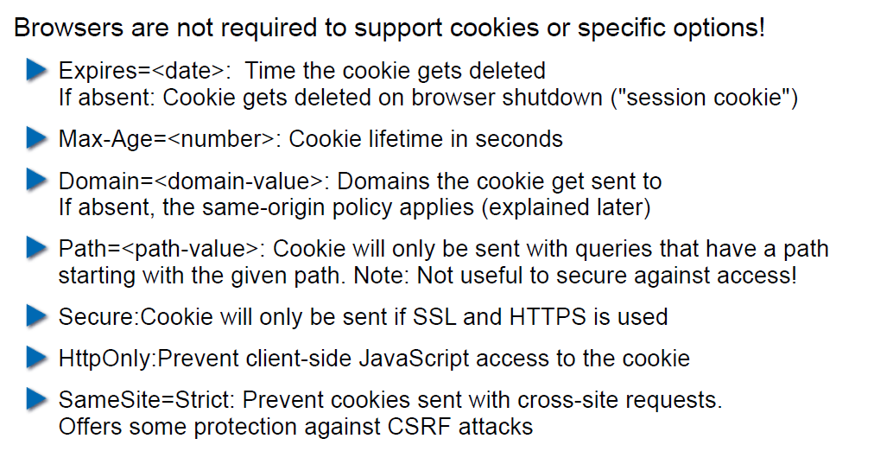

## Cookies: Access via JavaScript

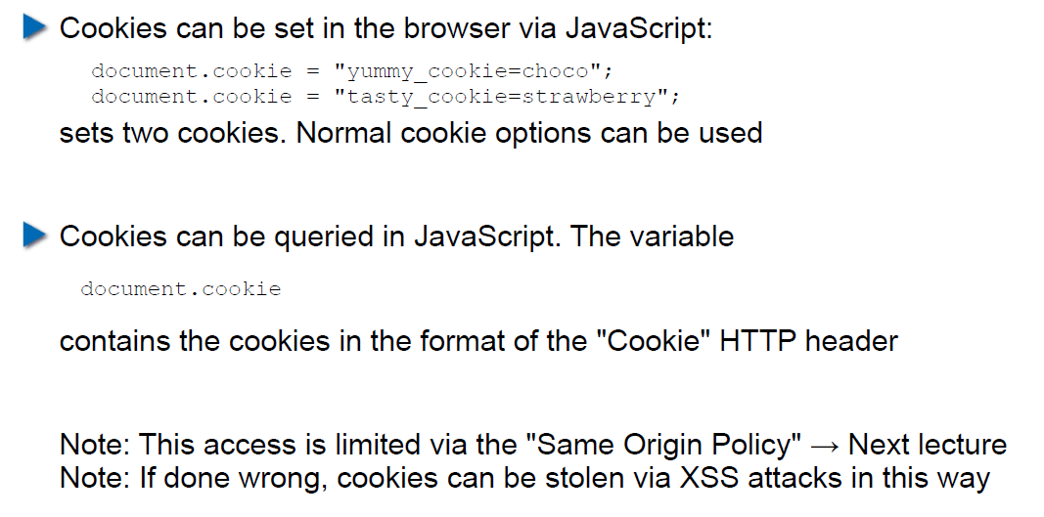

## Session Management

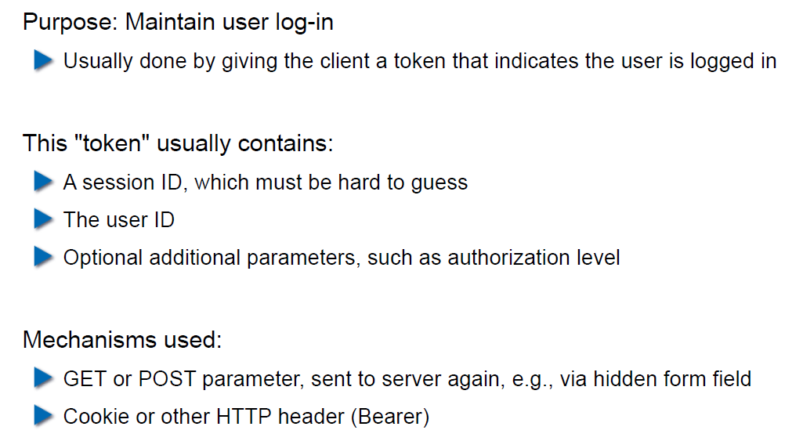

## Security Problems with Session Management

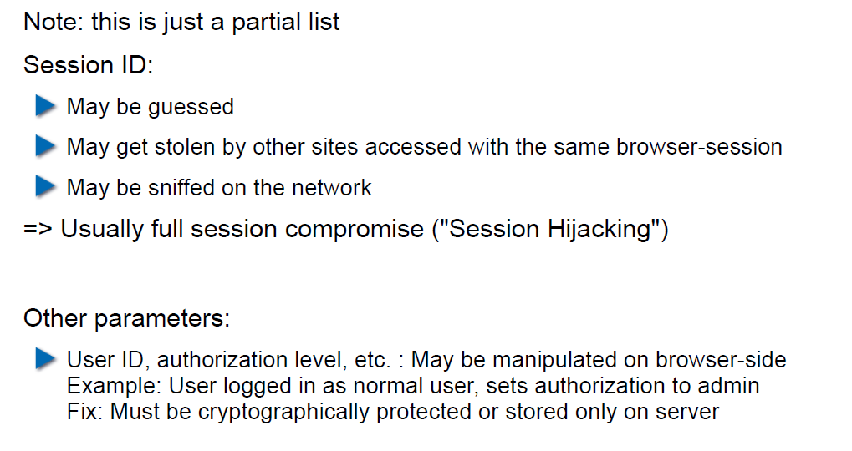

## Keeping State Securely on Client-Side

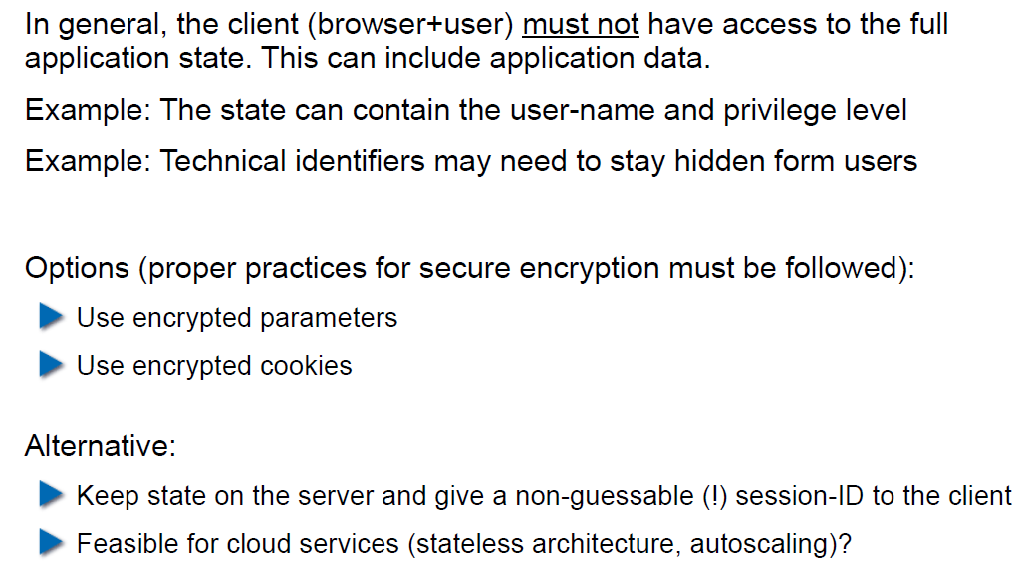

## Remark: Cookies and Application Paths vs. Proxies

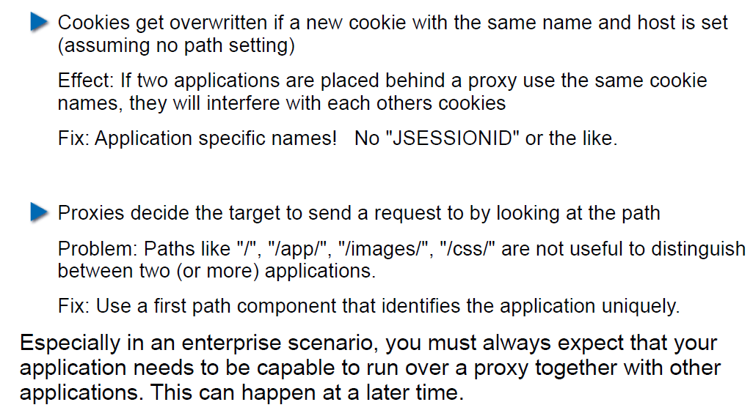

## SSL/TLS

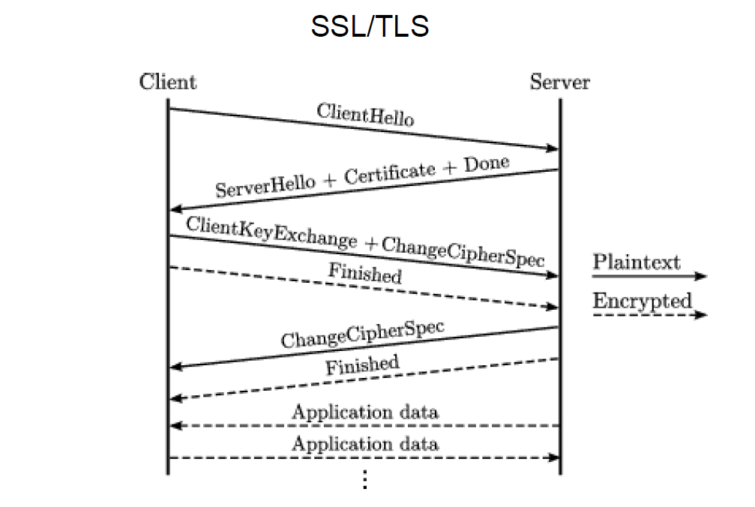

## SSL/TLS

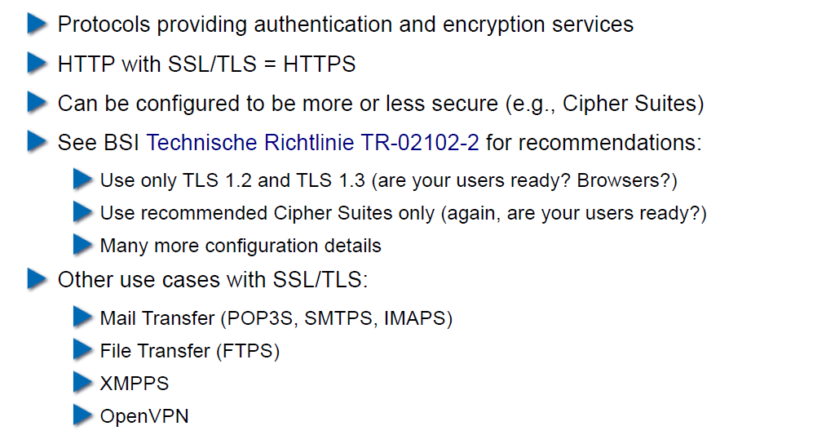

## CGI: General Idea

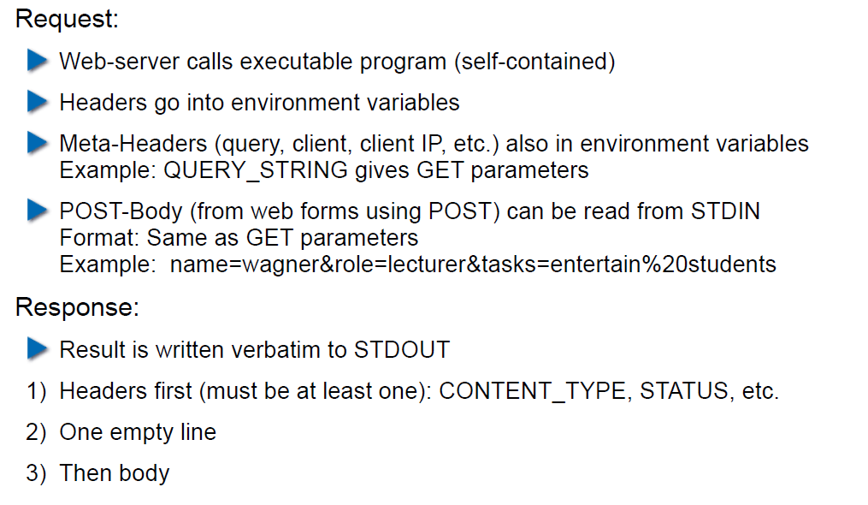

## CGI Scripts in Different Languages

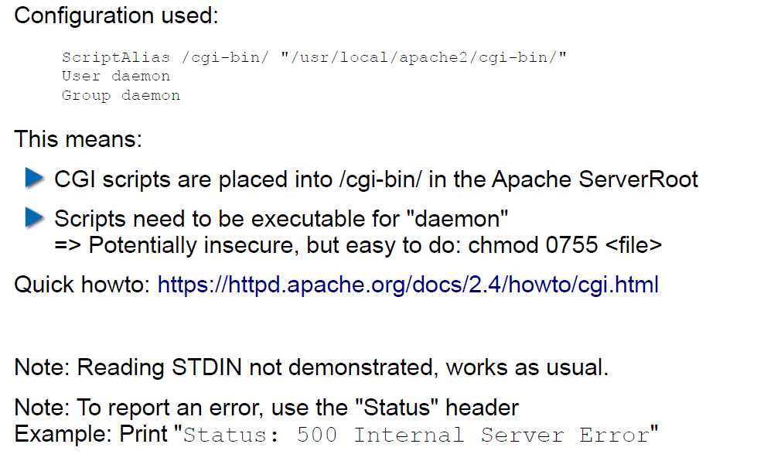

## CGI in BASH

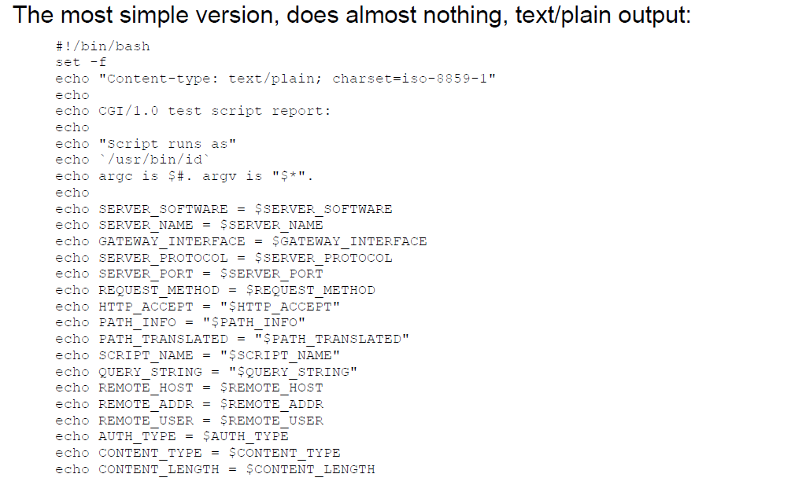

## CGI in BASH: Output

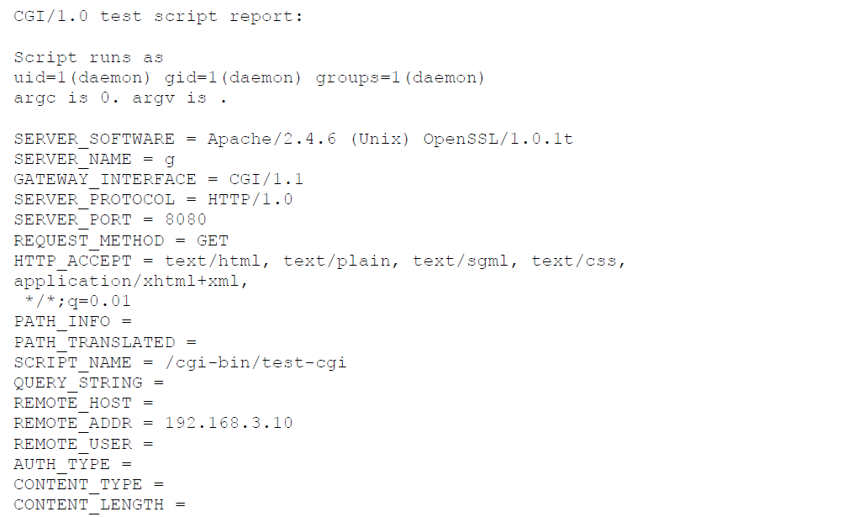

## CGI in Perl

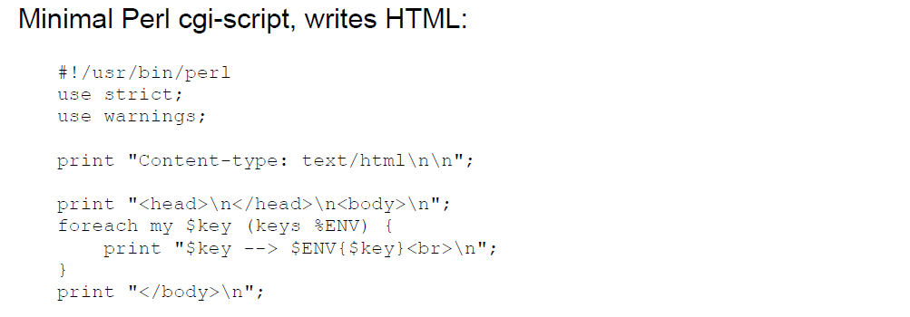

## CGI in Perl: Output

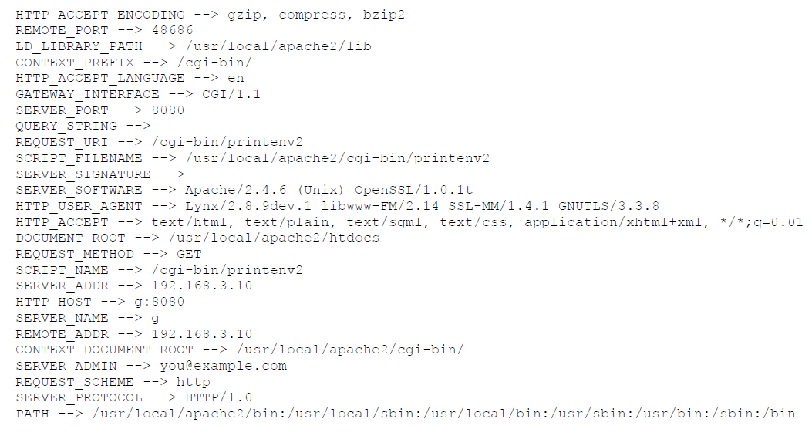

## CGI in C

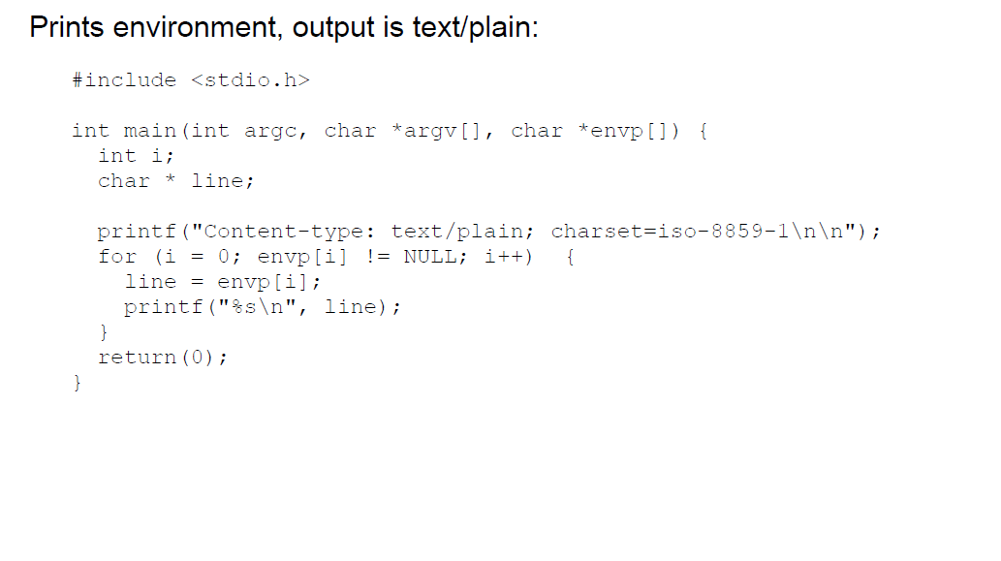

## CGI in C: Output

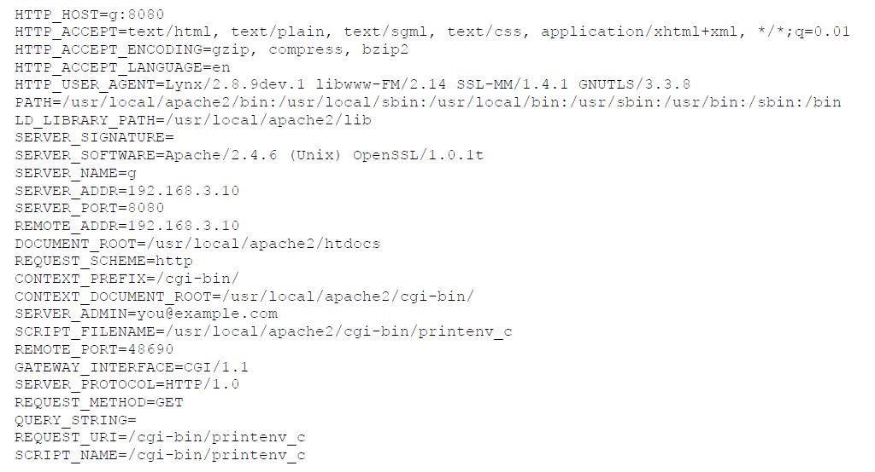

## CGI in Java

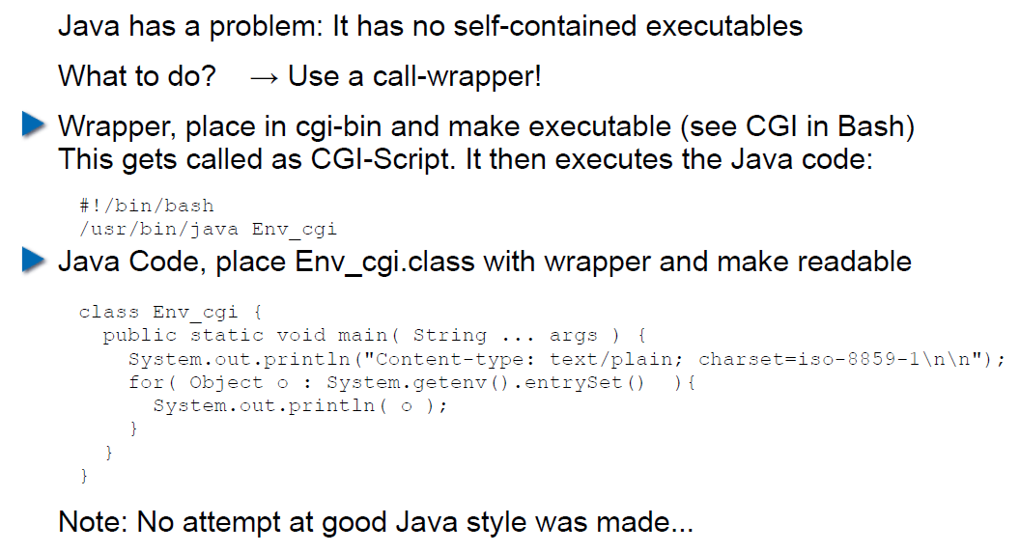

## CGI Security

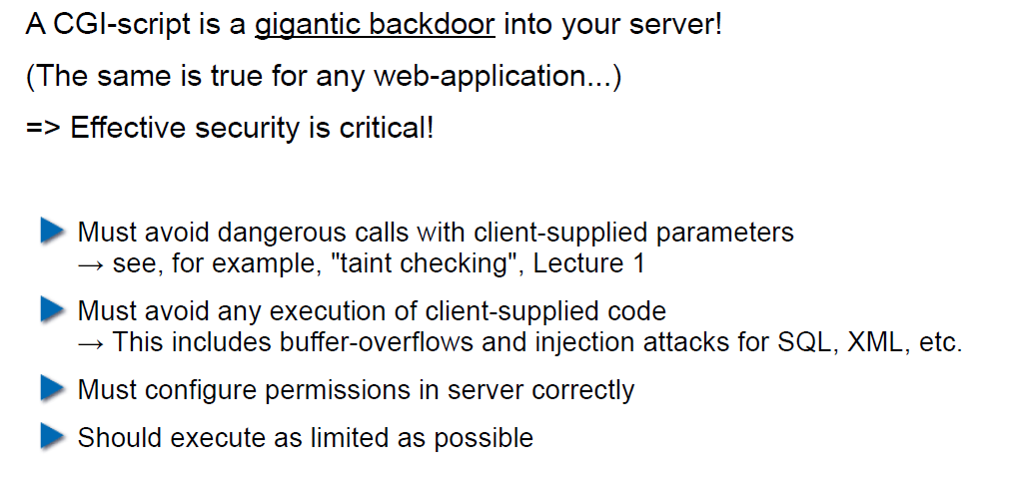

# Woche 8

## Dates

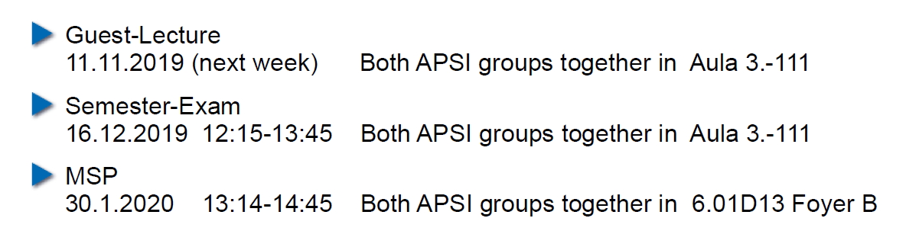

## 11.11.19: Guest Speaker about WAF

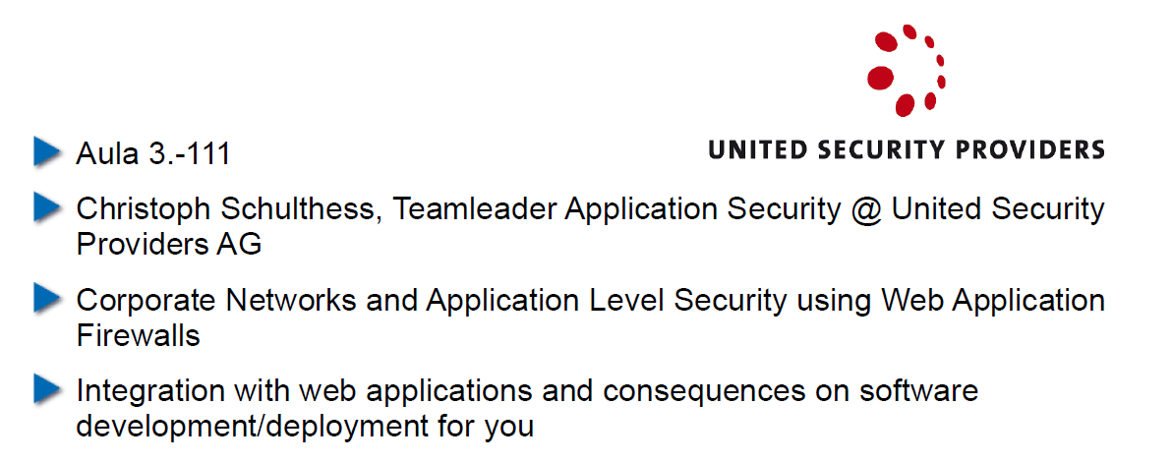

## Agenda

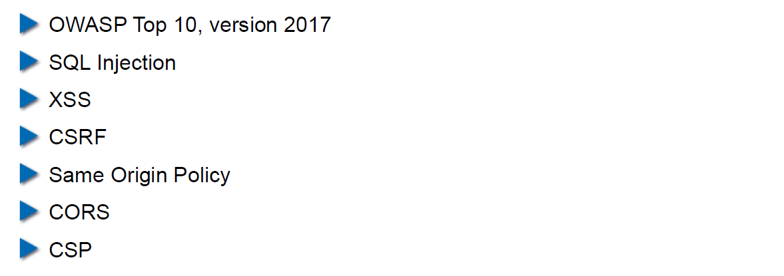

## OWASP – Open Web Application Security Project

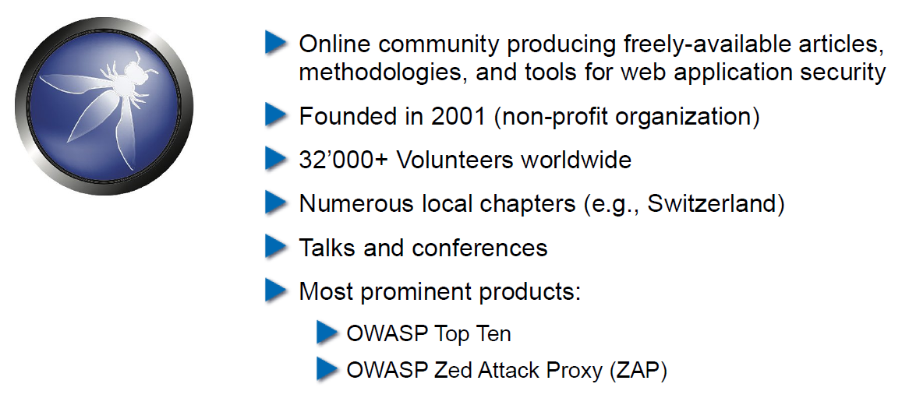

## OWASP Top Ten

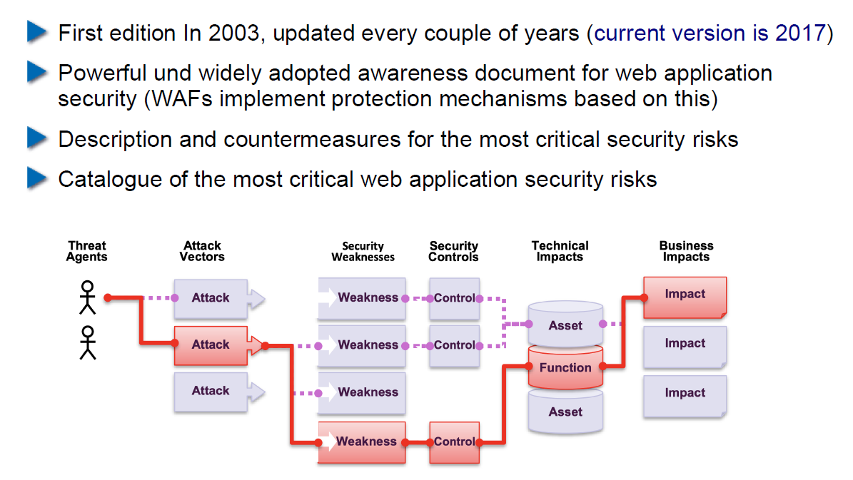

## OWASP Top Ten

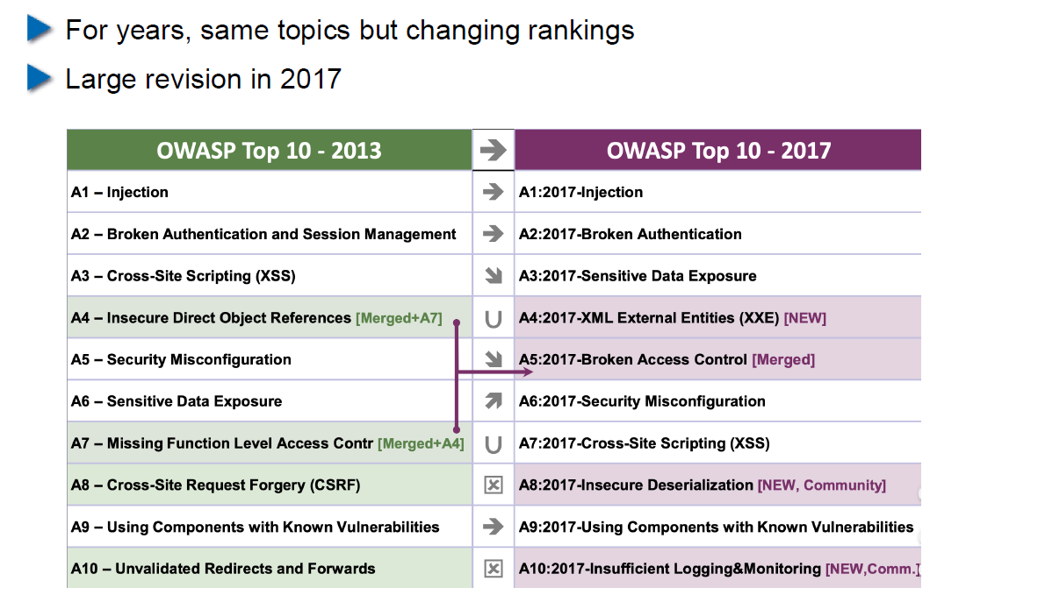

## Cross-Site Scripting (XSS): Cookie Theft

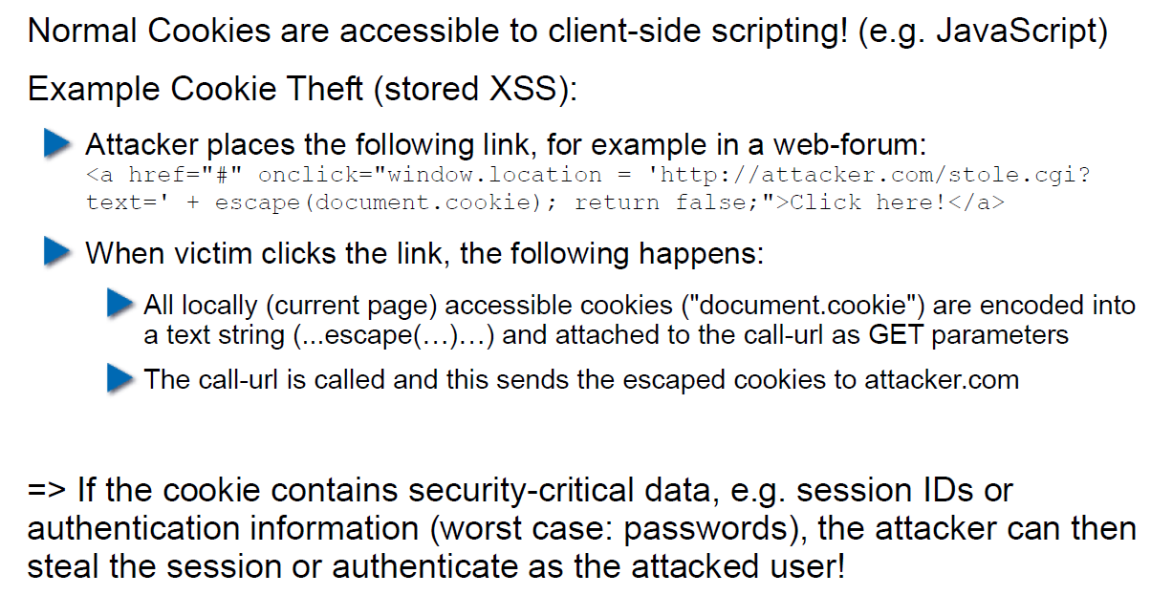

## Stored XSS Countermeasures

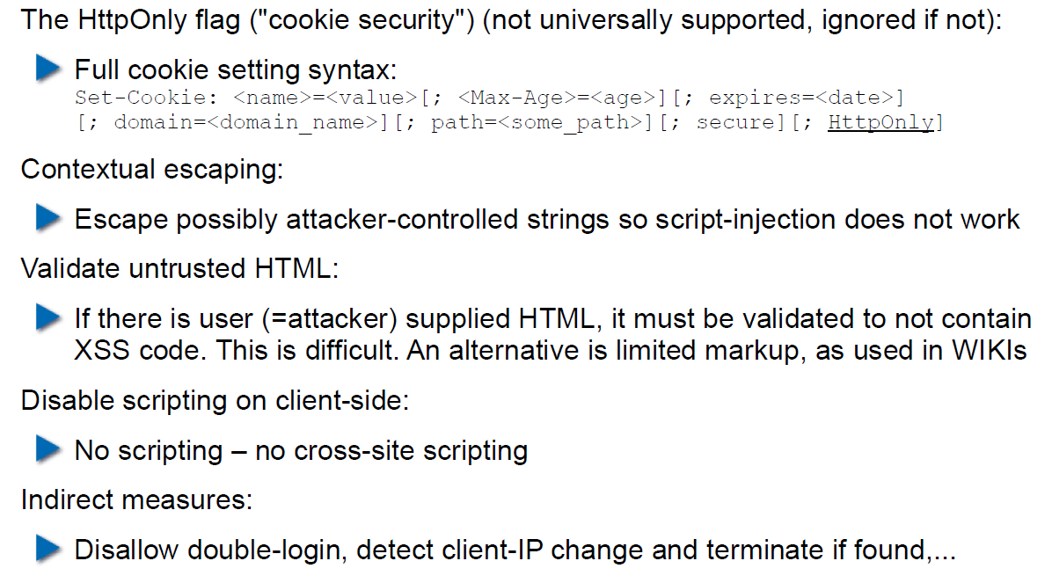

## Reflected XSS

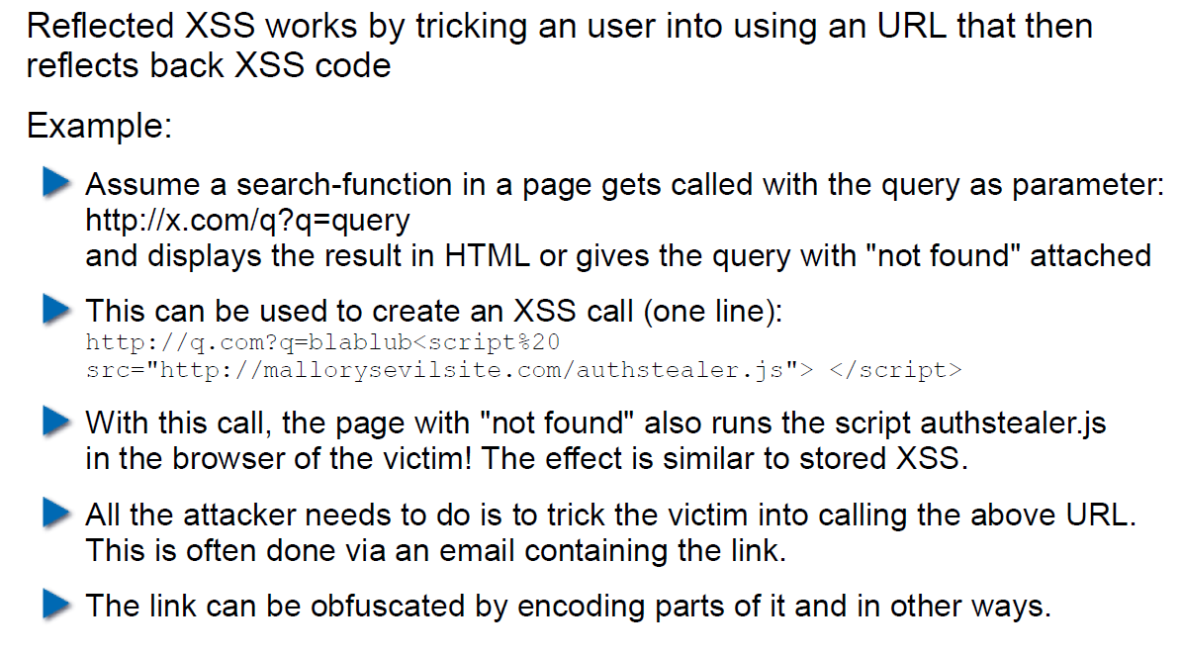

## Defense Against Reflected XSS

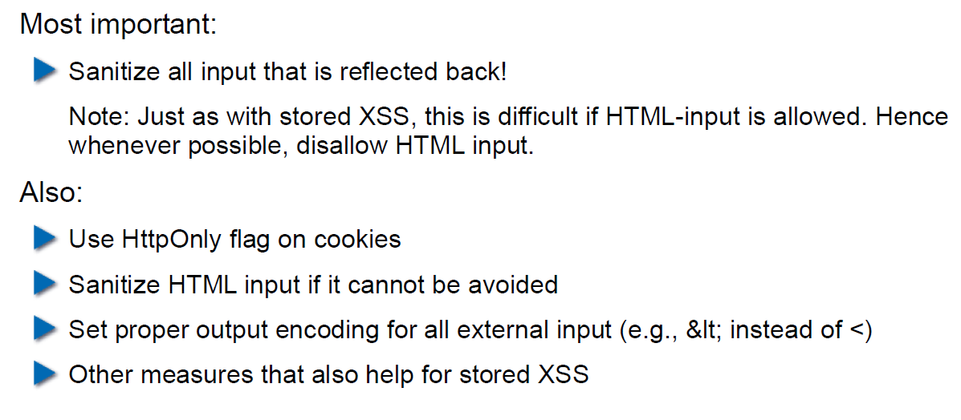

## Cross Site Request Forgery (CRSF)

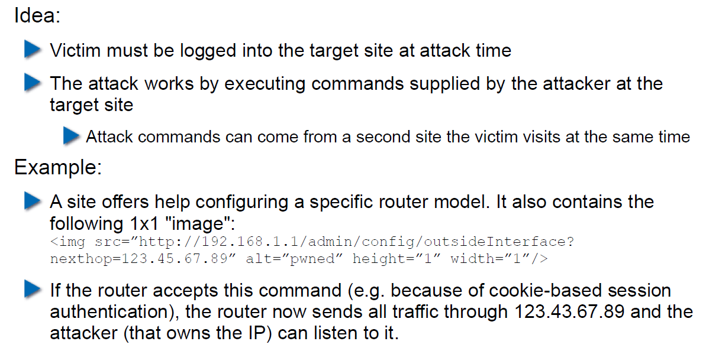

## CRSF Example 2

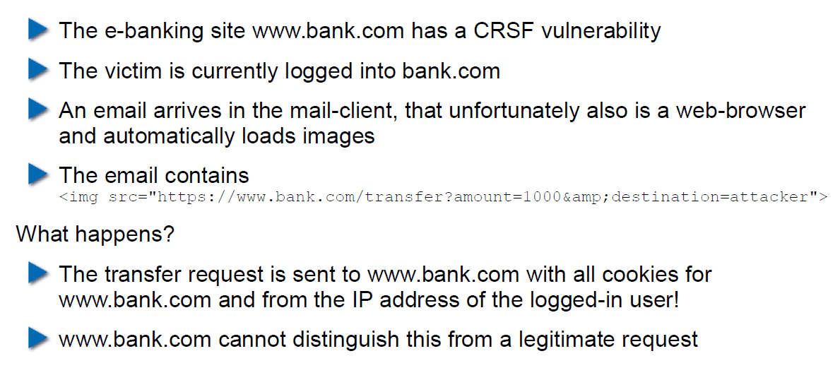

## CRSF Countermeasures

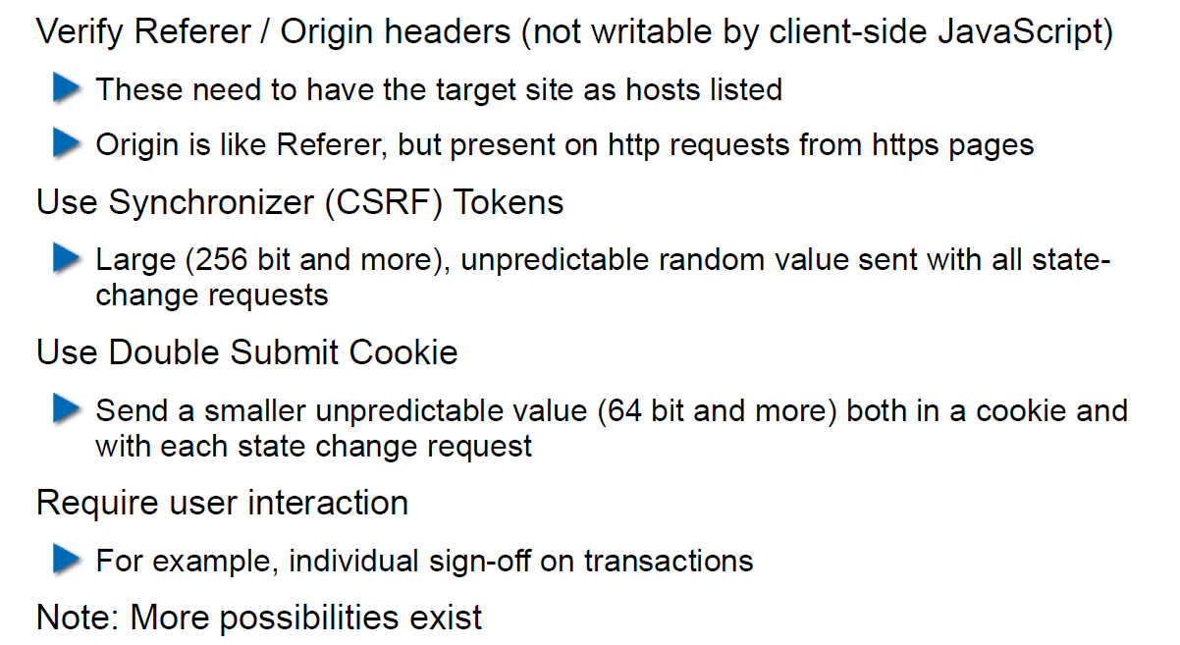

## Same-Origin Policy

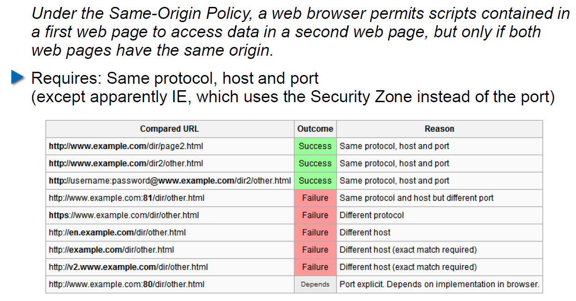

## Cookies and Same Origin

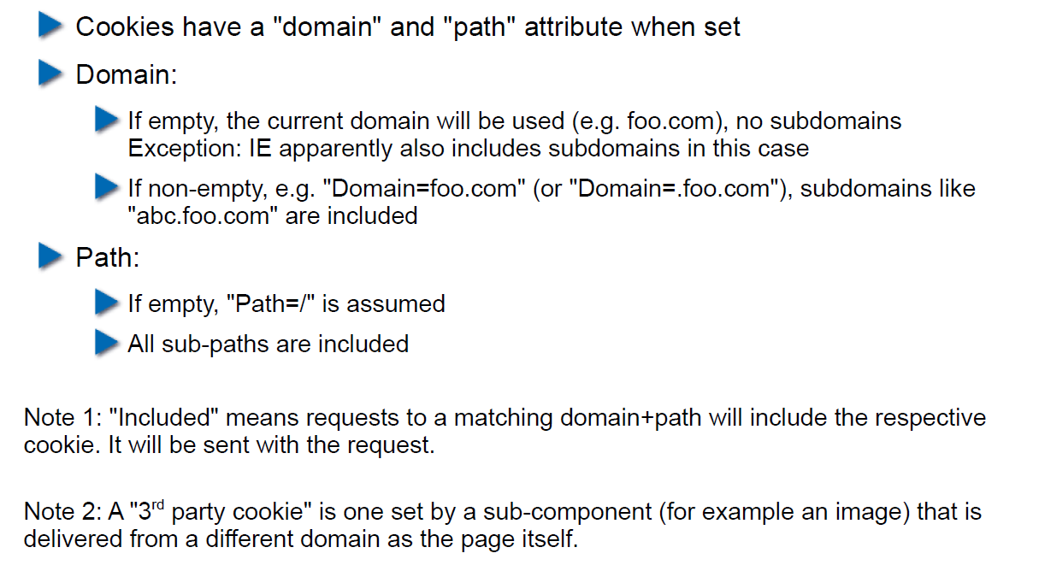

## Same Origin Policy (SOP) and its Limits

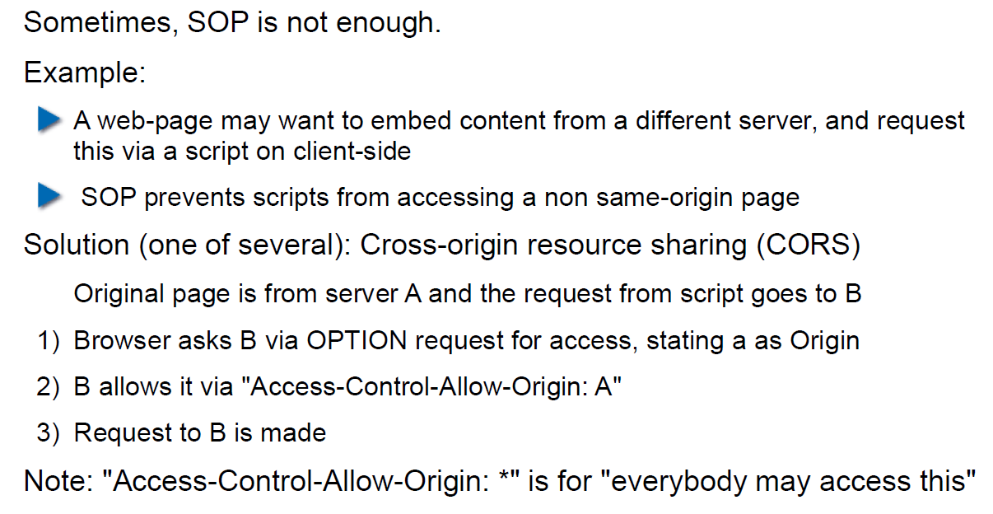

## CORS Overview

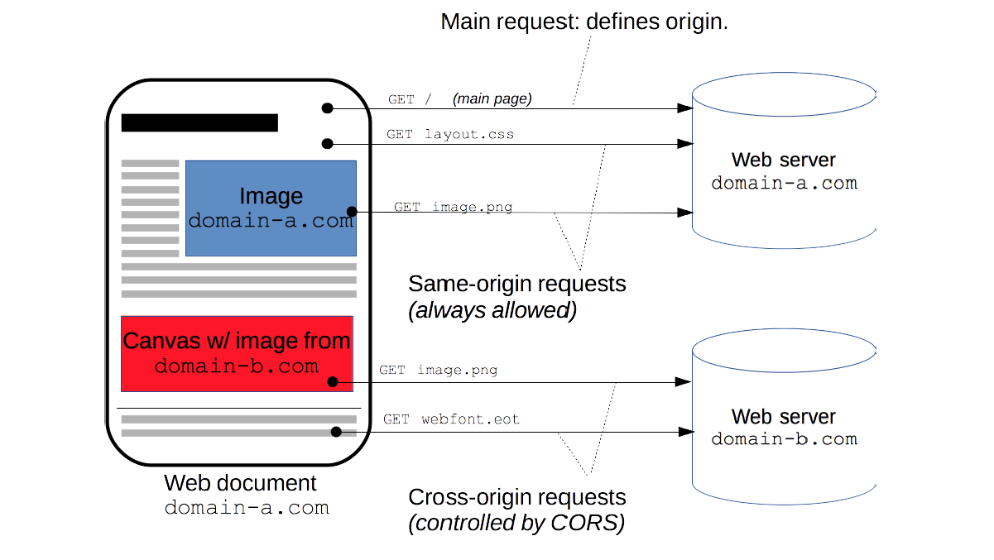

## CORS Preflight Requests

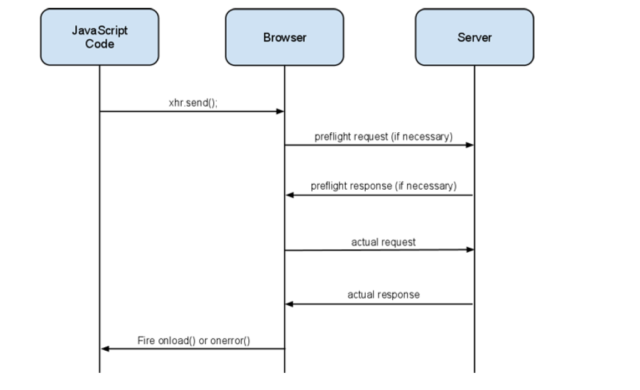

## CORS Example (slightly abbreviated)

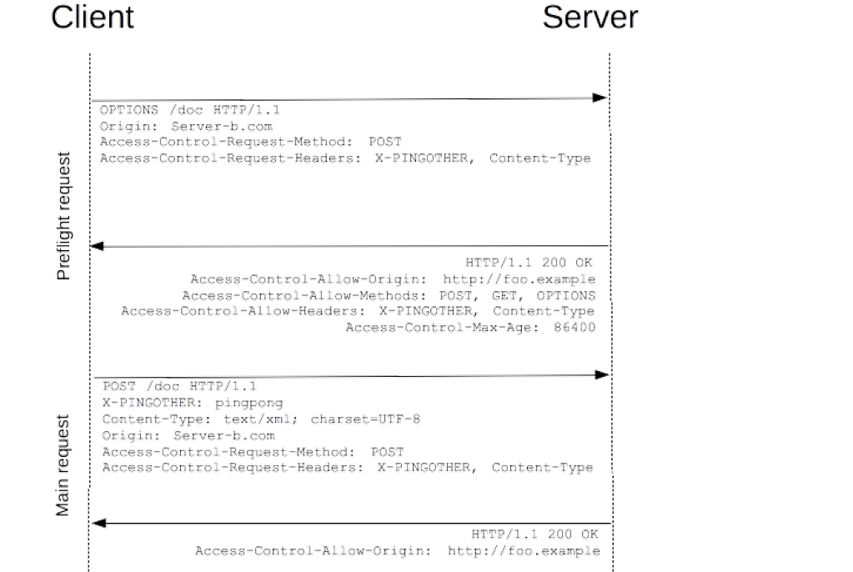

## CORS for Multiple Domains

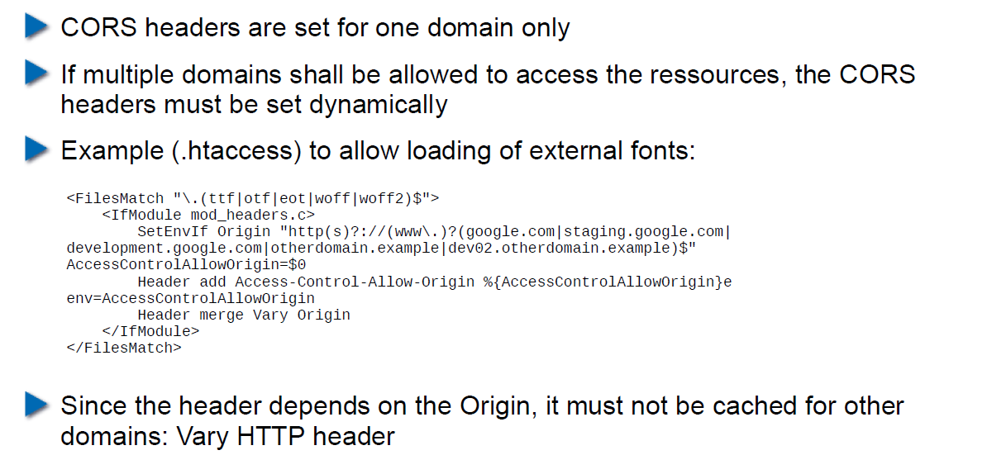

## Content Security Policy (CSP) Headers

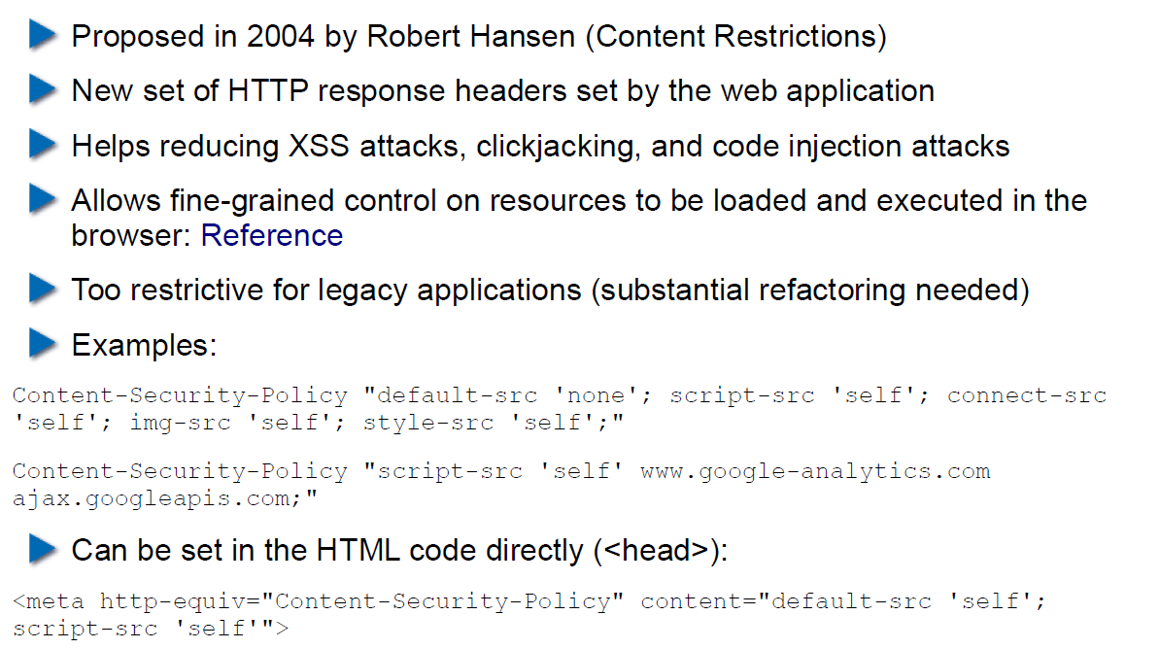

## Overview of Common CSP Options

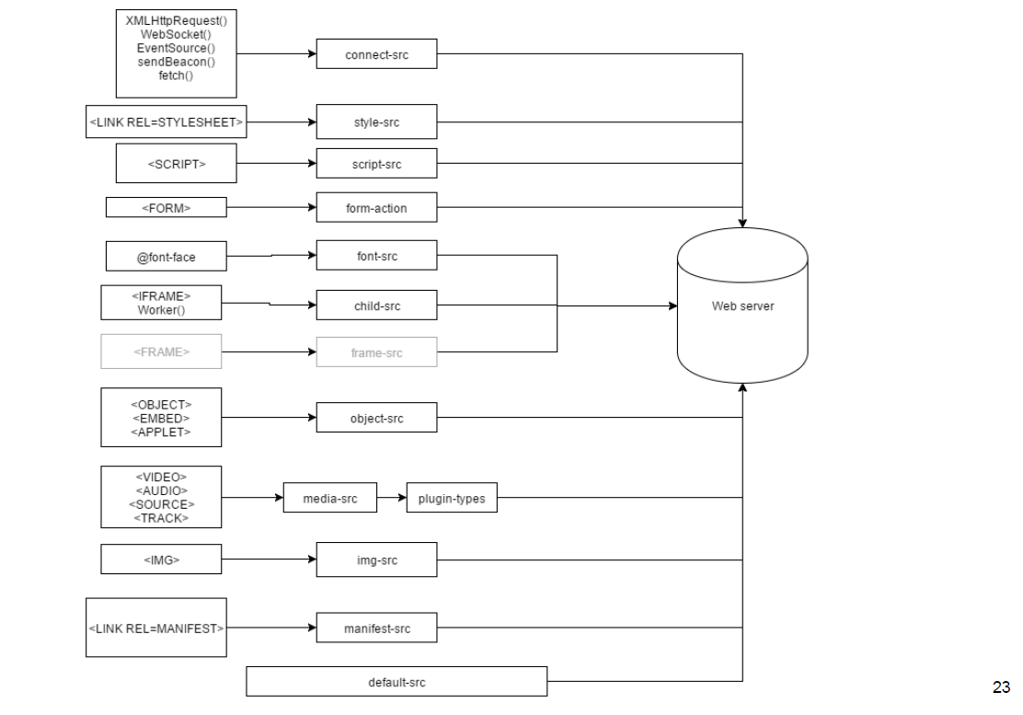

## Exercise: U08

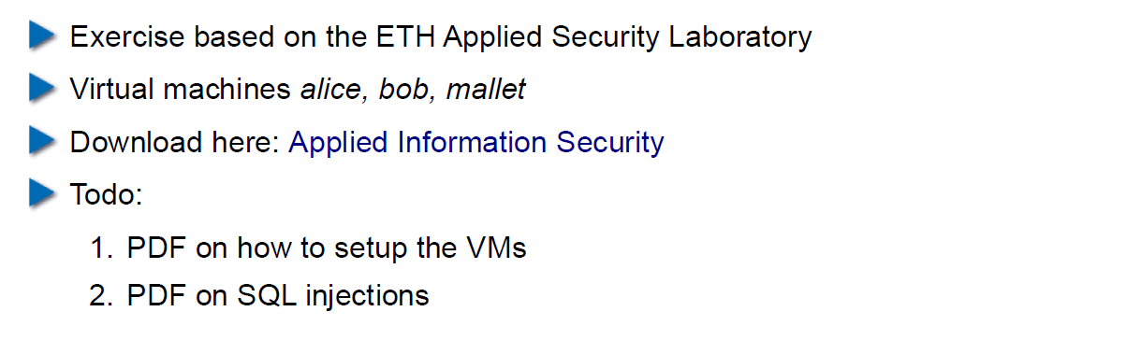

# Woche 9

## Agenda

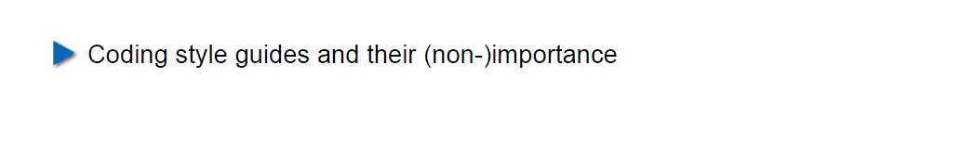

## Coding Style Guides / Coding Standards

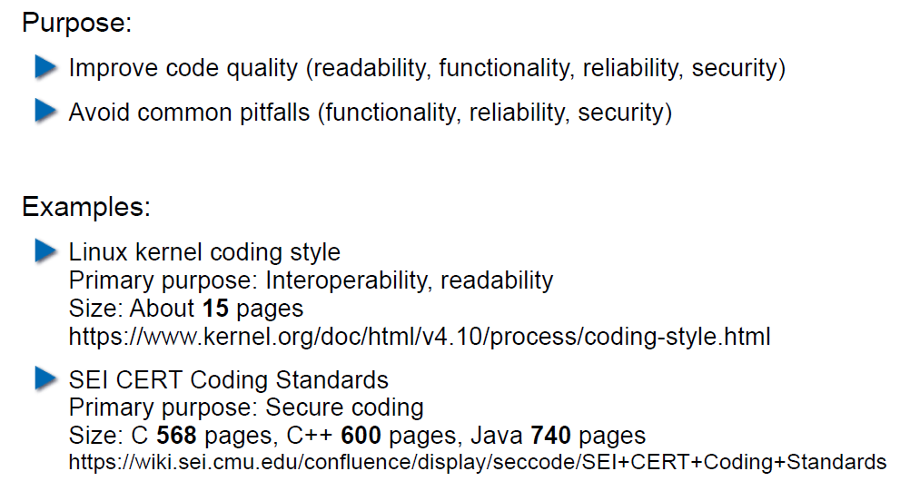

## Linux Kernel Coding Style: Introduction

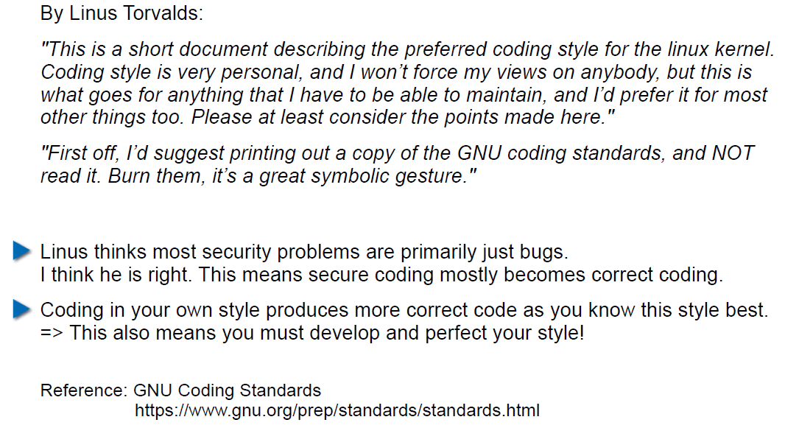

## Linux Kernel Coding Style: Examples (1)

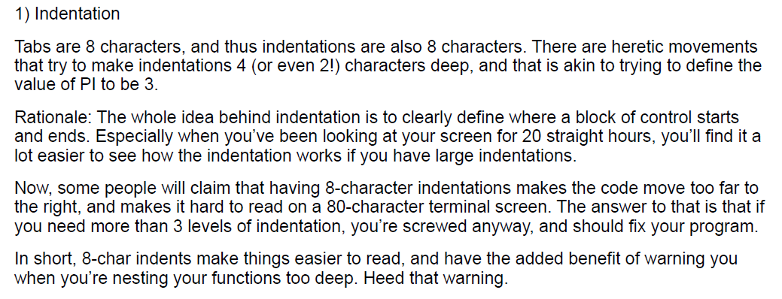

## Linux Kernel Coding Style: Examples (2)

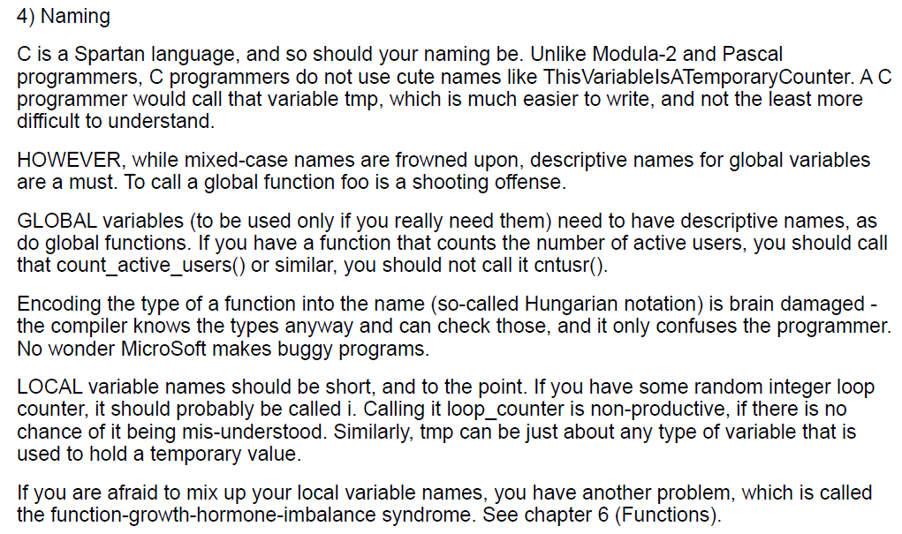

## Linux Kernel Coding Style: Examples (3)

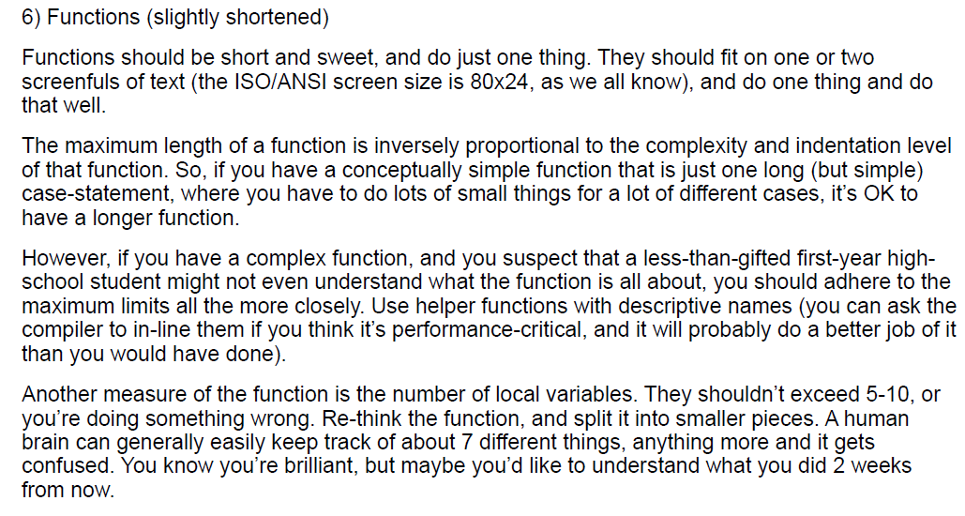

## Linux Kernel Coding Style: Examples (4)

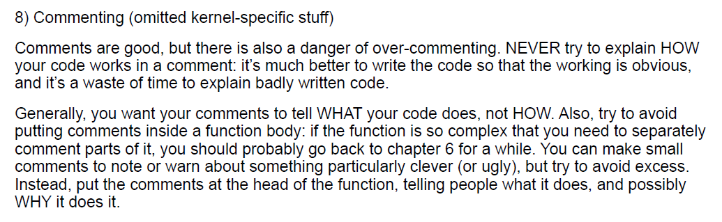

## CERT/SEI Rules and Recommendations

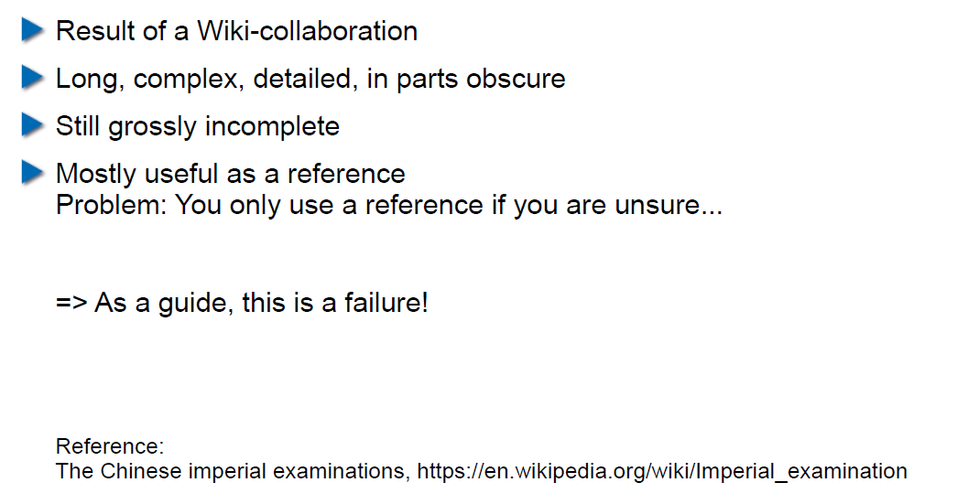

## What do Coding Style Guides Accomplish in Reality?

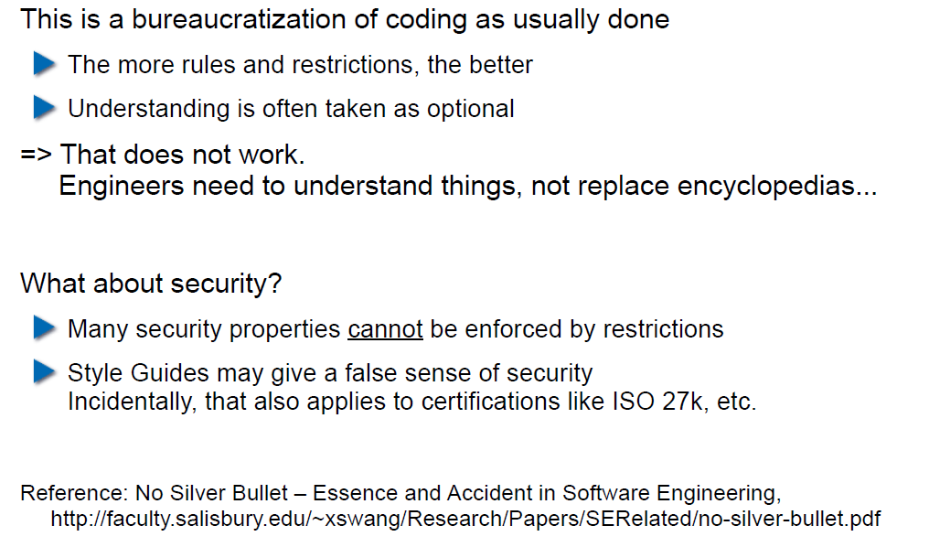

## Problems with Restrictive Coding Environments

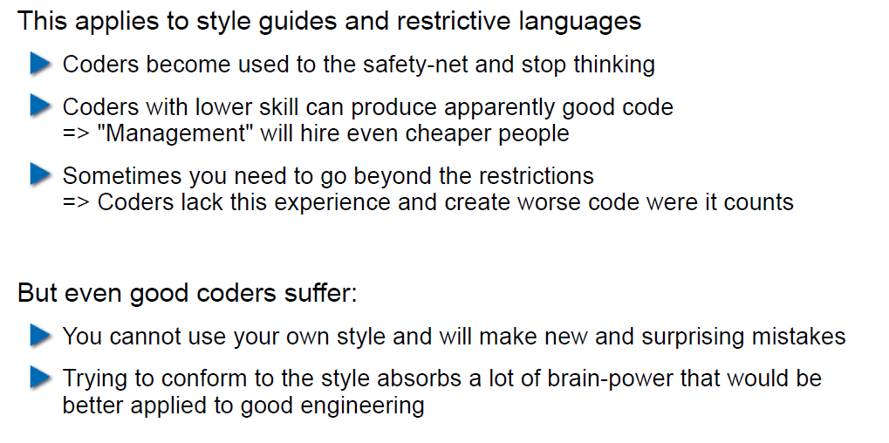

## What About Interfaces and Naming in Them?

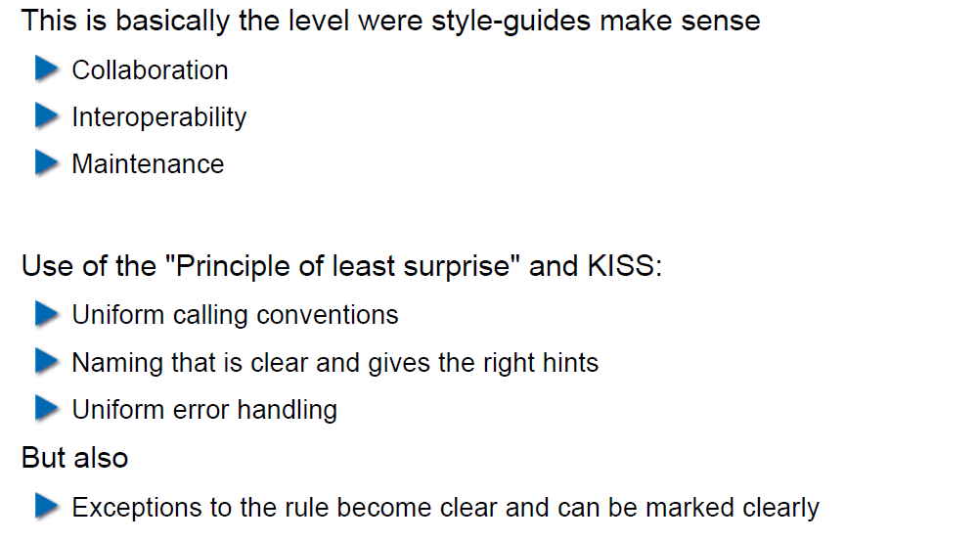

## So use a Style Guide or not?

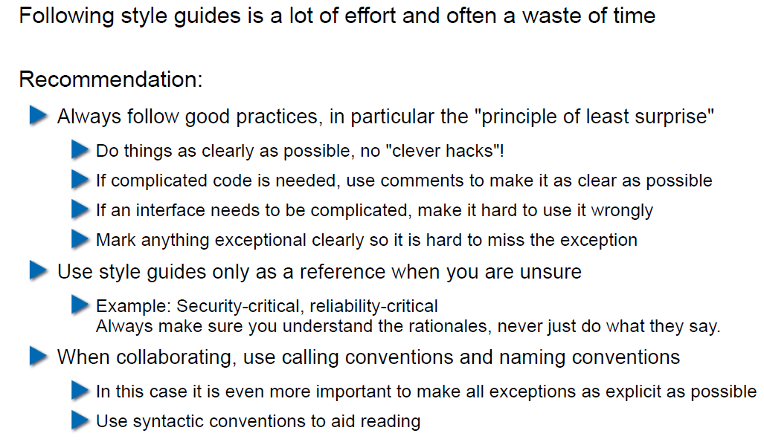

# Woche 10

## Agenda

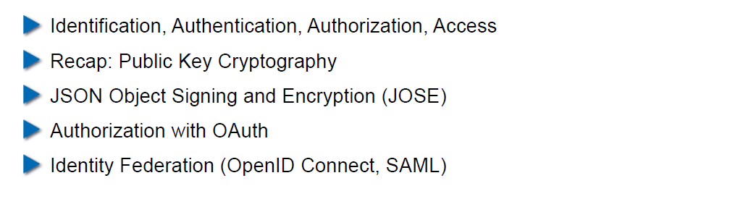

## Authentication

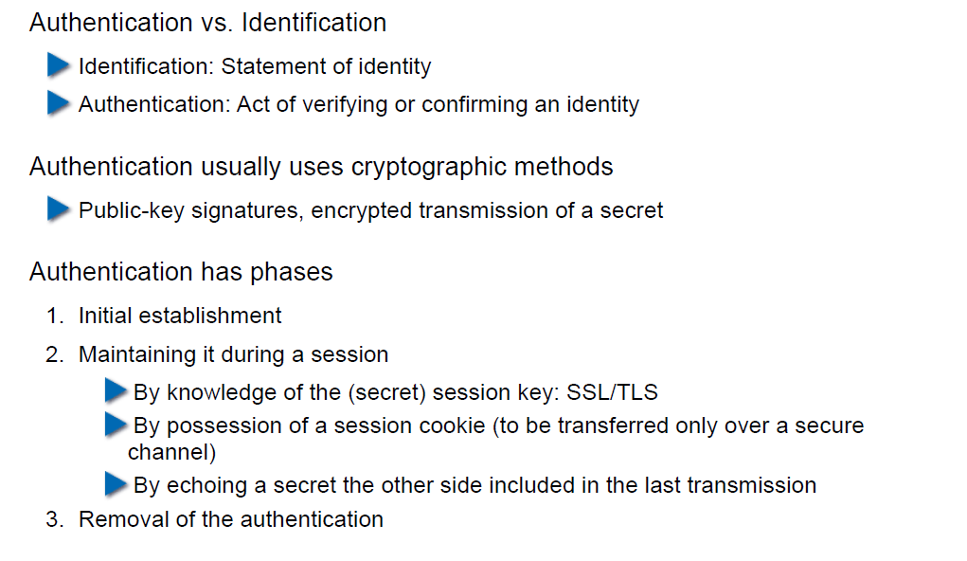

## Authorization

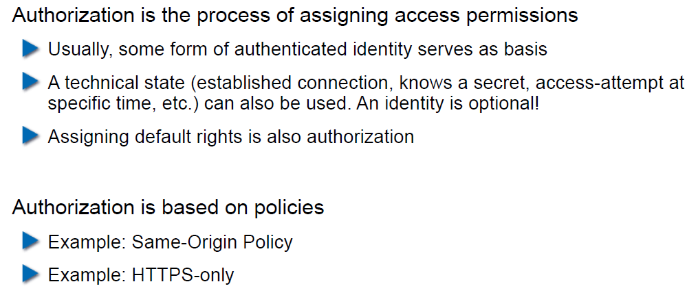

## Access to a Resource

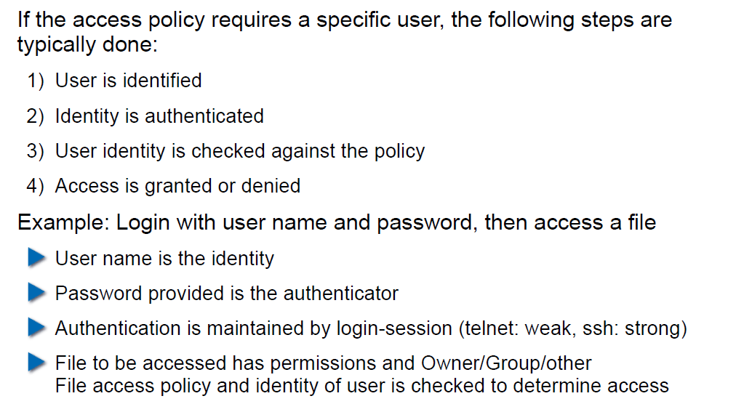

## Recap: Public Key Cryptography

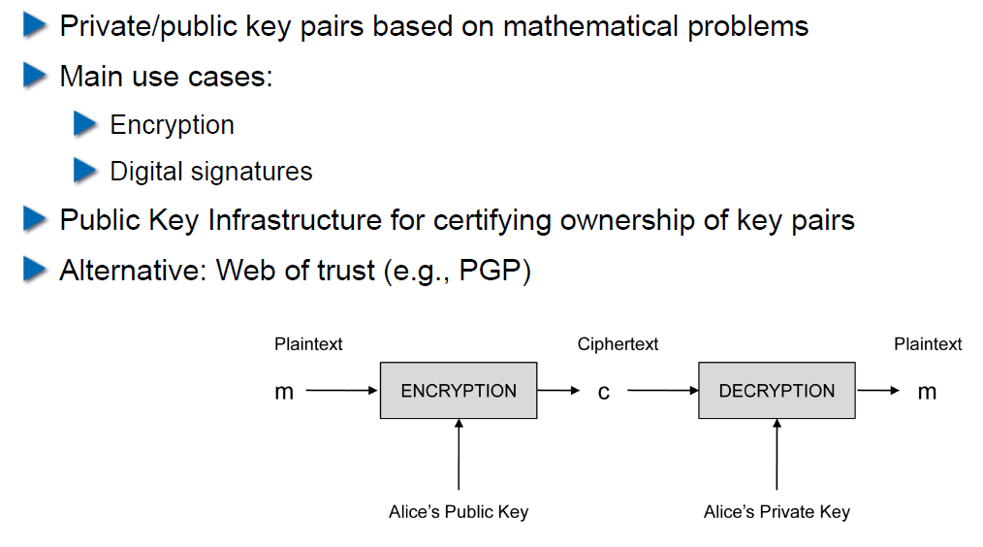

## JSON Object Signing and Encryption (JOSE)

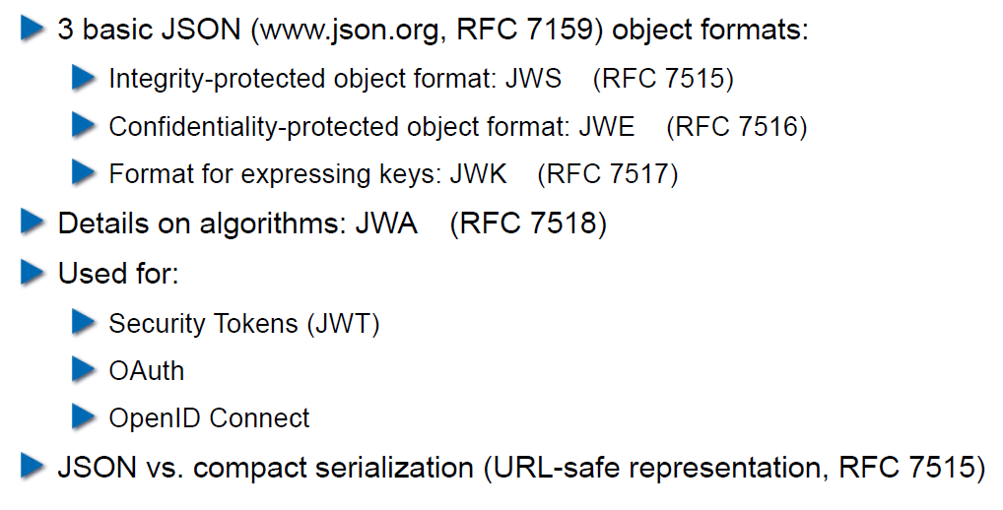

## JSON Web Signatures (JWS)

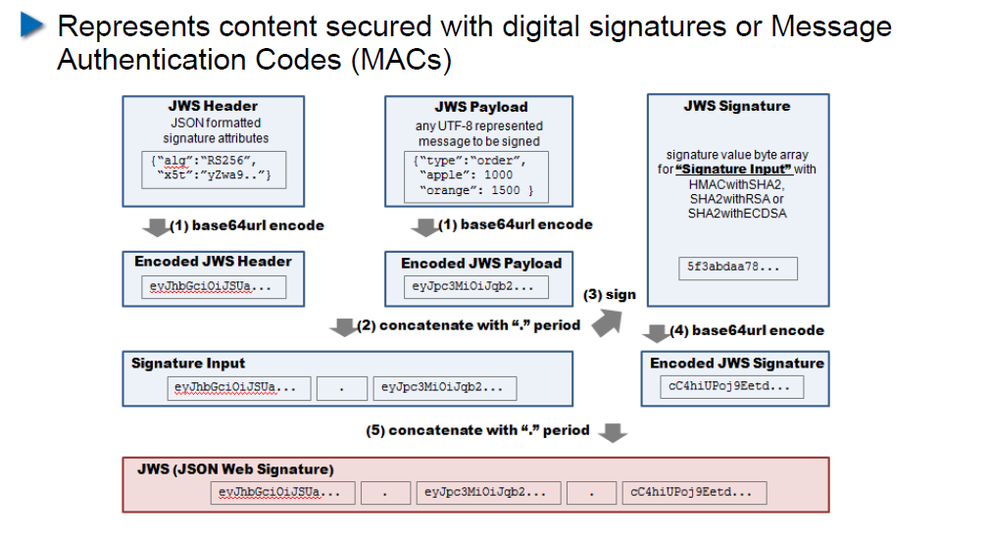

## JSON Web Encryption (JWE)

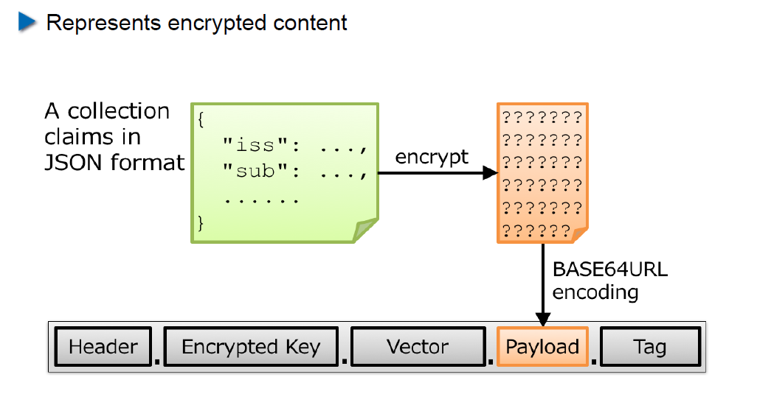

## JSON Web Token (JWT)

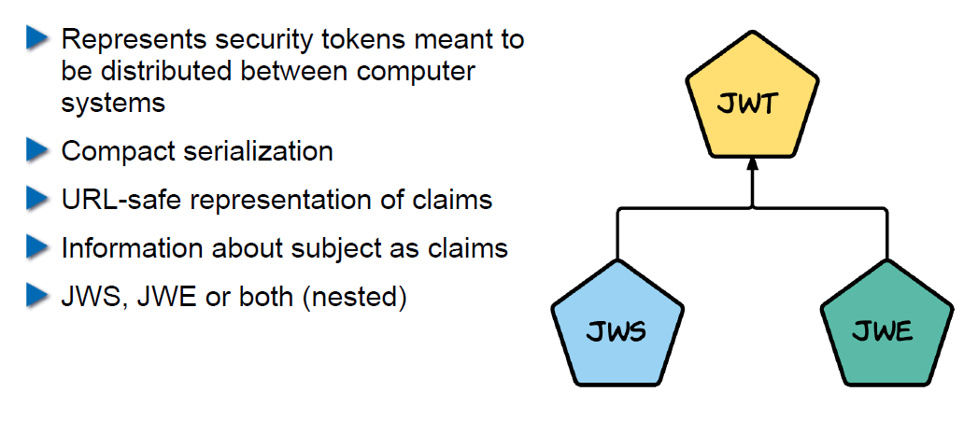

## Nested JWT

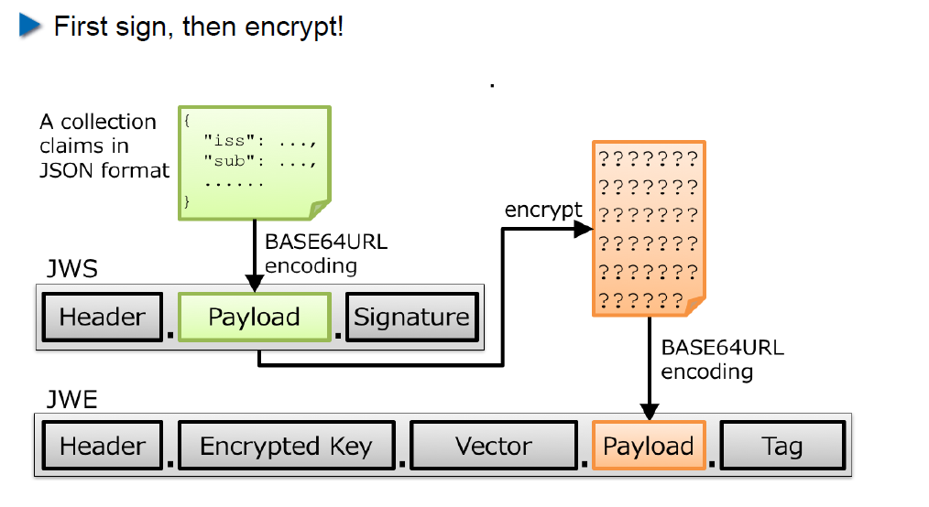

## JOSE Implementation Details

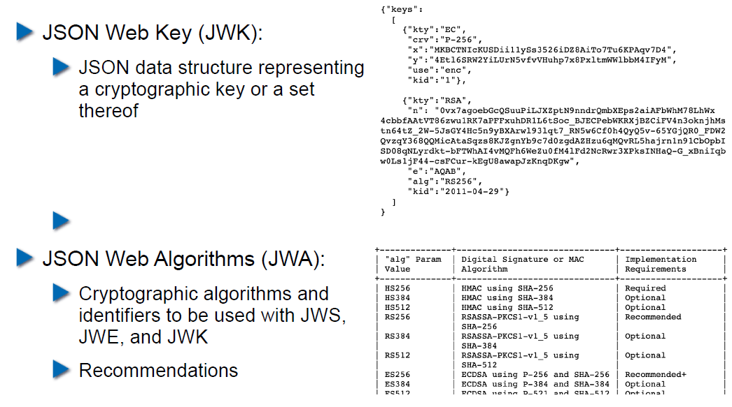

## OAuth 2.0

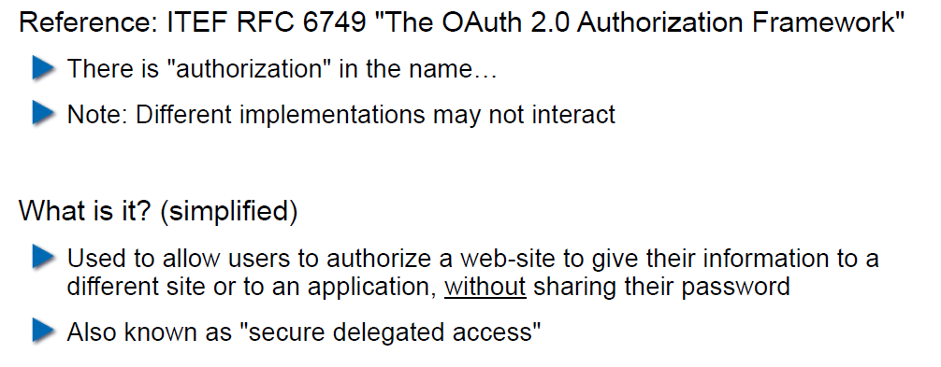

## OAuth Access Flow

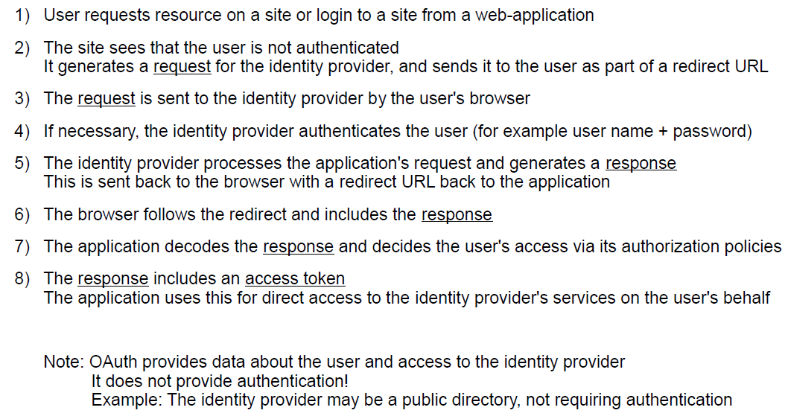

## Identity Federation

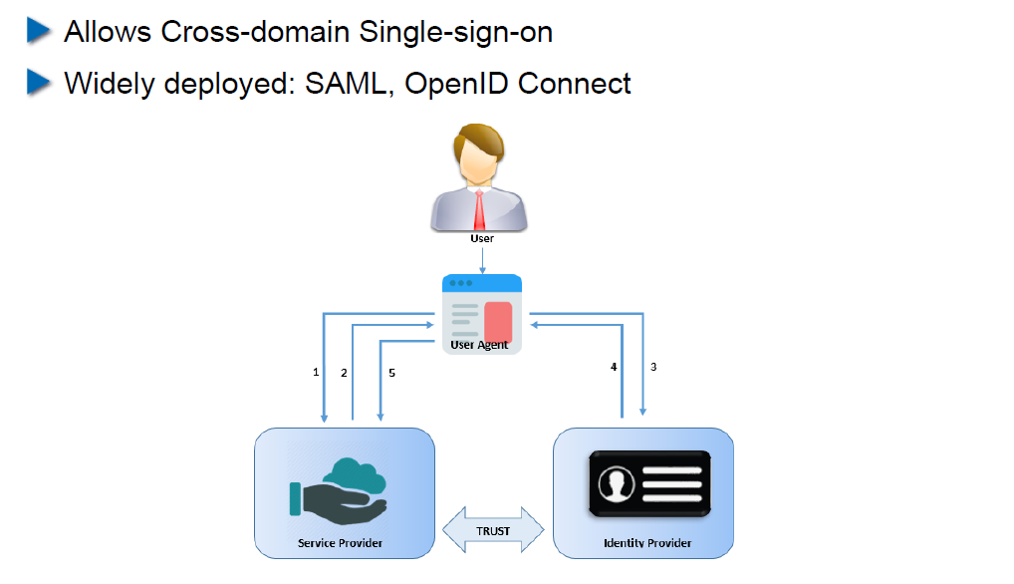

## OpenID Connect

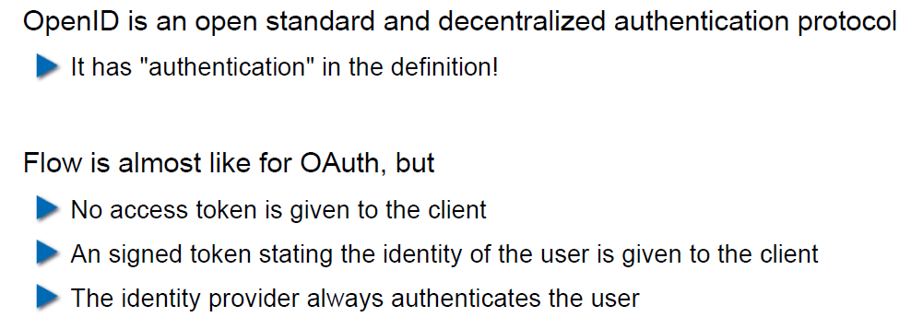

## OAuth vs. OpenID

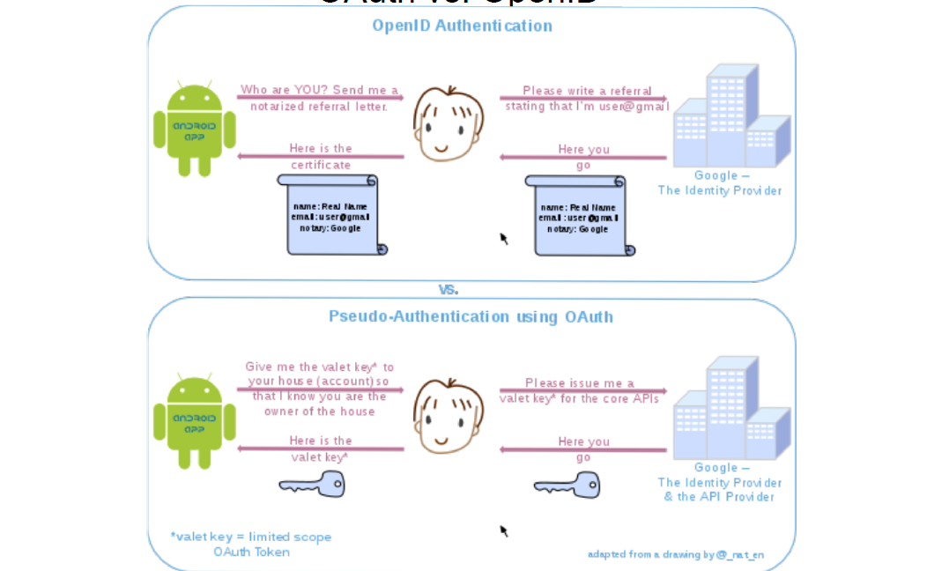

## OpenID Connect

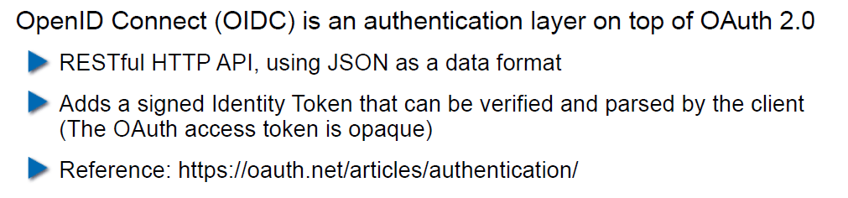

## Recent OAuth 2.0 Flaws

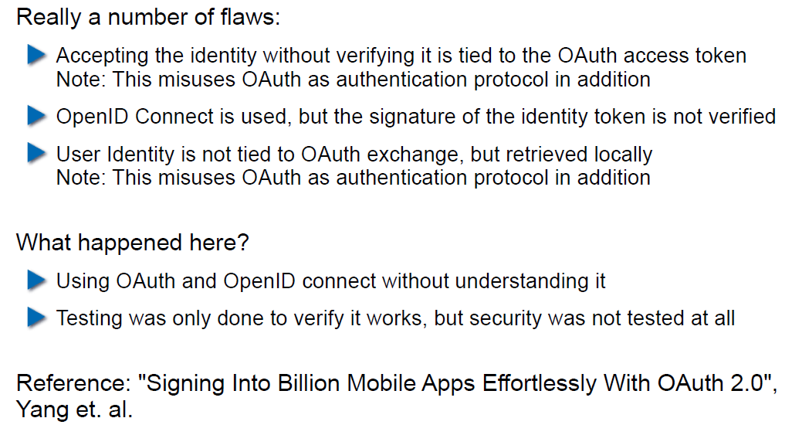

## SAML 2.0

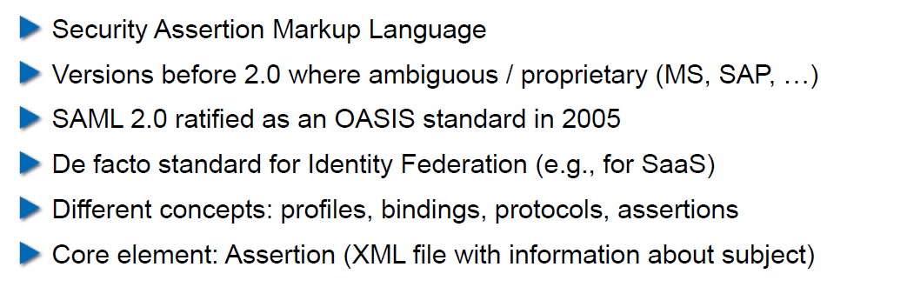

## SAML 2.0

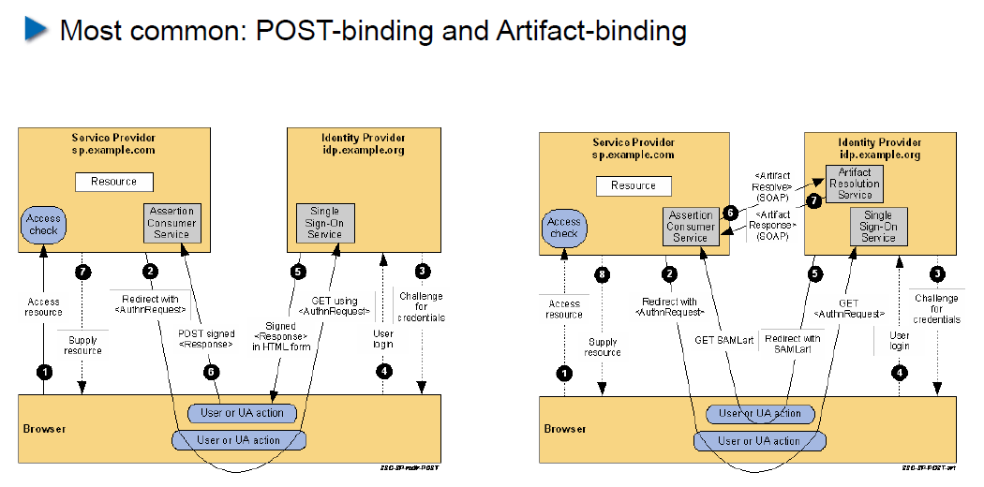

# Woche 11

In Woche 11 fand die Projektwoche statt.

# Woche 12